Completion Report
For one year (Jan ’08 to December ’08)
Of the educational support to the riot affected and displaced children of Danilimda area of Ahmedabad city.

Prepare by,

Centre for Development (CfD)
Ahmedabad, Gujarat
Con. 91 079 2657 7016
email – cfd.ad28@gmail.com
CfD_ad@youtele.com

Submitted to,

ASHA for Education
Cleveland Chapter
USA

Introduction of CfD

Center for Development (CfD) is a non-profit organization, which came into formal existence on 25th of January in 1996. It is register under trust and society act. It comprises of people from various walks of life, who have more than ten years of experience of working for the upliftment of the poor and the deprived section of society in Gujarat. The group came together specifically to address the issues of education primarily in Muslim and Dalit community. CfD believes in their complete emancipation and in creating a society with deep communal harmony.
Thus, the vision & mission of the organization are:
Vision
To create a humane and just society for the oppressed, deprived and exploited people of the society.

Mission

To inculcate the values of nationalism and equality and build awareness and initiate rights base movements through advocacy and action programs.

It currently works in urban segment in the city of Ahmedabad and in rural areas of Junagadh district of Gujarat. CfD’s target groups are Dalits, Muslims, Kolies and fisher folk communities. Women and children of these communities remain the focus group of the organization.

Background:

CfD started its work in 1998 with child labourers and has enrolled more then 1200 children into formal schools, till date. We found that irregular and inadequate income were the main cause of children’s school drop-out. Than we started income generation programs with their families. This helped greatly in keeping the children out of labour work. In 2001 there was massive earthquake which affected the lives of many people. This again affected the education of the children. Schools were closed for months for renovations and children and parents had fear so they did not send the children to schools. The second consecutive year, 2002, saw communal carnage on a very large scale. Thousands of people were killed and more then 150,000 people were displaced and living in relief camps. The riots continued for six moths and people were segregated in many colonies. The whole atmosphere was of suspicion and uncertainty. In this situation people could not think of sending their children to schools because of insecurity. Hundreds of children have dropped-out from schools. Many families shifted faraway from their original living place to newly built relief colonies build by religious organizations. Means of livelihood were destroyed; economic boycott and polarization of communities snatched their livelihood resources. The families became divided and their lives were disturbed in all facets. The main affected groups were children, girls and women.

CfD has been working with riot affected people of Danilimda, Behrampura, Piplaj and Ramol area. We were involved in the peace building exercise with these people from 2002. Education of the children was badly lacking in all these areas as most of the children did not go to schools and were drop outs. CfD started education centres for these children and also integrated peace building alongside by taking equal mix of children of both Dalit & Muslim communities in the centres. This helped the children to better understand each other. During the parents meetings, the parents of children of the two communities also got a chance to interact with each other. This really helped in forging friendships and developing a better understanding between the people of the two communities.

CfD’s contribution to educational support in last five year.

Year | Children coming to ECs | Children enrolled to formal schools | Children dropouts from school who were enrolled in the school from ECs | Children dropouts other then children coming to EC | Total children dropouts
2002-2003 | 1232 | 763 | 256 | 524 | 780
2003-2004 | 948 | 423 | 172 | 263 | 435
2004-2005 | 427 | 448 | 26 | 97 | 123
2005-2006-2007 | 278 | 194 | 6 | 58 | 64

In last five years we have enrolled more then 1200 children and they are now studying in formal private and government schools. But due to various circumstances like the present town planning scheme in Danilimda area, the people are relocated to distant places which are faraway from their original habitat. These areas e.g. Piplaj, do not have any schools in the near vicinity of their homes. Thus the children are again forced to drop out of their present studies.

Introduction:

The city of Ahmedabad is declared a metro city, and thus in the name of development massive construction is being done in the whole city on a very large scale. Many town planning schemes are being implemented which displace the people living there for more than twenty to twenty five year - though illegally. They are unaware about this development, so they have not made alternate arrangements. This is what has happened with the people of Danilimda along with other residents of Ahmedabad; more then 500 families have been affected by the town planning scheme.

The people of Danilimda were displaced due to Town Planning scheme and relocated to Piplaj area which is approximate 5 k.m. away. The people have been twice affected – first due to the riots and now due to displacement. This has badly affected their livelihood. Piplaj area has no infrastructure facility. They are allocated just a single room of 12 ft x 15 ft there. They have no bathroom facility available to them. There are no schools in this area. The nearest school is more than 5 k.m. away.

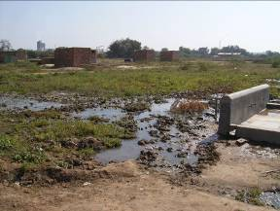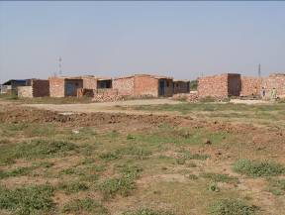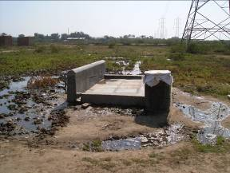

The children’s education is again disturbed badly. We have already enrolled 53 children who were previously in our education centres into formal schools and are supporting their education through our scrap paper project.

Activity:-

We had identified 116 children in Piplaj area who were in need of education facility. we are supporting these children by buying for them notebooks, school bags and some miscellaneous stationary like pencil, eraser etc.

We have started 4 education centres for these children. These kids consist of children who have dropped out of school and some who have never gone to school. Initially we thought of allocating classes to these kids on the basis of their age but later we decided to allocate them the centres based on their education. We came to this decision because many of the kids despite being 14 -15 years old had never been to school and were completely illiterate. The age group of these children is 6 to 16 years. We have benches in one centre. In 3 centres the children sit on the ground and study.

These classes are conducted from 10 am. To 3 pm. During 3 pm. & 5 pm. the teachers do their home visits to the homes of the children who are irregular in the classes and preparing for the next day’s classes.

A library cum activity centre has also been started in the area. The kids can come here after their classes. The library is open till 6 pm.

KADAM education program

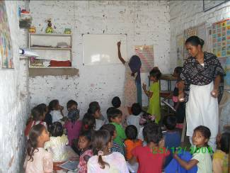
1. Education classes

We have started 4 centres in different significant names for these 116 children. Four Bal Dost are taking care of educational and value inputs in these classes.
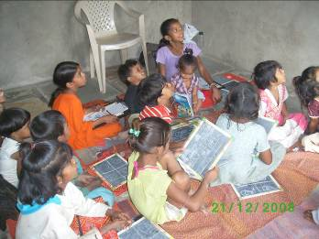
- Aarambh Education Centre
‘Aarambh’ means beginning.
- Tamnna Education Centre
‘Tamanna’ means desire.
- Saad education centre
‘Saad’ means voice.
- Udaan Education Centre
‘Udaan’ means flight – flight into a brighter future.

Details of Children in different Education Centres

Aarambh |  | Tamanna |  | Saad |  | Udaan
8 Boys | 7 – 11yrs  1 – 8yrs | 10 boys | 9 – 8yrs  1 – 12 yrs | 13 Boys | 5 – 11 yrs  8 – 9 yrs | 6 Boys | 6 – 8yrs
17 Girls | 12 – 6yrs  1 – 8 yrs  4 – 16 yrs | 15 Girls | 1- 12 yrs  14 – 8 yrs | 12 Girls | 5 – 6yrs  6 – 9 yrs | 19 Girls | 4 – 7 yrs  15 – 14 yrs
25 | Total | 25 | Total | 25 | Total | 25 | Total

Total 100 children come regularly to the education centres. The other 16 children cannot come to the centres regularly due to family issues & responsibilities, so they are given educational support at their homes.

Progress of the program

About Bal-Dosts
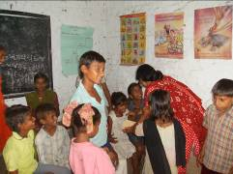
Bal-Dost meaning friends of the children – these are the teachers of the education centres. Currently 2 Muslim & 2 Dalit women are working as Bal-Dost with the children. 2 are graduates and 2 have cleared their 12th class.

The teachers are giving proper training and sensitization towards the children issues and issues of the area.

Initially it was very difficult to enroll the students as some of the children used to go to do odd jobs to help their family. These teachers used to go from house to house and convince the parents and children on the importance of education.

The teachers not just look after the personal hygiene of the children but also help in grooming them by adding value education.

About Program Coordinator

The co-ordinator organizes the parent meetings. She also gives training to the Bal Dosts on ways of handling the children as the co-ordinator is well trained and qualified for this. She is involved in the evaluation of the progress reports and overall evaluation of the performance of the Bal Dost and the progress of the children. She provides regular reports on the performance and progress of the education centres and ways and means of improvement.

1. Support of educational material

CfD has provided notebooks and other writing material to these children out of the support by Asha. Textbooks are given to the children from pasti project. Note books and set of pencils, eraser, sharpener, writing pads and colors were given as a kit to every child. The organization has also given a folder to each child to enable to keep their books & stationary safely in it.

2. People’s involvement in progress monitoring

We have involved the community in the program. First is we are meeting them regularly and briefing them about the status and progress of their children and asking their support that they must take care at home for the homework given by the Bal Dost. The second way is we take a token fee of Rs. 10/- per month from each child. This is because CfD feels that it will inculcate a value of ownership in the people. Free handouts are not taken seriously. In first six months we did not implement this but in the second half we have taken this token fee.

3. Parent Meetings

Regular parent meetings are held where the progress of the children are discussed with the parents. CfD holds meetings for the parents of different centres once every month. Total 24 meetings were held with the parents. These meetings are held on Sundays so that the parents are free to come. These meetings also serve the peace building process of CfD as parents of children of both the communities come and interact on a regular basis with each other.

4. Monthly Exam books

Every month the children’s progress is evaluated through a monthly exam. The papers of these exams are checked by other staff members. This helps in evaluating the progress of the children in a neutral manner as well as the performance of the teachers is also evaluated based on the results and progress of the children. These results are then recorded in the progress diaries of the children.

5. Hygiene Kit

CfD has a hygiene kit in every centre. This kit consists of a comb, soap, nail cutter, first aid kit etc. Due to the inadequate facilities of water, sanitation and health and hygiene including parents of this area are not very particular about their cleanliness. The teachers of the centres inculcate a practice of hygiene & personal grooming in the kids and make sure that all the children are clean and have their hairs combed properly and their nails trimmed. These practices maintain the children in discipline.
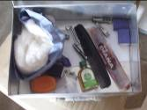
In monsoon we have called Municipal Corporation health department for cleaning the area and provide chlorine tablets.

6. Library cum Activity Centre

CfD has started a Library cum activity centre since Sep ’08. This consists of books and magazines for the children along with indoor and out door games. We have started this library cum activity centre from our scrap project funds. We feel that this will serve as a added attraction for the children as well as the parents to come to the education centres. Also all work and no play can make one dull, so the children after studying can play and relax.
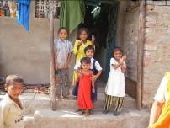
The children can come to this centre after their education classes and spend some quality time. The library cum activity centre is open till 6 pm. The idea behind starting this centre was because most of the children’s parents go to work and return home late in the evenings. They either loiter around or work in nearby local liquor den. In order to stop them CfD decided to start this centre where the children can come and read or play some good educational and recreative games.

7. Food

While working with the kids we noticed that most of the kids did not go home for lunch. On being asked the reason they stated that they had no food at home. Thus we decided to give the children 1 square meal consisting of nutritious food, twice a month. We would like the children to have atleast one proper meal a day but due to financial constraints we have to limit this to twice a month only. We are doing this from our scrap project funds.

Case Stories

Bhavna

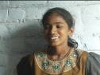
It was her dream to go in full uniform to a clean and good school. Her dream could not be fulfilled; now Bhavna is living in Ganeshnagar in a hut. She has 6 sisters and 1 brother. Her parents are vegetable vendors. They also sell other seasonable stuff to supplement their family income. Bhavna is a bright girl. 3 of her sibings also come to the centres. She wants to study and become a teacher and teach the other underprivileged kids like herself. We want her to fulfill her dream and become an asset not just for her family but also for the area.

Deepali

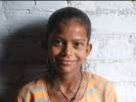
Deepali means lighting lamp, living in crucial and looking her sibling whole day. Situation makes her more mature in the age of 12 year. Not healthy but active and alert in learning; Taking leadership and ready forever to do things in the class room and for her friends. Her parents are doing miscellaneous labour work. She is very good in her studies and understands the importance of education. We feel that given proper guidance and help she can eally excel in her studies and fulfill all her dreams herself.
Afreen

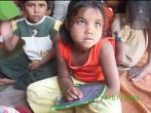
Afreen is 8 years old. Her father has been served 10 years imprisonment and is serving term in jai. She has 2 brothers and 1 sister. Her mother is a stay-at-home mom and her uncle supports their family. They do not have a house. Its just a shelter made of plastic & cloth sheets, where al the 5 family members stay. Her older sister does odd jobs like serve as a help in household or clean utensils for marriages and other parties to support the family. She is very quiet but loves to sing and sings very nicely. When she joined the centre she had never gone to school but now she can write Gujarati & English alphabets and numbers with ease. She wants to grow up and become a teacher so that she can earn money as well as educate the other kids in the area.

Rahul

We found Rahul working as bar tender at local liquor stand, working for whole day opening polythene bags (Potli) of country made liquor. He is just 10 years old. His dad passed away due to T.B. He has 9 sisters and 3 brothers of which 2 sisters have also passed away. His mom does odd jobs and sometimes even begs at the nearby mosques and temples to support the family. Rahul works at the liquor stand to help his family. He also runs errands for the people of the nearby area and gets tipped for it. This is his contribution to the meager family income. 2 of his sisters and 1 brother also come to the centre. He is a sharp kid but is weak at his studies due to lack of concentration. He always wants to do some or the other work and help his family. The bal dost understand this and help accommodate him and try to inculcate the value of education in him so that he does not give up his studies and take to wrong means.

Daxa

Daxa’s is a very tragic case. She joined our centres 4 months ago. She has 1 brother who is 2 years old and a sister who is 8 years old. Their mother passed away before 8 months due to HIV. Their father abandoned them. Their mother was a rag picker and they used to stay on the pavements. Their aunt who stays in the area brought the children to her place after their mother’s death. The aunt is also a widow and very poor. She also has a daughter who comes to our centre. She does odd jobs to feed herself and the children. So she leaves home early in the morning and comes back late in the evening. The girls do all the house work like washing clothes, cleaning utensils and the house. They are too small for this. They do not get proper food also. They used to eat paper and mud. The BAL Dosts are still trying to stop them from eating paper. They have never been to school. Daxa is very weak in her studies, but we feel that if she is given proper warmth and handling she will be a bright star.

Lessons learnt

- The issue of unemployment needs to be addressed because if the family income is insufficient the children’s income plays a major role in supplementing the family income. So the parents prefer that their children work rather than go to study.
- We have started vocational training classes for the parents of the children from the education centres. These include making file/folder, driving, mobile repairing and office assistant training. We are ensuring maximum women’s involvement in these centres.
- The area lacks basic civic amenities. The local people need to be made aware about their basic civic & human rights and how to take up their issues with the concerned authorities.
- The parents themselves are uneducated so it is essential to make them aware about the importance of education.
- The parents committee formed by CfD serves as a common platform for the parents to interact and address their common issues and look for ways to resolve them. It also serves as a tool in the peace building process and contributes to the harmony in the area.
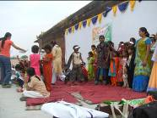
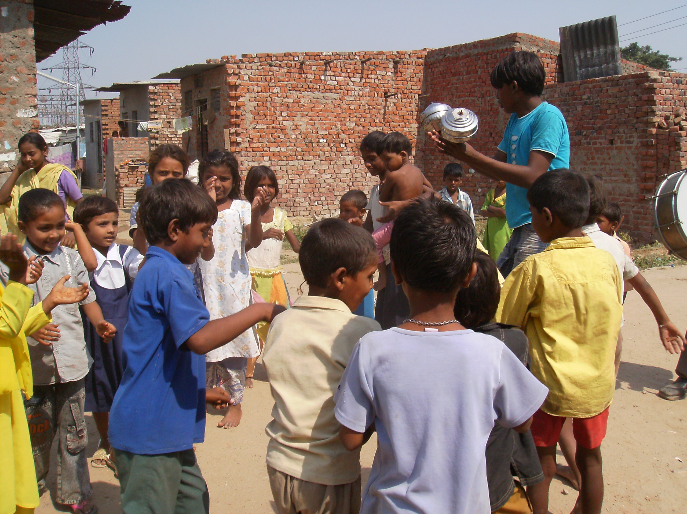

- The kids need to be taken out for interaction with kids from other areas & backgrounds. This also helps in sensitizing the kids from well-to-do families about the issues of kids from other backgrounds.
- Civil society also need to be involved and made aware about the issues of these children and the area. Many people do not come to this area because it is on the outskirts of the city and far from their localities.
- There are many other kids in the area who need to be involved in our education centres but due to constraint of money we are unable to do so. We are approaching other agencies, organizations and individuals in order to raise funds.
- Time is a very big constraint for us. The funding that we get is for a limited period and the issue before us needs long term intervention. We are trying our best to make the effort sustainable in the absence of funding but we are still very far from it.
- It was observed by us that most of the kids did not get one square meal a day. It is difficult to pray on an empty stomach leave alone study!! As a small step we have started giving them food once a month and we plan to make it on a daily basis. We do need funding for this.
- The kids used to loiter around after the education classes. The girls on the other hand were not very comfortable at home in the absence of their parents who are at work till late evening. To help them spend quality time and also give them space to sit we started the library where the children can come and read books and magazines.

- The activity centre has indoor & out door games. Once a week all the children are made to play outdoor games near the centre. They can sit and play indoor games in the centre.

Other Information

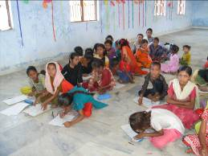
- 26 children want to and are ready for enrollment in formal schools but there are no formal schools in the nearby areas. Fees, books, uniform + commuting to far away schools is unthinkable for the children. CfD wants to take up this issue at a larger level with the establishment to enable the children to get higher education.

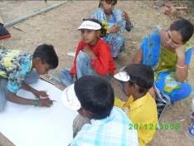
- We had taken the children from the education centres to Sarkhej Roja for an interaction program organized by Centre for Social Justice (CSJ). In this children from public schools and slums interacted with each other and played different games, enacted plays and participated in drawing and painting. This along with being enjoyable was very educational and informative for the kids. It was the first time they interacted with kids belonging to a very different economic, social & geographical background and vice versa.

- Times of India have also appreciated our effort in its Teach India program.

