Progress report

Eradication of Slavery and Trafficking through transitional education, income generation and defense of human rights in Varanasi, Bhadohi and Chandauli Districts

For the period of

October- December, 2008

Project Supported by,
FREE THE SLAVES,USA

Report submitted by
MANAV SANSADHAN EVAM MAHILA VIKAS SANSTHAN
128,Shivdaspur, Lahartara,Varanasi-UP , INDIA
Phone: 91+542+2372191, 91+9451895332
Email: msvs2006@sify.com , bhanuja_msvs@hot,mail.com

MSEMVS – Eradication of Slavery and Trafficking through transitional education, income generation and defense of human rights in Varanasi, Bhadohi and Chandauli Districts

Reporting period: October – December, 2008

Planned Activities during reporting period  In relation to  Transitional Schools | Implemented activities (please show numbers reached, where relevant) | Outcomes/results measured  (please quantify or give examples) | Difficulties, reasons for major deviations, and adjustments to plans
250 children remain enrolled at 5 MSEMVS schools three in Varanasi and two in Bhadohi | 5 schools implemented | 250 children are still getting education with proper educational materials and mid day meals.
Vocational training of older children attending schools | Vocational training conducted for chalk making, book crafts, tailoring and screen printing | 113 children imparted in different trades of vocational training
Regular Follow-up of the children mainstreamed in Govt Schools from MSEMVS schools | Regular follow up done by MSEMVS team,CVCs and the parents | All the children mainstreamed are in school now and they enjoying education in formal schools.
Regular meetings of Children’s Panchayat in the villages and on-going support to participating village matters especially education, rights of girl child etc | This activity has conducted at each centre | Now 8 Children’s Panchayat are active in the villages and imparting in matters of the villages especially with children’s issues
Leadership building and Human Rights Education to the children | This was integrated with the formal curriculam | The children in upper classes are able to understand about Child rights,Right to education and other basic human rights and ways to get it.
Start of a new school in Chandauli district. | A school was started in Chakiya Block of Chandauli district. | 58 children including 29 girls from debt bondage families are getting education.
Any additional activities or news, not in workplan:

Number of schools currently in operation through support from FTS, OMCTP, and Asha: 6 (six)

Number of schools in operation through BfW and GOI: 5 (five)

Planned Activities during reporting period  In relation to  Social and Economic empowerment of parents | Implemented activities | Outcomes/results measured | Difficulties, reasons for major deviations, and adjustments to plans
Production and Marketing of the goods by the women. | Marketing promotion efforts made by the team as well as the volunteers.  Stalls and Exhibitions conducted in the city | The products are going in to market through different channels
Skills Training of Women’s group newly formed/ assessment of need | Training for Pottery, Candle and Woolen cloths conducted for the women in groups | 39 women for candle, 12 women for woolen weaving and 20 for pottery participated in training
Formation of New SHGs of the women in the villages | The meetings for formation of SHGs in other three villages conducted | Three new SHGs have been formed
Capacity building and registration Co-operatives of fathers for self employment. | Could not done |  | Formation of company of those men’s group is still pending and MSEMVS could not do more due to all process happens in Lucknow in this regards.
Any additional activities or news, not in workplan:

Number of parents beginning skills training, this period: 39 women for candle, 12 women for woolen weaving, 20 for pottery
Number of parents completing skills training, this period: 39 women for candle completed their training and 8 women for pottery completed training.

Number of group members starting to make their own income, this period: 39 by candle, 12 by beads, 17 by woolen cloths and 6 by pottery.

Planned Activities during reporting period  In relation to  Defense of human rights and social movement building | Implemented activities | Outcomes/results measured | Difficulties, reasons for major deviations, and adjustments to plans
Formation of 3 CVCs in Chandauli district | Meeting and contacts made for identification of the problems and group discussions held in the villages of Chandauli held | Three new CVCs have been formed in Chandauli – two in the villages and one in town area.
MSEMVS human rights training of volunteers including village-based CVC members and volunteers in Chandauli. | A training was conducted | 32 people from 6 villages participated in that training and Advocate Mr.Gyan Prakash given training to them on legal issues.
Formation and Meeting with PRI-in 5 more villages on the issues trafficking | Meetings and capacity building events conducted | 3 villages in Chandauli, 2 in Varanasi and one village in Bhadohi covered under this initiative in which altogether 57 PRI representatives & ex representatives participated and sensitized.
Legal Literacy Camps (2 days) in the villages of Chandauli and in urban set up in Varanasi. The issues will be gender issues, anti-trafficking and bonded labor laws, community outreach | This was incorporated with above Human Rights training in Chandauli
Training of Block-level Vigilance Committees on the legal issues in Varanasi & Bhadohi | Two training was conducted in Bhadohi Block and one training was conducted in Sewapuri Varanasi | Altogether 98 people were made trained on the issues of right to information, NREGA, Housing, Trafficking and Missing Children etc.
MSEMVS identification and documentation of children trafficked into area. Liaison with police and Labor Department for continuation of conducting raids | A raid was conducted | 1 child bonded labour and 5 adult bonded labourers were rescued in which one was from Nepal,4 were from Bihar and one was from Varanasi. | The labour department official didn’t cooperate enough and this resulted delay in issuing Release Certificate.
Follow up of a range of legal cases affecting local residents with the support of Advocate of HRLN-JVI | This was done | The details are given below.
MSEMVS training workshop for NGO/CBO Network members in Bhadohi Block. | This was conducted | 34 people including students,lawyers,women groups,teachers and the members of NGOs/CBOs participated.
Meeting with PRI-in 3 villages in Chandauli on the issues of trafficking | This was conducted | It is mentioned above
Pressure building event in Varanasi and Bhadohi for activation of CWC (under JJ Act) and Bonded labour Vigilance Committee (under Bonded labour Act) formed by the Government/  Policies devoted to ending bonded labor and to the fostering the welfare of children in collaboration of DDWS and other local organization in MSEMVS network.  Meetings with CVCs formed in Varanasi, Bhadohi and Chandauli districts. | The RTI were filed for getting information about these. |  | The concerned departments given the information very late, some given the inadequate and irrelevant information, so we filed new RTI for our specific information
Training of CVC members and volunteers supporting in urban set up in Varanasi and Bhadohi town area. As estimated 20-30 persons will be trained. The issues will be gender issues, anti-trafficking and bonded labor laws, community outreach | A training was conducted in Varanasi | 18 volunteers participated in that training and this event was also a introduction of YOUTH network (youth outh for Uniting against Trafficking & Hiv- aids)in the urban area. | In bhadohi we could not conduct such training and this will conduct in next phase.
Sensitization workshop for Block/Sub district level officials and authorities in Sewapuri Block in Varanasi. | This workshop could not be done, the personal contact were made for sensitizing the authorities about the problems and appropriate action taking
Block level Networking and Advocacy with PRI in Varanasi and Bhadohi. | This could not be done |  | Due to sub election for assembly in Bhadohi we could not do this. This will be done in next phase
Social Audit of the Govt run schools with CVC members in 10 villages in Varanasi and Bhadohi. | This was done | The MSEMVS team, trained CVC members and volunteers took part in the social audit in 10 schools in 10 villages
Mass Awareness event World Human Rights Day (10th December). The facts came from Social Audit will be shared with villagers and with authorities. | The written memorandum with the findings in social audit of schools was given to the authorities at block level in Varanasi and in Bhadohi for taking the appropriate action. |  | We are still waiting for making action by the authorities in this regards.We will go to district level authorities with those issues in further period.
State level Advocacy with FTS Indian Partners on issues emerged in the field related to Trafficking. | This could not done
Any additional activities or news, not in workplan:
Formation of Network of Youth | A network was formed of youths in the rural area and now expanded in urban area. This network name is YOUTH and it is active on the issues of Trafficking and HIV-AIDS | 12 youth clubs (containing 240 members) in the villages and more than 50 youths in urban area are the member of this network and they are active on these issues.

Legal cases to prosecute traffickers begun, this period: Number: One
Details: One in Chandauli in which the trafficker is in jail and the advocate is still opposing the bail of the trafficker.
Three FIR against the traffickers have been lodged in Varanasi and Chandauli

Legal cases to prosecute slaveholders begun, this period: Number: Two
Details: One in Varanasi in which a restaurant owner has penalty for Rs.20000 against the child labour
One in Varanasi in which a restaurant owner has to be prosecuted

Legal cases to assist individuals for other purposes (e.g. dowry, filing cases for social rights like Indira Awas), this period: Number: Eight
Details: Two of Dalit atrocities, Two Dowery cases, one Illegal loaning, one Legal Rights for a women,Two land rights.

Total number of legal cases being taken forward by MSEMVS, at this time: Number: Eleven

Details of any legal cases reaching a conclusion (results gained): One family got Indira Awas in Varanasi

New CVCs created during this period: Three in Chandauli and two in Bhadohi

Total number of CVCs in action now, linked with this program: 49

Planned Activities during reporting period  In relation to  Staff capacity building and organizational development | Implemented activities | Outcomes/results measured | Difficulties, reasons for major deviations, and adjustments to plans
Staffs/CVC representatives Training on Networking and Advocacy | A two days training was organized on the issues of Advocacy & Networking | 26 team members participated and got training about different aspect of networking, lobbying, rights based intervention, advocacy and knew about different existing networks
MSEMVS starts a District Information Centre for making easy access to the people Right to Information. This centre will be run at the data resource centre. | This was done | 32 RTI filed for the villagers and the information/data were collected on the issues of Cases of Trafficking, Cases of Dalit atrocity, Cases of Women Exploitation and Cases related to Govt.services.These information were shared on different level for analysis and action taking.
Staffs training (5 days) on Gender and Violence issue, exposure visit for making a better understanding | This could not done |  | Due to non availability of trainer time it could not be done. This will done in Jan-Feb,2009
Any additional activities or news, not in work plan:

Other anecdotal examples of success, case studies, or other necessary explanations e.g. challenges to the program:
(if sending photos, please attach as separate files, and ensure you only send us ones that have permission from the main subjects).

Photos:

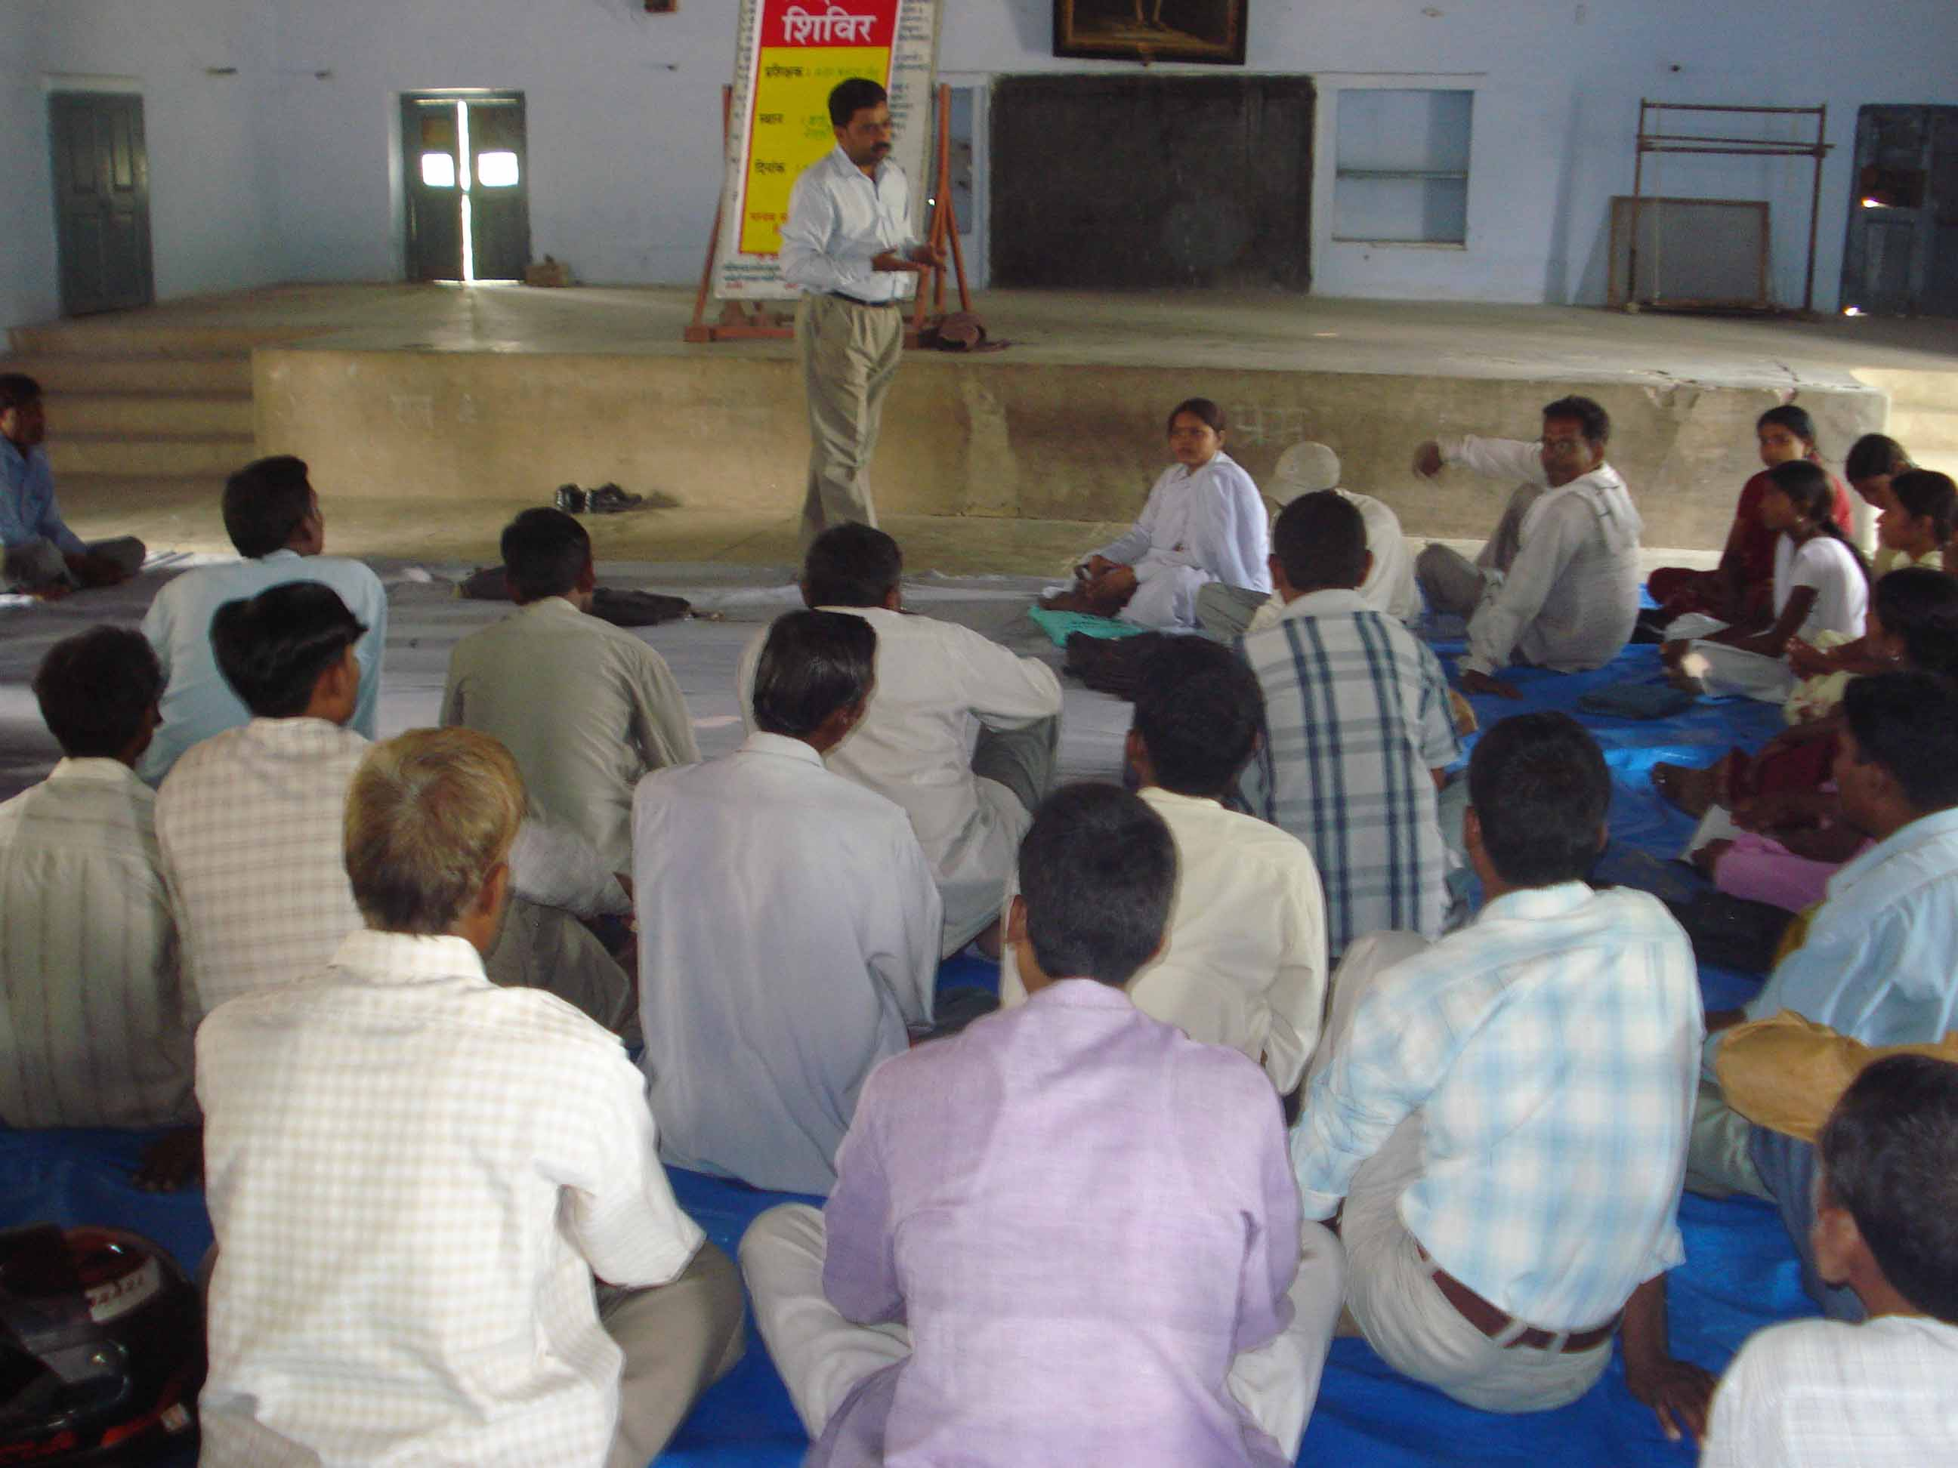 | 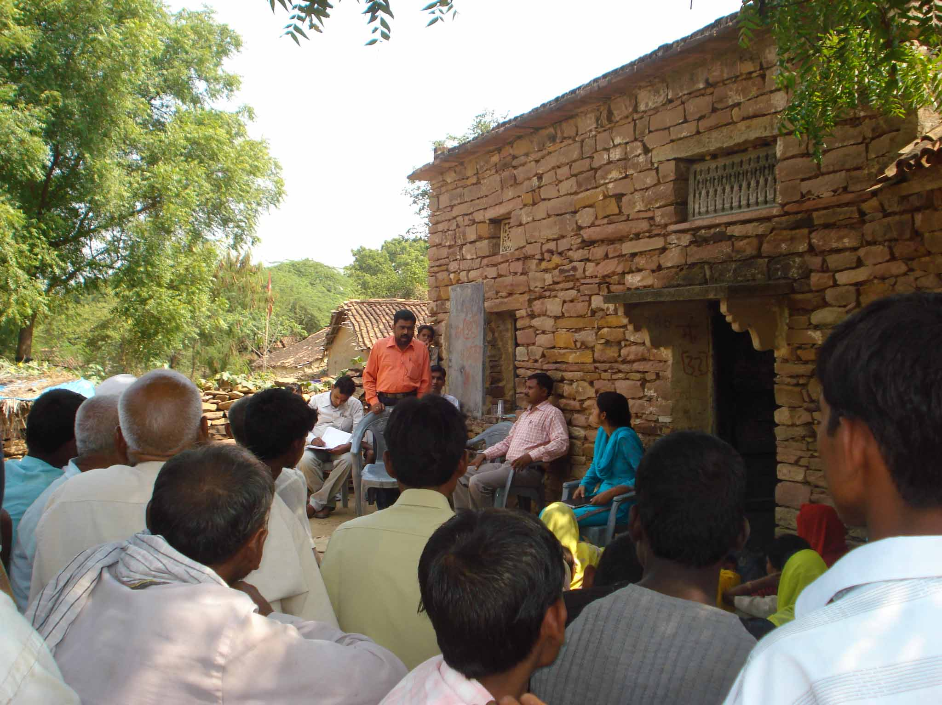 | 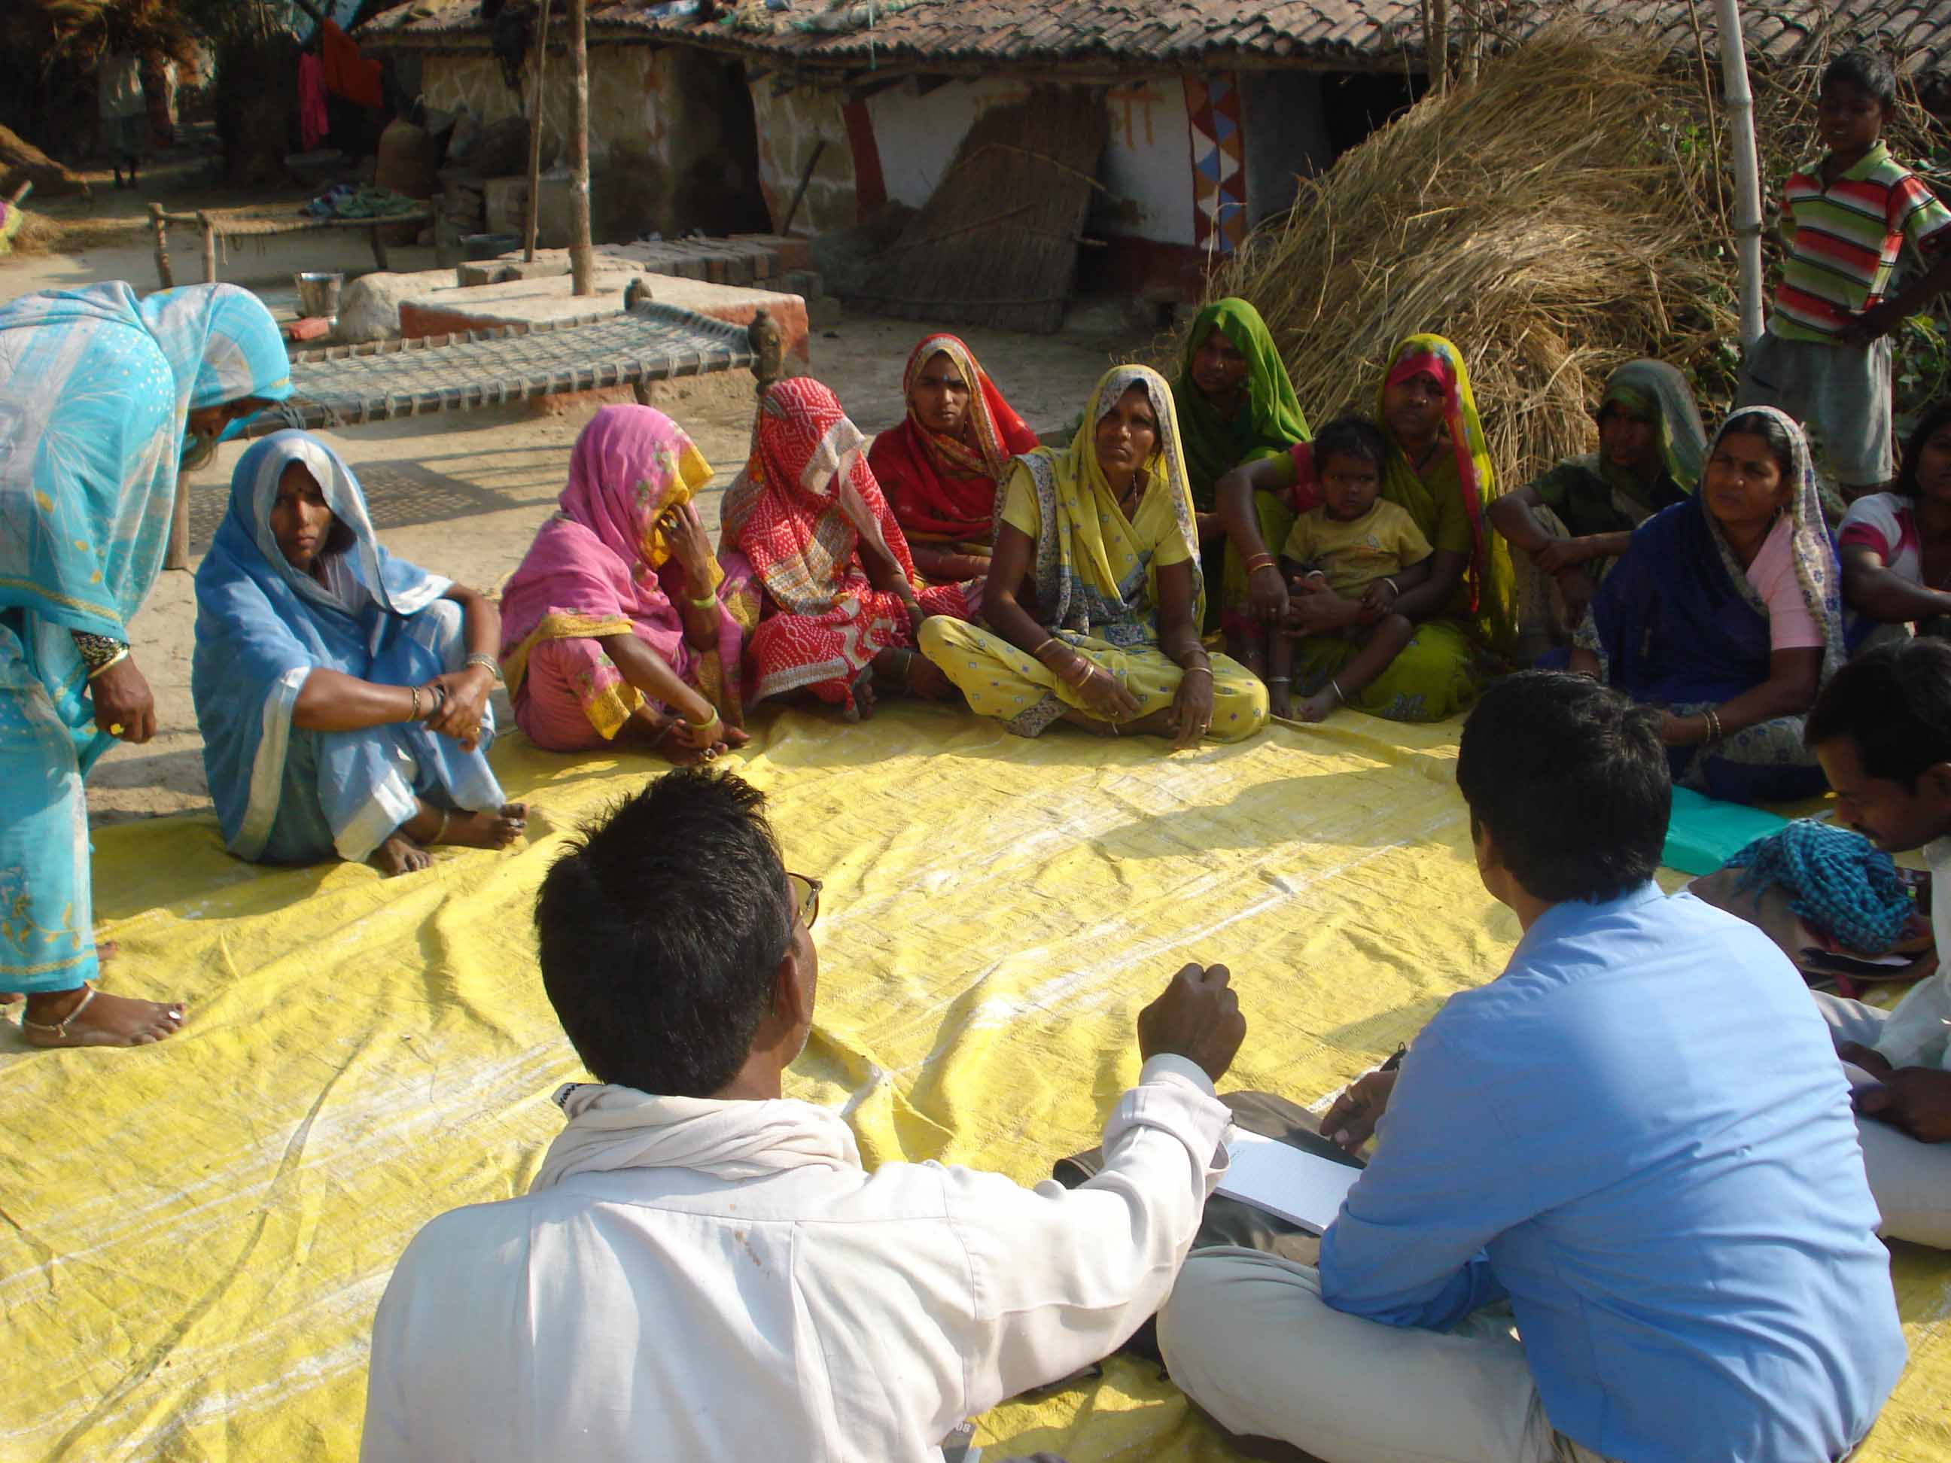
Legal Literacy in Varanasi | Legal Literacy in Chandauli | SHG formation meeting
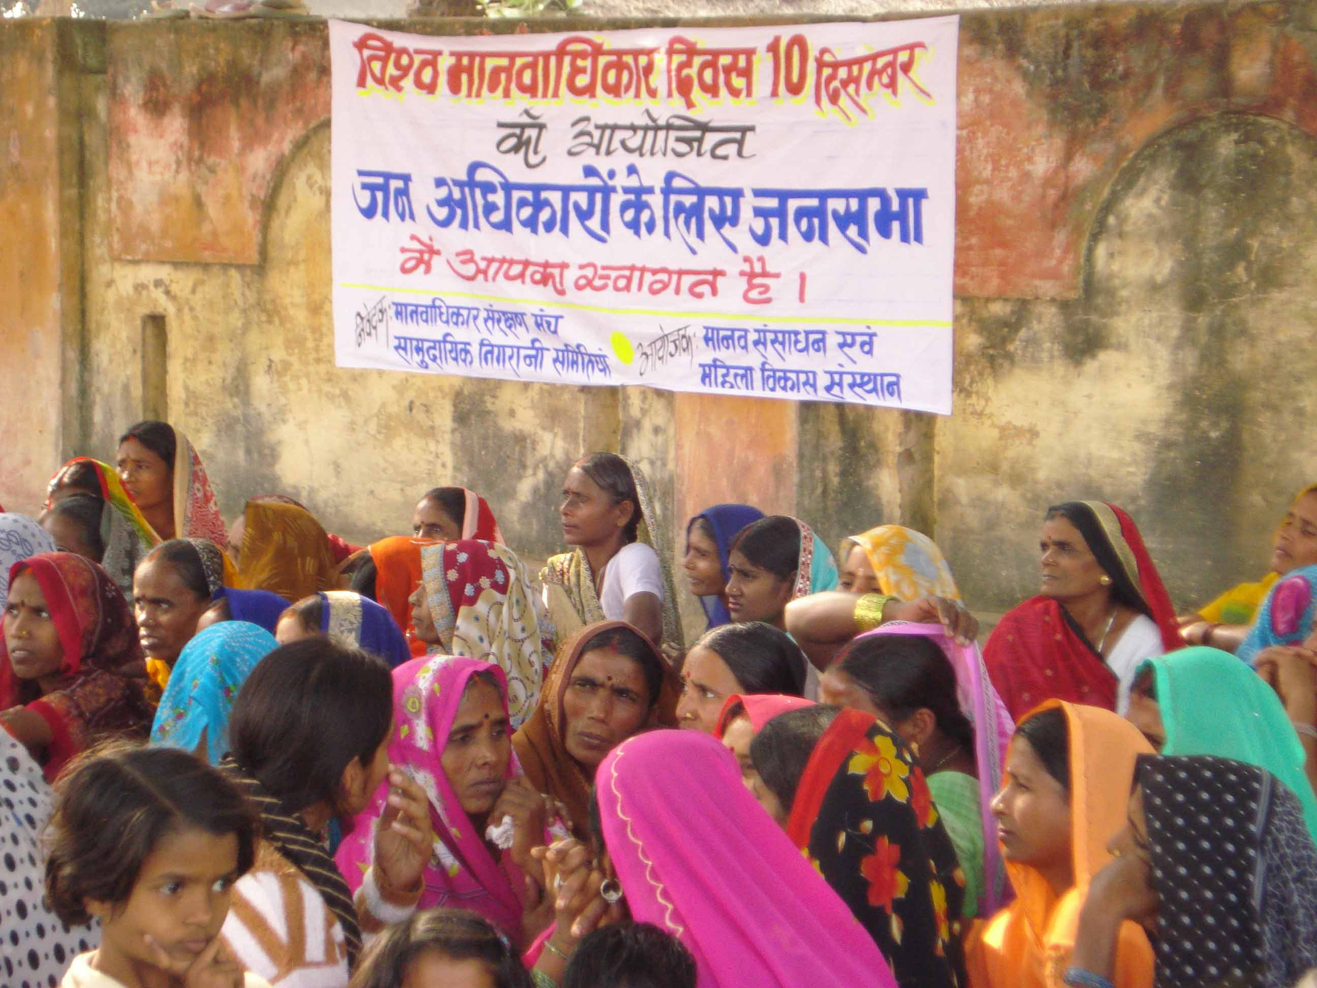 | 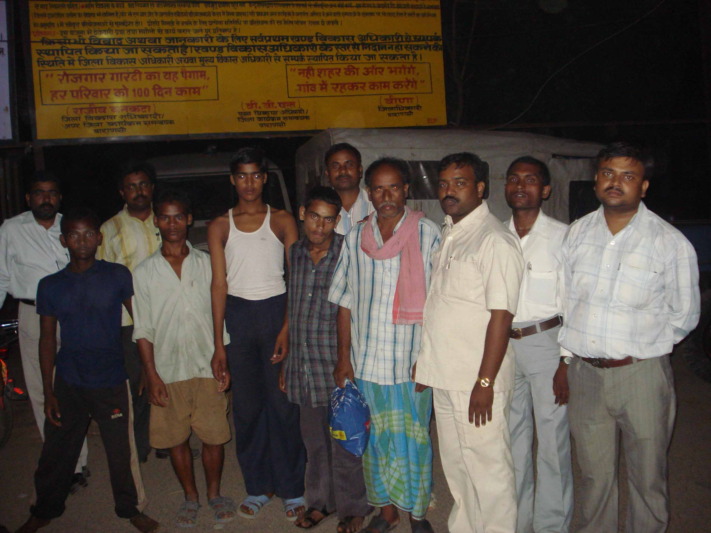 | 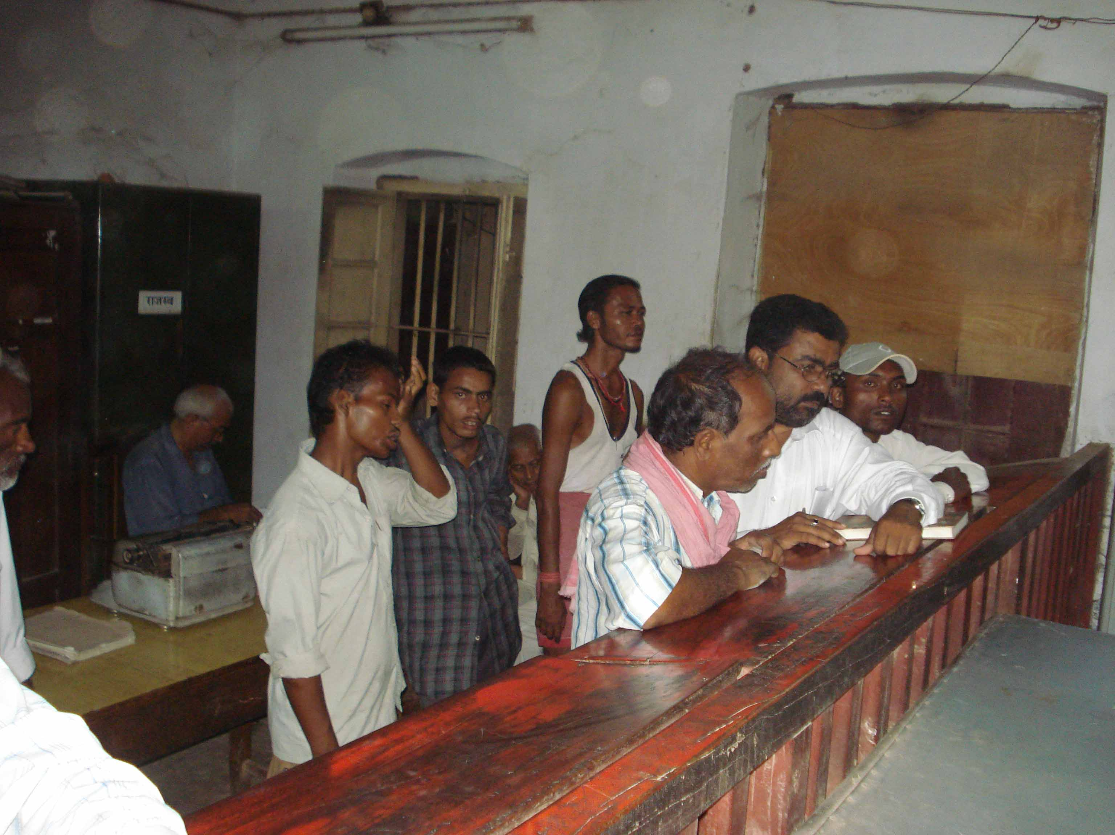
Demonstration al Block | Released bonded labour | Rescued bonded at SDM office

