Questions- Lakshmi Suryanarayanan
Headmistress, Olcott Memorial High School
Besant Nagar, Chennai-600090
Email- lsuryanarayanan@gmail.com

General Resource Room Report
Olcott Memorial High School, Chennai-90
September 2008

Recall- As stated in Area 4 of the General Resource Room proposal, we have plans to reach to the community through parents of the school. We had planned one at Urur Kuppam in August – September 2008.

Current status- The Urur kuppam interaction with the community was postponed because there was a more pressing need to meet the parents of the communities in Chemmencheri. Parents , especially the mothers of the 66 children coming from this far away new area, where the very poor have been relocated after the tsunami, are facing problems of acute unemployment. The community meeting was convened on 12th September 2008 in the primary school ground in that area, after 5pm to help parents who were out to work to attend the meeting.
The main purpose of the meeting was to discuss training needs and self employment opportunities for the women especially as most of them found it difficult to commute long distances. The social work department of Srella Maris college helped with the resource persons and has promised to start a couple of small business activities’ training- in candle making and revive the soap making activity by trying to locate markets for the products.

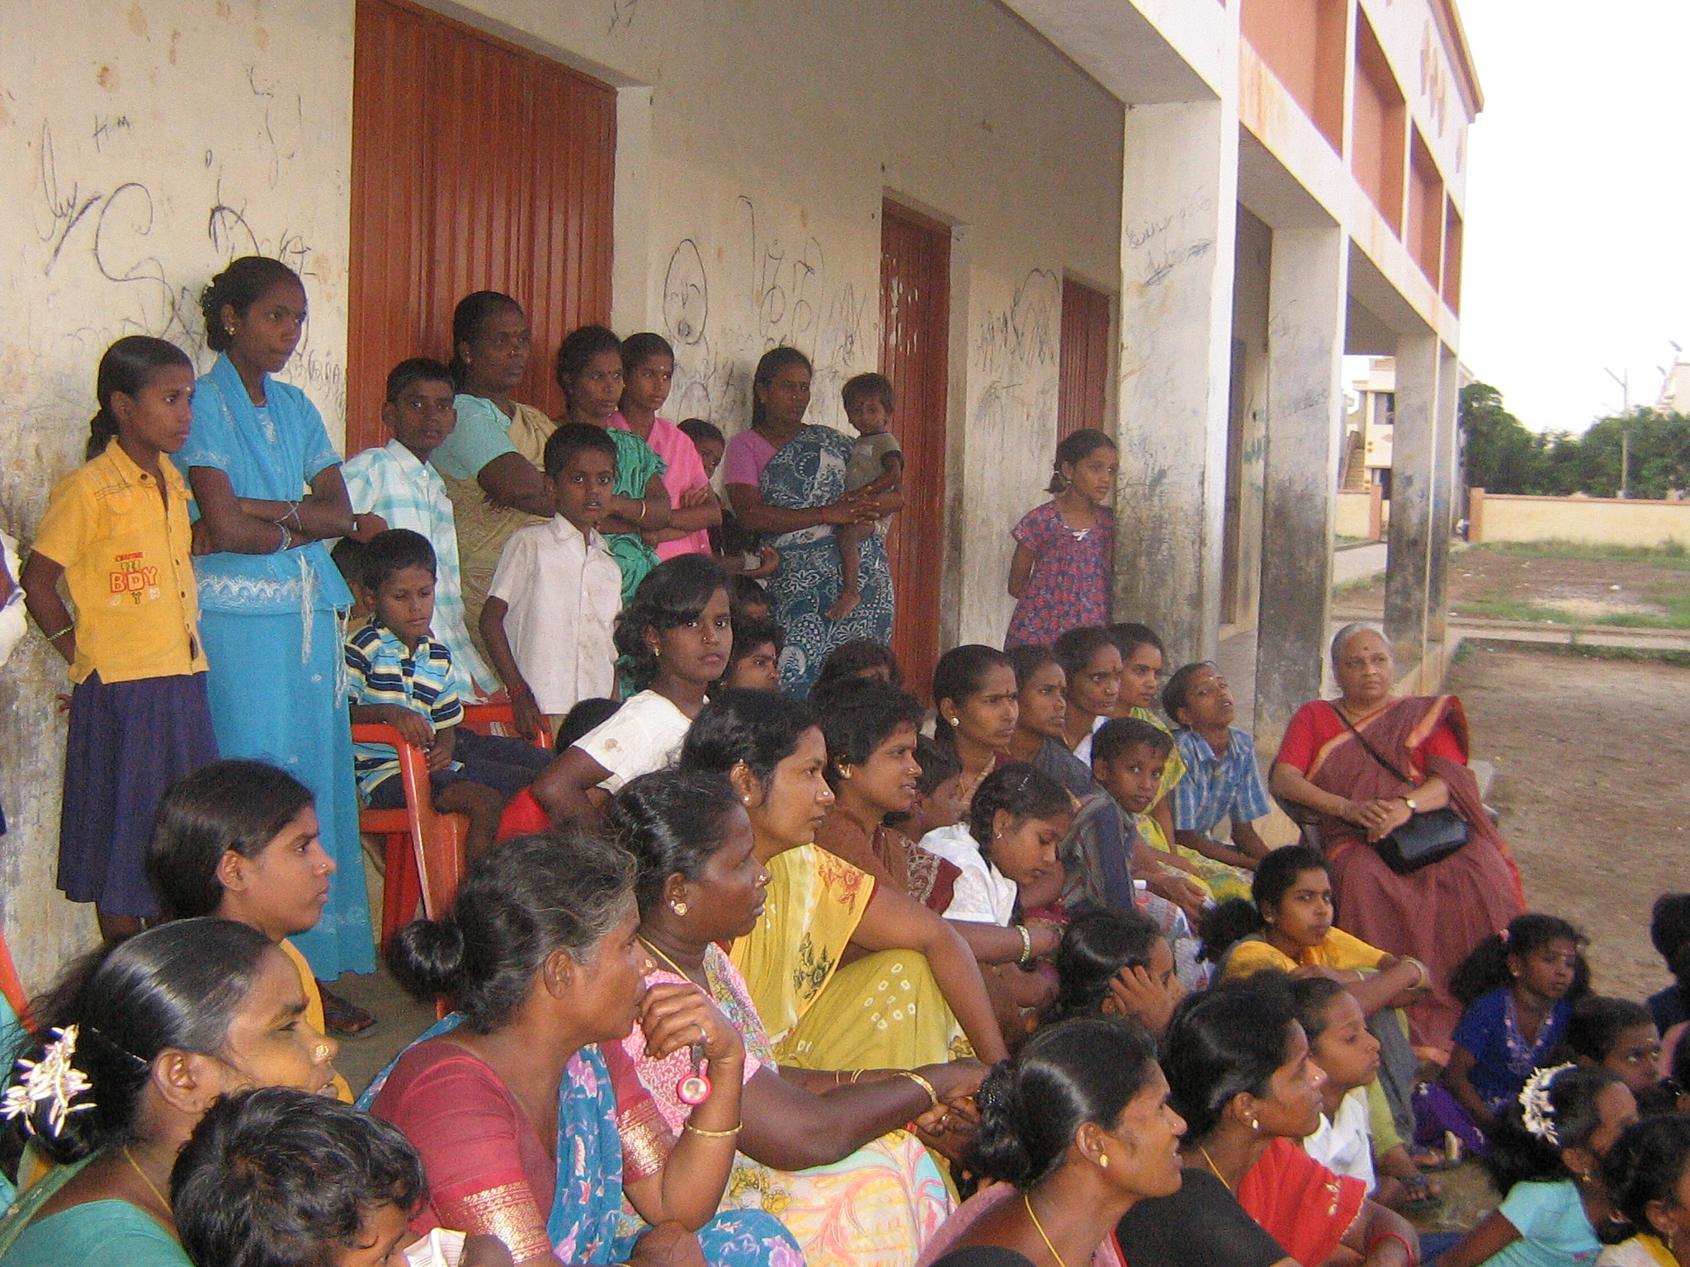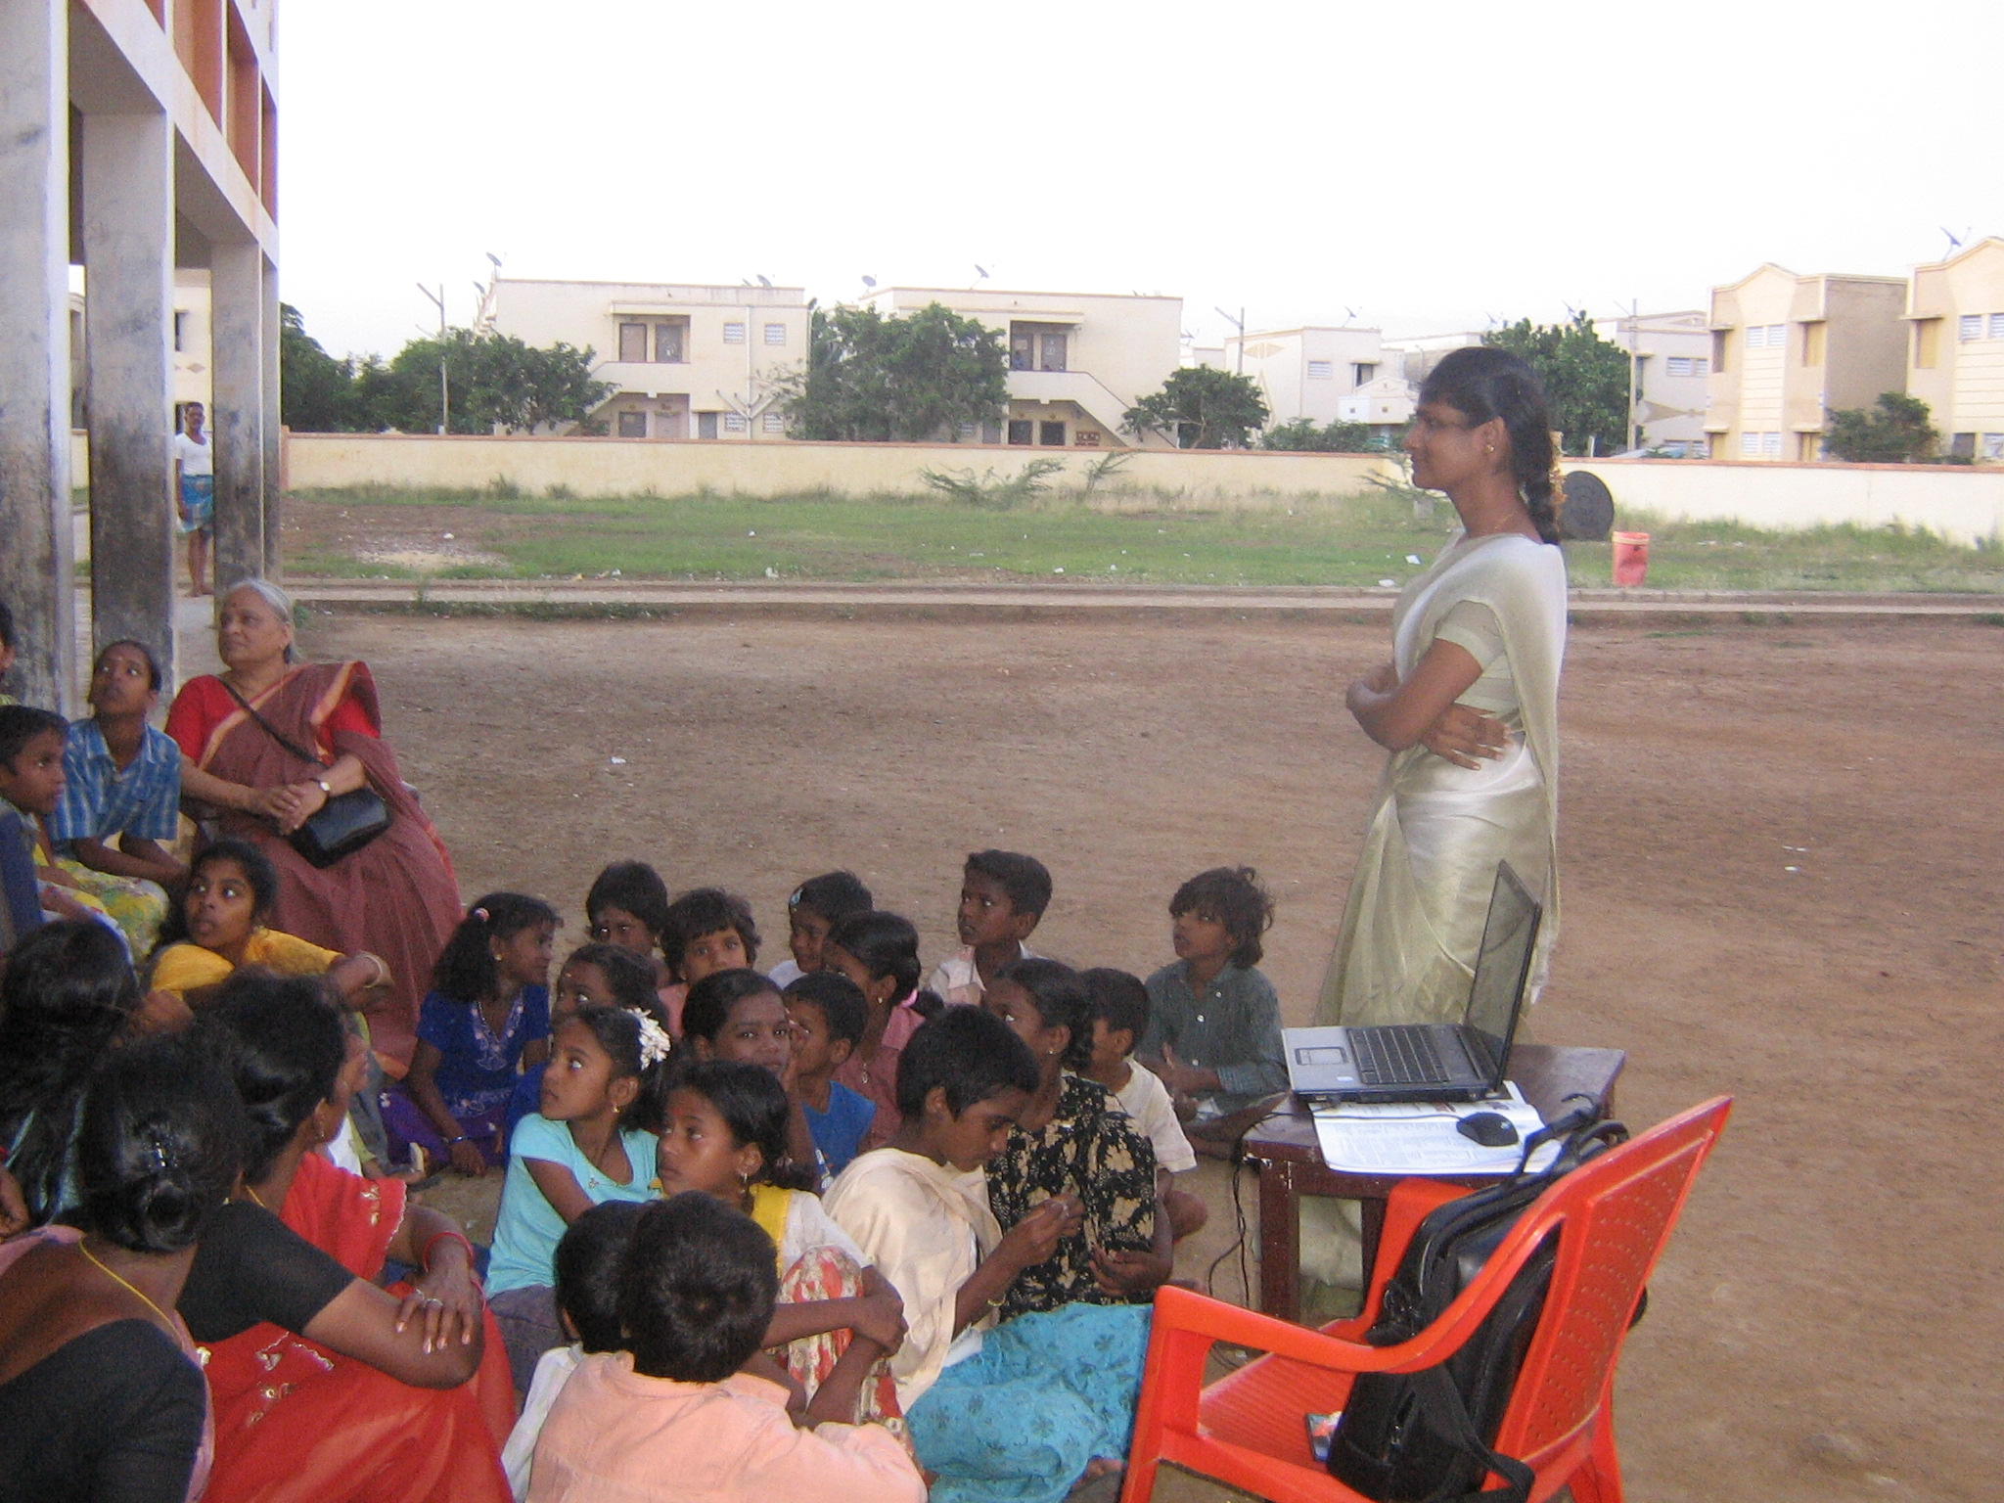
Community members mainly mothers and children are seen above, listening to the talk on parents being able to take care of basic health and hygiene even in the difficult circumstances. The resource person from Stella Maris college showed a film strip a short story made by the Rotary club for the specific purpose.

The parent community was very concerned about the load of books for their children and the infrequent bus services. The school headmistress promised to provide additional set of text books for all the children from this area that could be kept in school. Children can keep the text books they usually carry at home. They would just need to carry the notebooks alone. Parents were assured that school bags were also being arranged for the children. The parents were also told of the efforts made to improve the frequency of bus services. The public transport department has been given requests by the “Children’s Parliament” Group of the school requesting for better bus services. The parents also talked about the need for providing breakfast (kanji) earlier than the present time as most children left home very early (between 6.30 and 7 am) to reach school on time.

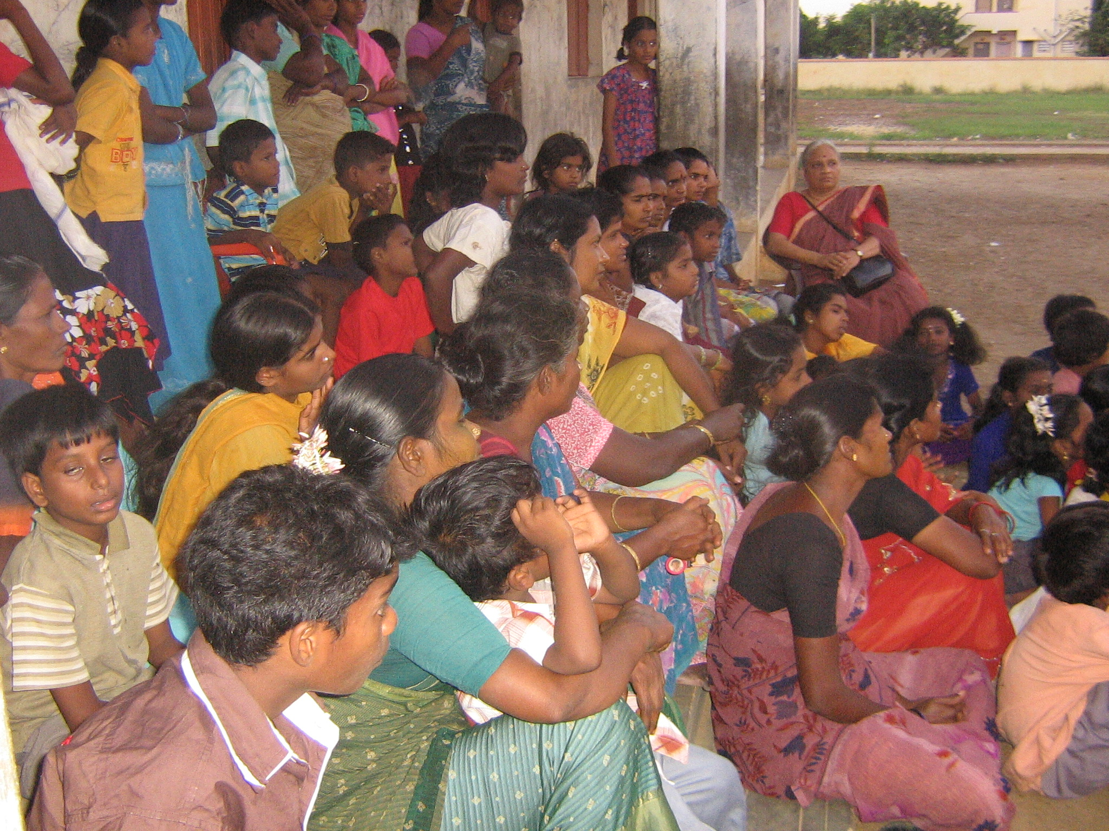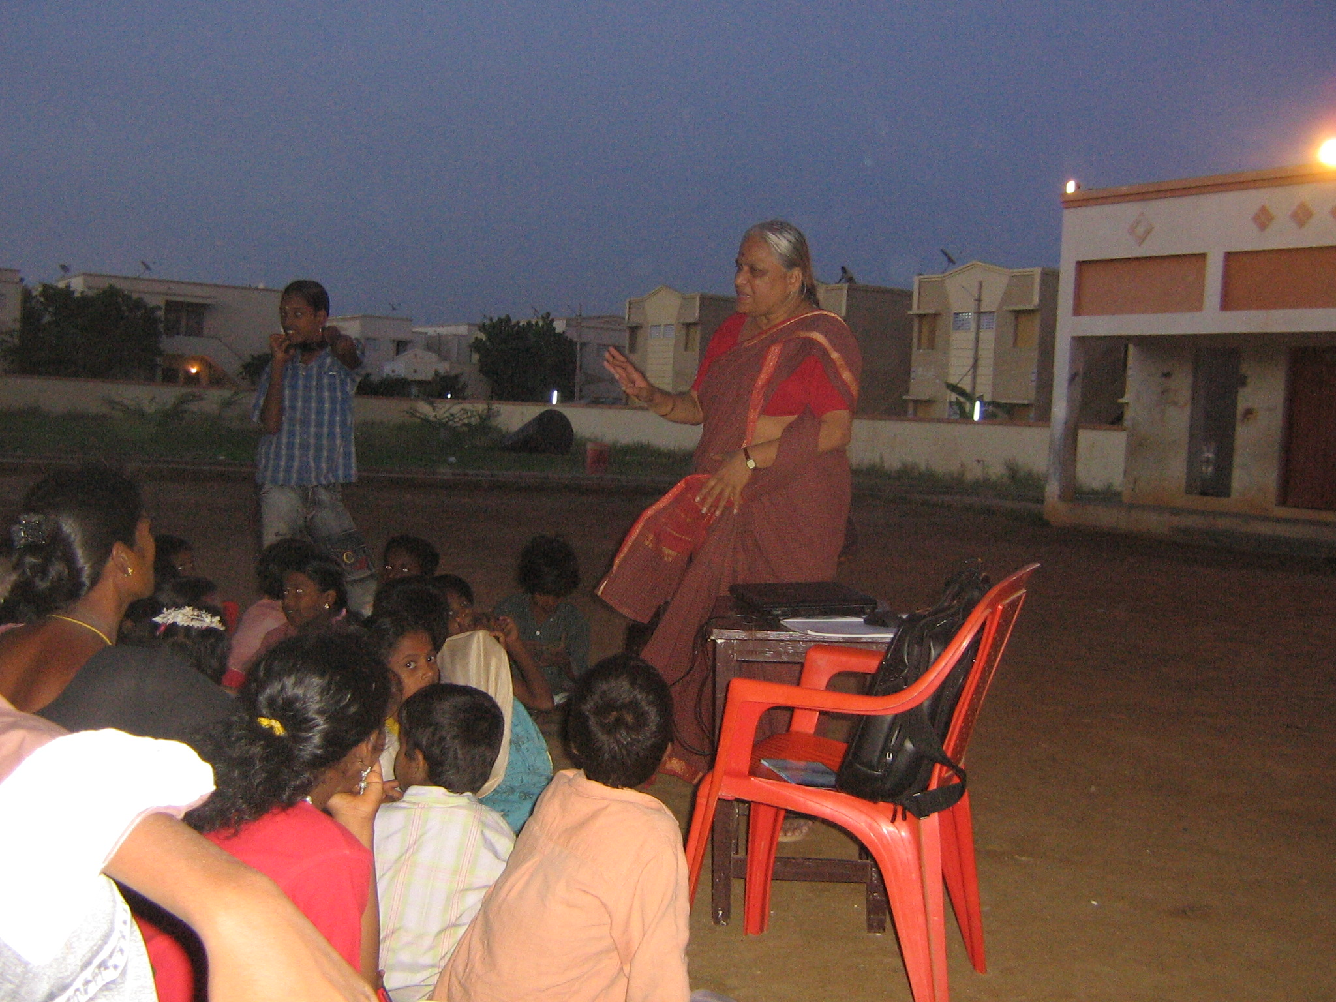
The headmistress is seen here addressing issues that children have in commuting such distances, less school bag load, need for providing school bags.

Follow Up Action- Order for text books for these children besides and some others coming from far off areas has been placed. Workshop dates for women’s entrepreneur empowerment are fixed and communicated to the parents. Bags will be given to them through the support of Pitt Macdonald Trust. The kanji aspect was also being worked out. More buses are running since Sept 16th, 2008 the 10th anniversary of Arignar Annadurai.

Expenses for the programme-
The cost of the event was Rs1800 nearly.
These included transportation costs for the resource persons and headmistress, cost of drinking water, snacks and tea for the participants, cost of renting the lighting arrangements in the venue (meeting got over well after dark)

Other important work:-
- The resource room is functioning from a room other than the one earmarked for the purpose. This is because the work of remodeling the room has come into some road blocks. The newly allotted room has been painted by the counselor, art teacher and students. Only the paint costs have been incurred. Toys and other counseling related material have been garnered. A set of drums have been donated to the room and the art master has also started helping some students.
.
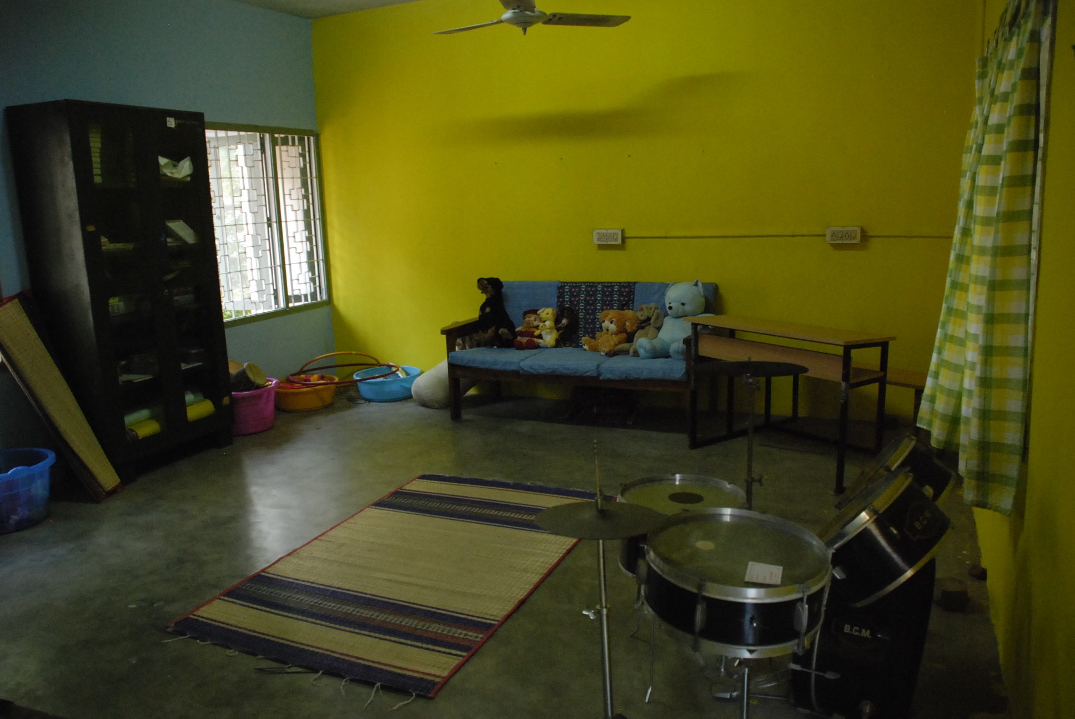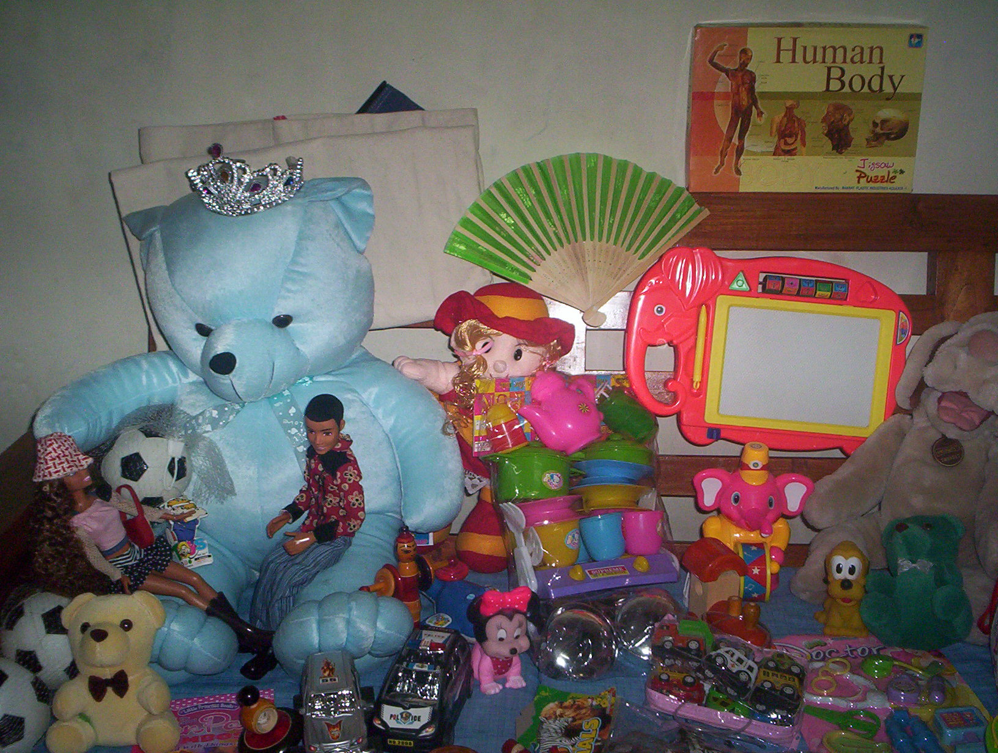
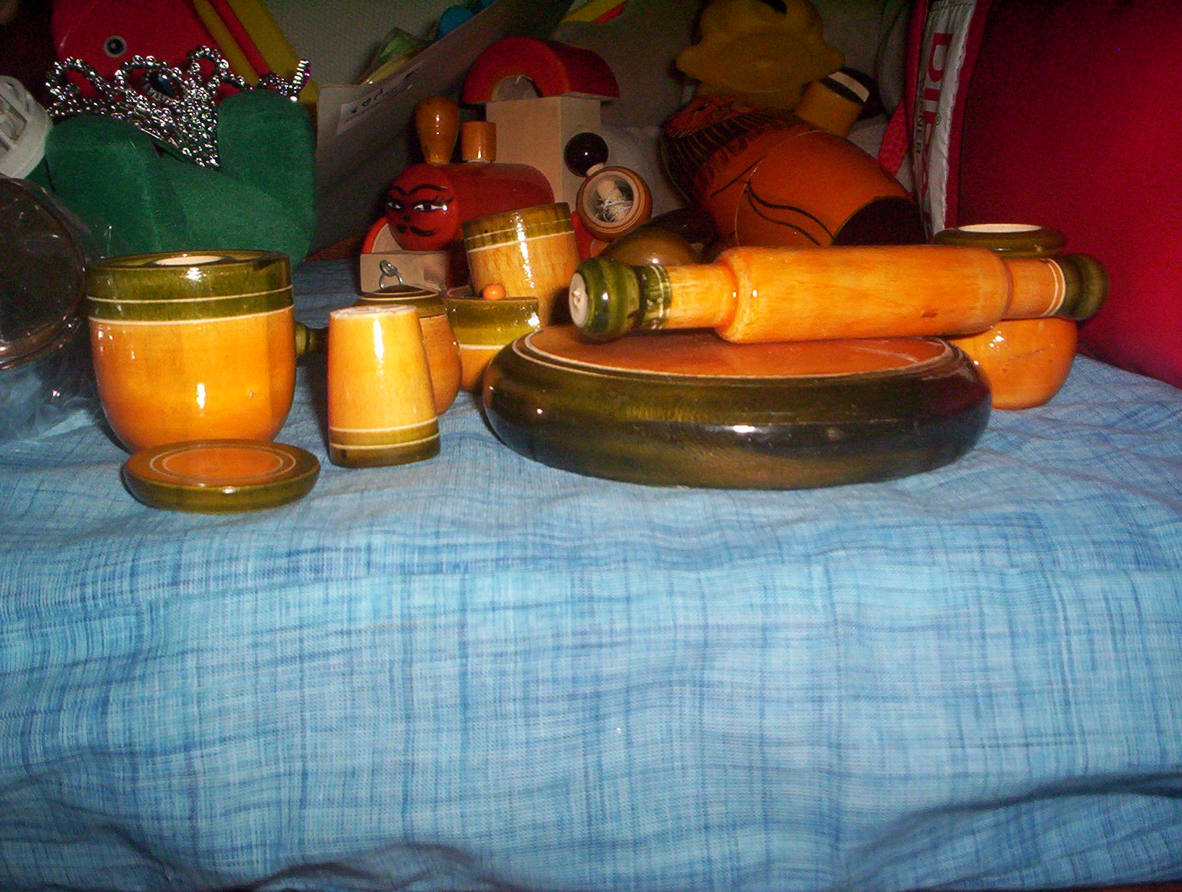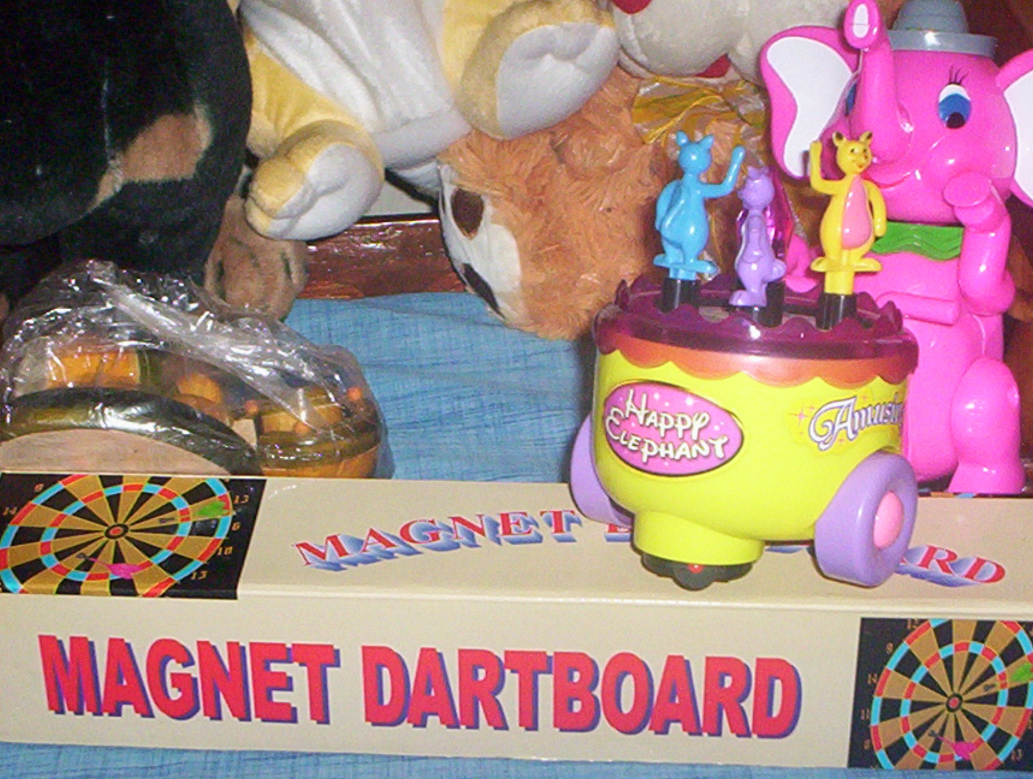

- After consultation and inputs from the Madras Dyslexia Association (MDA), work with a special educator 8 students of class 5 who need special attention.
- More studies are being done with respect to concessions for std10 children by MDA.
- A special teacher has been appointed to help with class1 and 2 English to help with this area where children experience difficulties.
- A child with hearing disability in Class 1 is receiving special inputs from a speech therapist and he is showing improvement. Support has been extended to him for improving his hearing aid.

Area-1 | Existing | Requirements | What needs to be done | Estimated Costs of different items | Grant Utilization so far
Improvements to the counseling room | A room 20’ by 14’, with electricity connection.  The room is dark and unattractive.  There are cement blocks with holes instead of windows.  One tube light and two fans | The room needs better ventilation and rodent and protection from insects. | Replace the holed cement blocks with windows and provide meshing against rodents and insects. | Windows and meshing INR50000  (USD1300) | Plans drawn up- May not be able to do the needful within the estimated cost. So for the present another room has been allotted
Improvements to the counseling room |  | Make the room attractive | Painting the walls with good quality light coloured paint | INR6000  (USD150) | Painting the walls and adding mats and some curtains at the cost of Rs2500
Improvements to the counseling room |  | Improved lighting | Add three more tube light fittings | INR1000  (USD30) | Not required for the present room. Will be taken up when the other bigger resource room work is taken up.
Improvements to the counseling room | A good writing board, flip chart board. | Scribble areas | On one side of the wall – 2.5’ from the ground and 3’ wide and 20’ long- good writing metal board which can be used as a magnetic display board as well. | INR20000  (USD520) | Flip and chart boards have been bought at the cost of Rs4000 approx.
Improvements to the counseling room |  | Anger outlet and management corner | Soft corner for punching- punching bags - | INR10000  (USD250) | Materials have been bought for Rs10000. Some more soft toys have been ordered from an innovative soft toys maker. Rs 20,000. Will use the money in the previous head for this purpose.
Improvements to the counseling room | Allocation for materials and computers | 3 computers and acessories | Funds available from technology grant recently received by the school | Nil | The students have started using the resources in the new computer room. The room has 10 new computers and 5 more are being added soon.

Area-2 | Existing | Requirements | What needs to be done | Estimated Costs of different items | Grant Utilization so far
Diagnostics for disabilities certification and IEP programmes | Knowledge of places where these can be done at subsidized rates and experience with small numbers | Payments for the centers of assessments. Conveyance costs for students and accompanying adults for various sittings | Provision for 40 children (7% of the student population)  Assessment costs  Rs400 per child | 40*INR500=  INR20,000  (USD 525) | More than 15 students have been taken to MDA for assessment. MDA has not charged for diagnostics. They have helped find remedial teachers for the differently abled students for two days a week on a conveyance paid basis. Rs200 per session for 4 children in 2 batches (8 in all), twice a week One support teacher for classes 1and 2 for English has also been found. We are looking for at least a couple of more support persons. Money spent so far Rs 4000
 |  |  | Provision for Conveyance costs Rs100 per child | 40*INR500=  INR20,000  (USD 525) | Money spent so far is Rs240
Area-3 | Existing | Requirements | What needs to be done | Estimated Costs of different items | Grant Utilization so far
Skills training and apprenticeship location for slow learners | Craft section | Costs for exploration and also trials for the children for the first year- 15 students (2.5% of the student population | Conveyance costs for exploration | 15* INR300=  INR 4500  (USD120) | We are still scouting around for such persons. Money spent so far is very small
 | Craft section |  | Conveyance costs for apprentice students | 15*INR1000=  INR15000  (USD400)
Area-4 | Existing | Requirements | What needs to be done | Estimated Costs of different items | Grant Utilization so far
Outreach into community through parents | None | Once a month for 10 months in a year | One meeting a month in an area by rotation | 10*INR1000=  INR10000  (USD 260) | Rs1800 at Chemmencheri

Plans for October – November 2008
- Community programme at Urur Kuppam
- Work with more learning disabled children.
- Find special teachers to help with Std10 weak students with guidance from MDA.
- Train parents in Chemmencheri on small business areas.
- Work with parents who are unemployed to find employment.

