Nilesh L. Murdeshwar Karnbadhir Vidhyalaya
Site visit report

Conducted by
Dr. Rupesh Pophale, Mr. Vinod Nawarange, Mrs. Geeta Nawarange
13th March 2008

Background:

Nilesh L. Murdeshwar Karnbadhir Vidhyalaya is situated in taluka Jawhar, district Thane, Maharashtra. It is run by Pragati Pratisthan which is an organization involved in various educational and non- educational activities in this backward, tribal area.

Report:

On 13th March 2008, we reached the Nilesh L.Murdeshwar Karnbadhir Vidhyalaya at Jawhar. This school provides education to the deaf and mute children from Junior K.G. to 4th standard. Along with educational activities school is involved with non-educational activities such as Cashew Processing Centre, Biogas Plant, and Shade Net House. Those activities are helpful for rehabilitation and overall development of handicapped children.

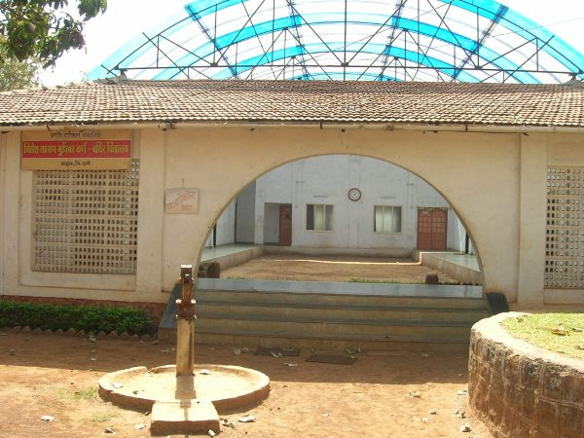
Facilities at school

(I) Library:
School library has various educational and non-educational books. But they are less in number. As those handicapped children learn quickly by pictorial presentation, books of such pictorial presentations will be very beneficial for children.

(II) Speech Therapy Room:
This is a sound proof room where audiovisual aid is placed. With the help of this instrument children hear sound as per their decibel loss and they will be introduced to various words with their meaning. In this way children are taught talking.

(III) Hall/auditorium:
In this hall school carries out various cultural activities. Along with that it used for activities of awareness for local tribal people.

(IV) Class Rooms:

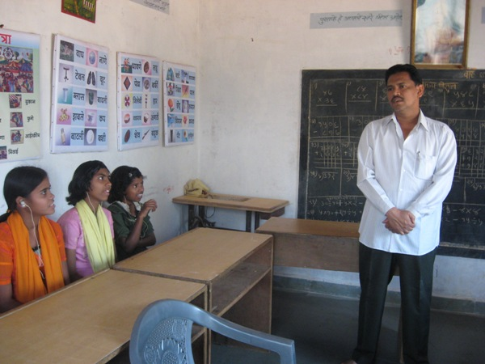

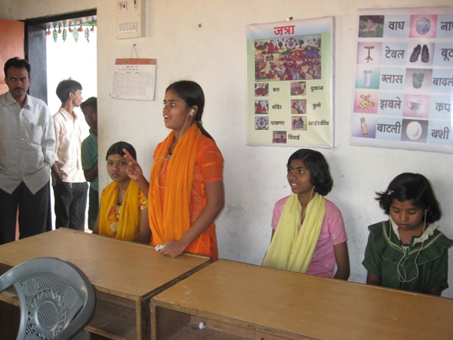

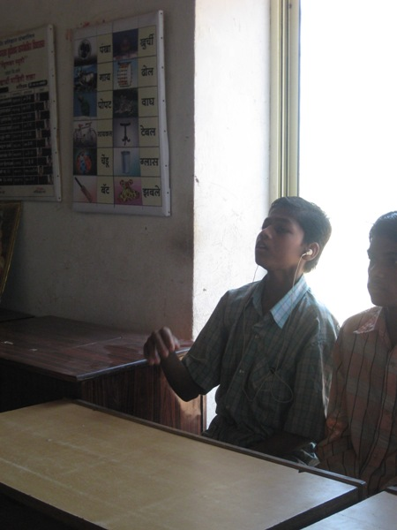

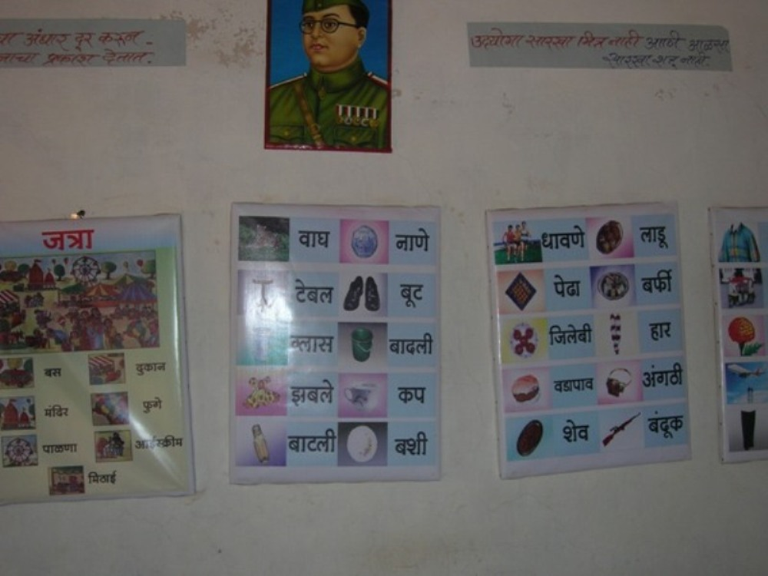

All class rooms have group hearing aid. This aid delivers equal intensity of sound to all students. This is better than individual hearing aid. Every class has different educational pictures or posters which are prepared as per need of students.

(V) Mess facility:
As this is a residential school, school provides breakfast, lunch and dinner to all children.
Food is prepared on advice of expert so that children will meet their requirements. It is prepared in hygienic conditions and with locally available food items. But school is lacking in funds to provide those facilities.

(VI) Creations of children:

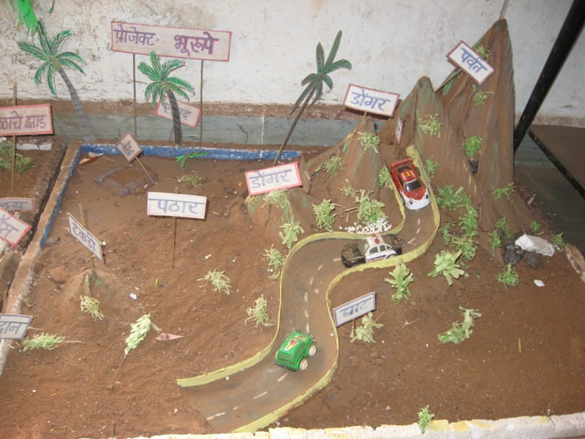

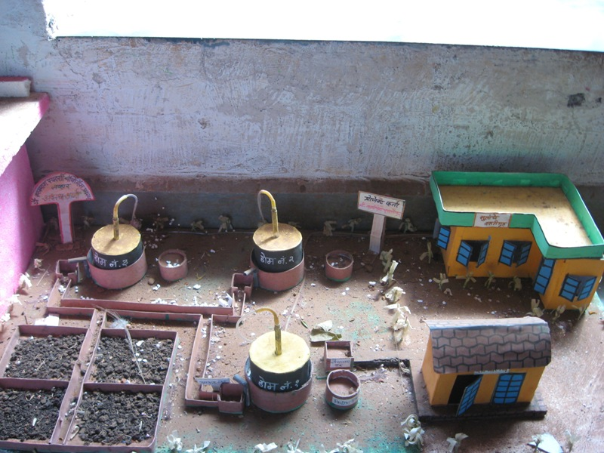

(VII) Hostel Facility:
Hostel is available for both boys and girls. But renovation is required for betterment of children.

(VIII) Cashew Processing Centre:
Cashew processing is by organization staff with help of students. Those are sold in local market and returns are used for school.

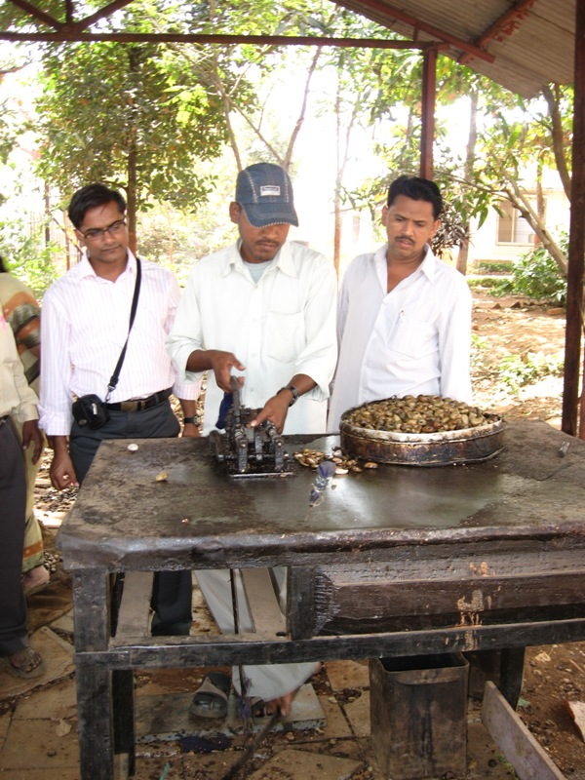

(IX) Biogas Plant:

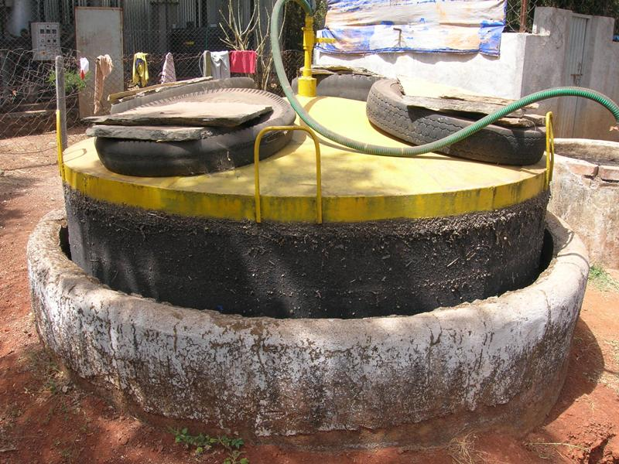
Biogas plant uses Jatropa oil cake for gas production which is used for day to day activities at the school.

(X) Shade Net House:

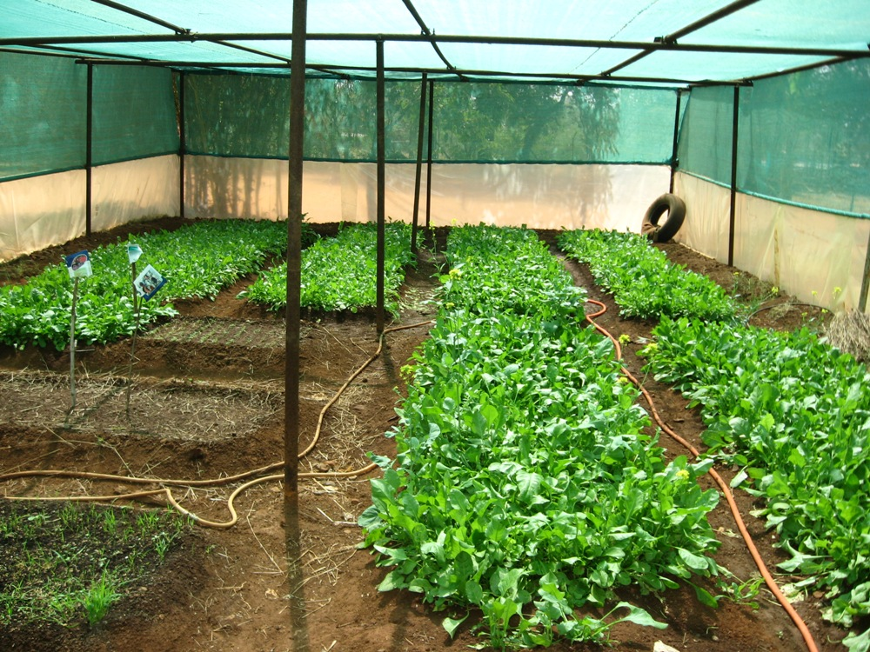

Shade Net House is used for production of vegetables which are used for school children. As all children are living in the area where agriculture is chief source of income, this activity is helpful for children in their career development.

(XI) Staff:
This school is run by organization, Pragati Pratisthan. Mrs. Sunanda Patwardhan is treasurer of the organization. She is associated with the organization since its establishment. She is extensively involved in various developmental activities going on in the area. Under her guidance staff works very sincerely and effectively.

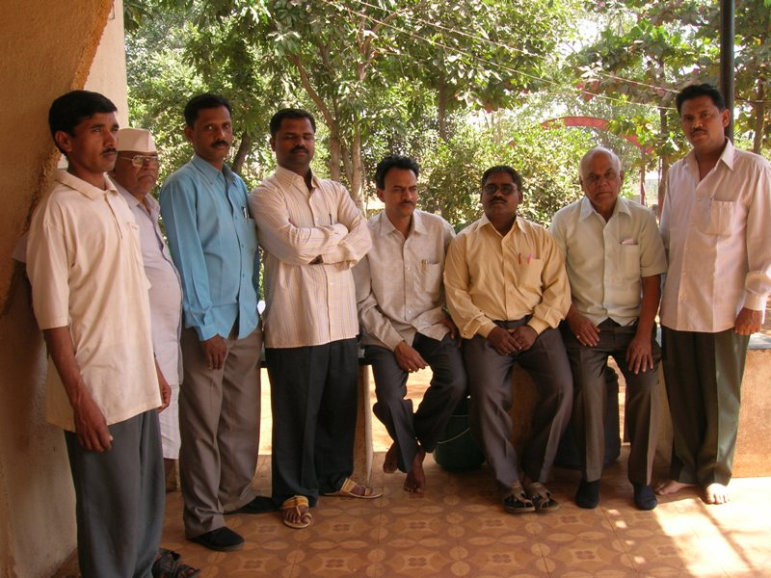

At the end we were touched with the efforts taken by the staff to educate and develop those handicapped children.
But certainly they are lacking in infrastructure and funds. We are giving the requirements for up gradation of school facilities.

Items | Amount | one time/ annual
Audiometer | Rs. 40,000 | one time
two sets of computer with printer | Rs. 50,000 (each)= Rs. 60,000 | one time
LCD projector | Rs. 60,000 | one time
Group hearing aids(quantities: 3) | Rs. 50,000 (each) = Rs1,50,000 | one time
Charger cell kits(8-10) | Rs. 1000(each) = Rs. 10,000 | one time
Library- educational pictorial books | Rs. 6000 | one time
Grant for extra children enrolled-15 | RS.850(each) = Rs1,53,000 | annual
Extra grant for 50 children | RS. 350(each) = Rs2,10,000 | annual
Total | Rs 6,89,000

