Water, health & education for women & children in Thar

- Grant Details

1.1. | Grant Period | October 2012 to September 2013
1.2. | Name of Project | Water, health & education of women & children in Thar
1.3. | List of communities where  project is being carried out | Six villages of Jodhpur district. The list of villages is annexed
1.4. | Target Group | Women, children & village community.

- Preface

Rajasthan is one of the poorest states in India, chronically impacted by droughts and has one of the lowest literacy rates and a poor child sex ratio. The Thar Desert region of the state is particularly under-developed. The root causes are multiple-levels of deprivations generated by forms of inequalities based on gender, culture, caste, history, geography, economy etc. Gender disparity coupled by rampant droughts is main reason for giving limited attention to girl child education in this region. The status of girls and women are determined by structural power relationships dominated by gender and cultural patriarchy. The communities in Thar region are particularly vulnerable because of its historical, geographical, social and economic conditions, which put people, particularly women and girls, in marginalised positions.

Many families in Rajasthan dependent on agriculture for their livelihood suffer from the consequences of recurrent droughts. Drought directly impacts women and girls. Girls are often removed from school to help contribute to the household income or take over domestic responsibilities. Many times, these girls do not return to school to complete their education as they have to travel further to fetch water or firewood during drought periods. Women too are very busy for collecting fuel wood, water and fodder for animals throughout the day.

GRAVIS – ASHA initiated Water, health & education for women & children in Thar project in designed with an integrated approach to problems of women and children (especially girls). The project is catering the wide needs of female population ranging from water security, to health and education. The project is committed to improving the lives of marginalised community by facilitating empowerment of women through drudgery reduction and enhanced livelihood. With an equitable approach to development, GRAVIS programmes aim to address the multiple, overlapping and intersectional social determinants of poverty.

- Project Duration

This project was for twelve months starting from October 2012 to September 2013.

- Project Location and Coverage

The proposed project was implemented in 6 villages of Osian block of Jodhpur.

- Objectives of the Project

The programs of GRAVIS are mainly committed towards wellbeing of rural community, particularly marginalized & women. The philosophy, in which GRAVIS believes, focuses on holistic development of villages as they are the socio-economic development unit of country. Keeping this vision of organization in view, the objectives of the project are:
- To enhance water security through rain water harvesting.
- Improve the status of health of the vulnerable sections of the society, especially covering the groups of women and children
- Improve education of children, special focus of girl child education.

- Activities accomplished under project:

  - Construction of Taankas:
Western Rajasthan is the dry area and here, people are mostly depending on Rainwater. Availability of water for the family and livestock is only available through the stored rainwater. For storage of water a taanka is an individual or collectively owned structure which collects and stores rainwater for drinking and household purposes. 12 Taanka have been constructed in reporting period, they collect rainwater and serve a family for 5 to 6 months in a year, and later on structure is good storage tank for water from pond and tube wells. Taanka is and vital structure for the community people, especially for women who is responsible for collecting water from different sources. Major impacts seen after the constructed Taanka are as follows:-
- Availability of water nearby household
- Livestocks have been benefitted due to water availability in the household
- Availability of safe drinking water nearby home
- Regularly maintenance of health and hygiene
- Saving of time and money of the family
- Reduction in diseases due to availability of safe drinking water nearby home
- Increase vegetation near house
- Children of family having taanka going to school, and
- Increase in social status of the family, a symbol of pride for family having taanka.

The list of taanka beneficiaries is attached as annexure in Table 2.

  - Community health

Medical Camps
Community particularly women in the Thar are not aware about the health needs. Lack of knowledge and unhygienic condition make them vulnerable and due to which they suffer with various health threats. In dry region, unavailability of green vegetables and nutritional fruits accelerate these problems. Inadequate food and poverty put primary healthcare a second precedence for people living in Thar. For women it never gets space in priority list. For multiple health problems, medical camps are immediate relief to community. Camps deal with various seasonal illnesses for which people usually either avoid to take medication or feel difficult to go to nearest hospital because of vast distances. To overcome with these, 6 medical camps were organized target villages. The GRAVIS hospital sends a medical team, consisting of one physician and one village health worker to remote areas in order to educate the locals on basic health issues, and to spread awareness on seasonal diseases, waterborne diseases, general diseases and other fatal diseases. The medical camps also serve as a makeshift temporary clinic, treating participants for illnesses and vaccinating them against preventable diseases. Common illnesses treated at medical camps include asthma, fever, cough and colds, gastroenteritis and eye diseases. The list of Medical camps is attached as annexure in Table 3.

  - Primary Education

As per the Indian Government Census 2011, female literacy in Rajasthan (52%) lags behind the national average of about 65%, with rural regions lagging even further. Disaggregated district level data reveals that this pattern is further accentuated in the Thar region –overall literacy rate in the Desert is very low and only around 10% of females are literate. While girls play an integral role in the household economy and constrained by the need to traverse large distance to reach schools, their participation in schooling is limited.

GRAVIS established two primary schools at two project villages. GRAVIS initiated two primary level schools are running in Minno Ki Dhani and Dabri villages well. These schools are established in remote hamlets of villages. These schools are easily accessible to children and parents also think in safe of small kids to study near about home. The boys - girls ratio in Minno ki Dhani school is 60:40 while in Dabri school ratio is 40:30. Two teachers are giving services in Minno ki Dhani (one is GRAVIS contribution) and one teacher is appointed at Dabri School. These schools are enhancing female literacy by promoting girls education in respective fields.
- Annexures
Table 1 – List of project villages
S. N. | Village | Implemented from
1 | Minno Ki Dhani/ Jharia | GRAVIS sub-center Gagadi
2 | Dabri | "
3 | Khabra Khurda | "
4 | Cherai | "
5 | Karnaniyon ki Dhani | "
6 | Ekalkhori | "

Table 2 – Details of Taanka Beneficiaries

S. N. | Beneficiary Name | Husband / Father Name | Village | Distance of water source
1 | Pushpa | Sumeraram | Khabra Khurda | 2 km
2 | Mandu | Lunaram | Dabri | 2 km
3 | Jasu Devi | Roopa Ram | Ekalkhori | 2 km
4 | Patasi | Kozaram | Dabri | 3 km
5 | Devi | Baburam | Karkaniyon ki Dhani | 3 km
6 | Chuki | Ghewar Ram | Khabra Khurda | 3 km
7 | Jamali | Subhan Kha | Cherai | 3 km
8 | Santosh | Kishanlal | Minno ki Dhani | 3 km
9 | Dariyav | Parasmal | Ekalkhori | 3 km
10 | Ganga Devi | Tejaram | Minno ki Dhani | 3 km
11 | Lila | Shyam Prakash | Cherai | 3 km
12 | Durga | Ramu Ram | Khabra Khurda | 3 km

Table 3 – Details of Medical camps
S. N. | Village | Dates | OPD
1 | Dabri | 24/6/2013 | 39
2 | Minno ki Dhani | 7/8/2013 | 41
3 | Khabra Khurda | 10/8/2013 | 43
4 | Cherai | 6/8/2013 | 38
5 | Karnaniyon ki Dhani | 12/8/2013 | 37
6 | Ekalkhori | 11/8/2013 | 42

Picture of project

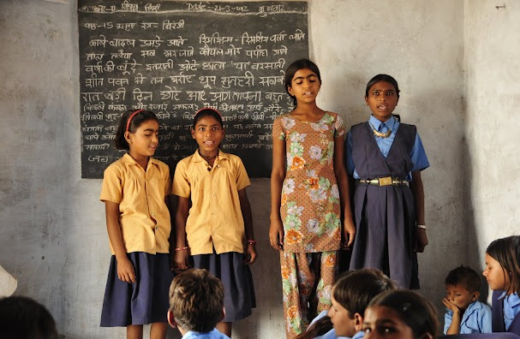

Improved girl child education

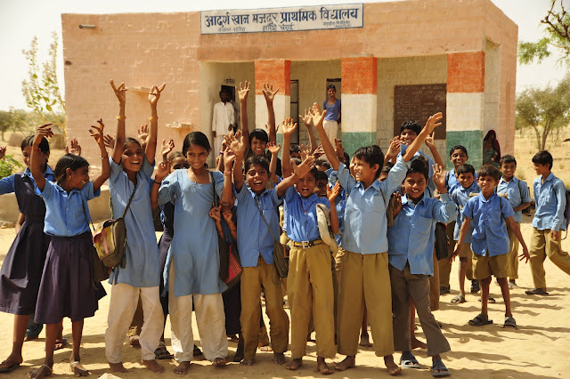

Open environment to children – Minno ki Dhani School (both)

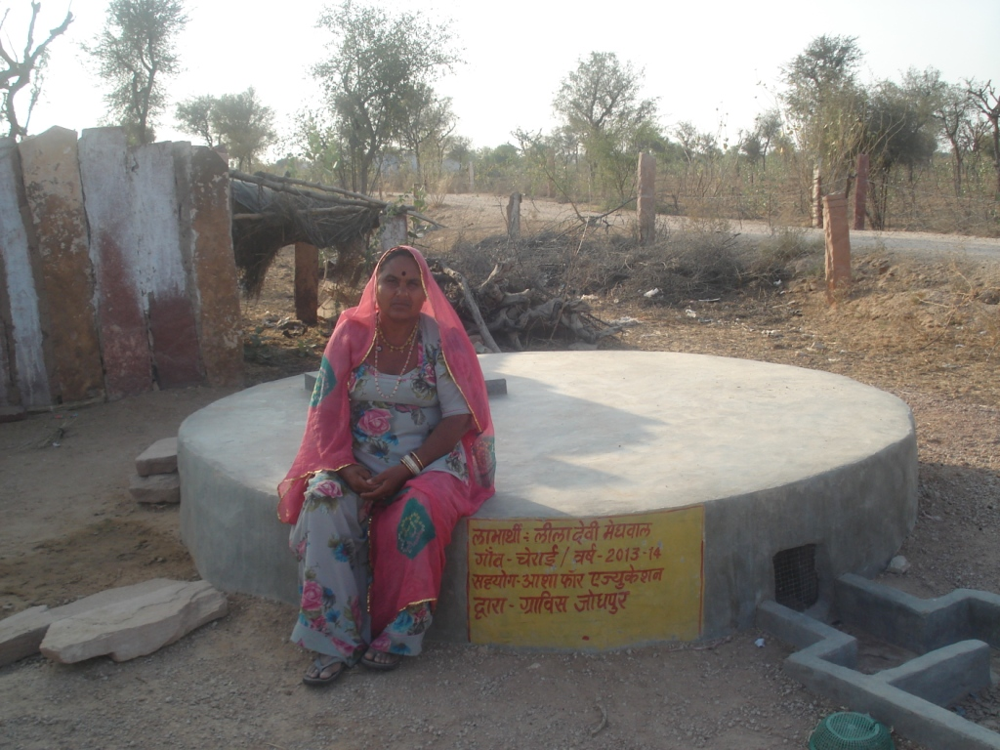

Lila Devi – Taanka beneficiary
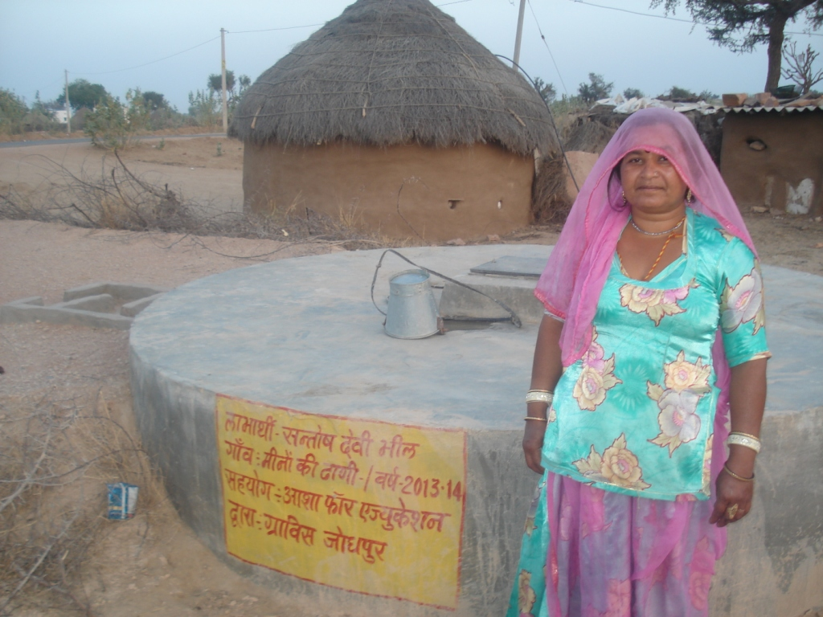

Santosh – Taanka beneficiary

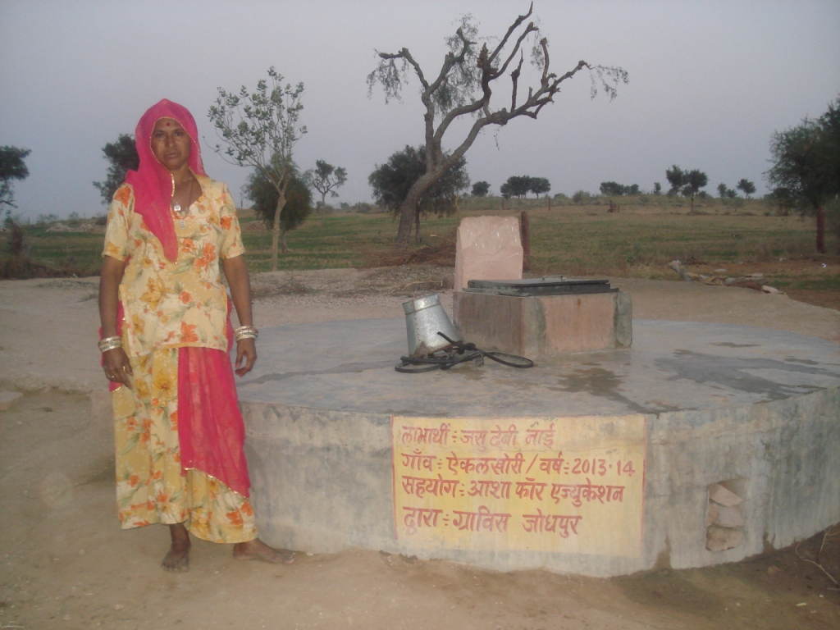
Jassu Devi – Taanka beneficiary

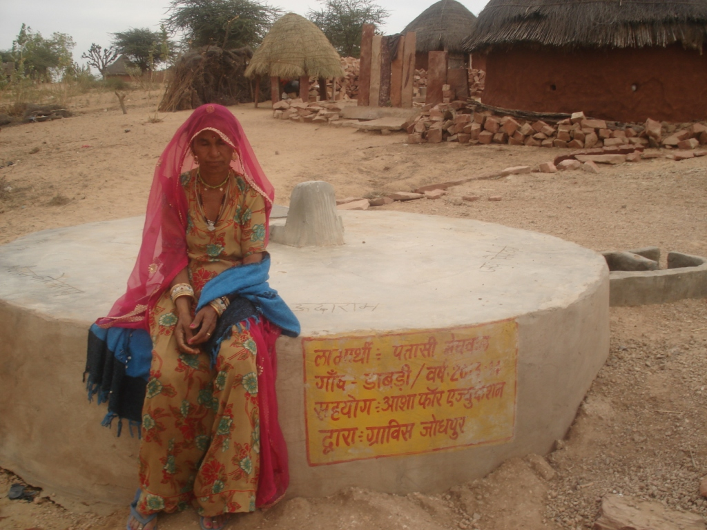

Patasi Devi – Taanka beneficiary

