Sita School Report
July 2016
October 2015 – mid-April 2016
Following a week’s holiday for Dasara the school continued for the school year until mid-April.It was a busy term with a number of events, excursions and visits alongside the regular classes.
In the October Report mention was made of a group of young people who came and helped to make a playground area which included a zip-line and climbing ropes. The children have greatly enjoyed playing on these new apparatus.
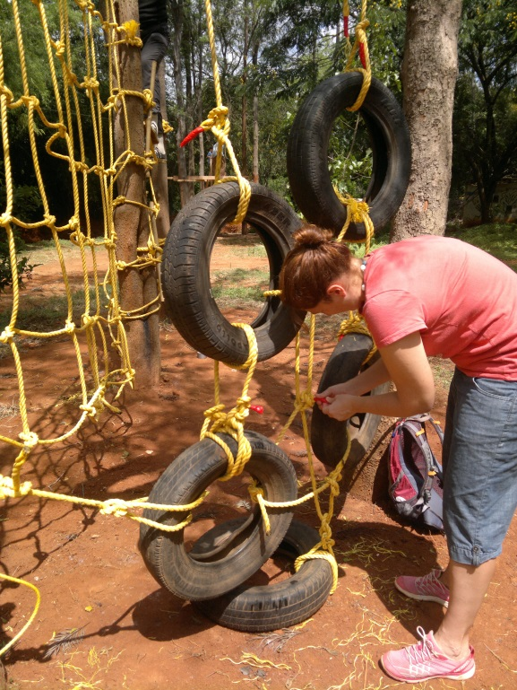 The new play area with tyres, ropes and a zip-line.
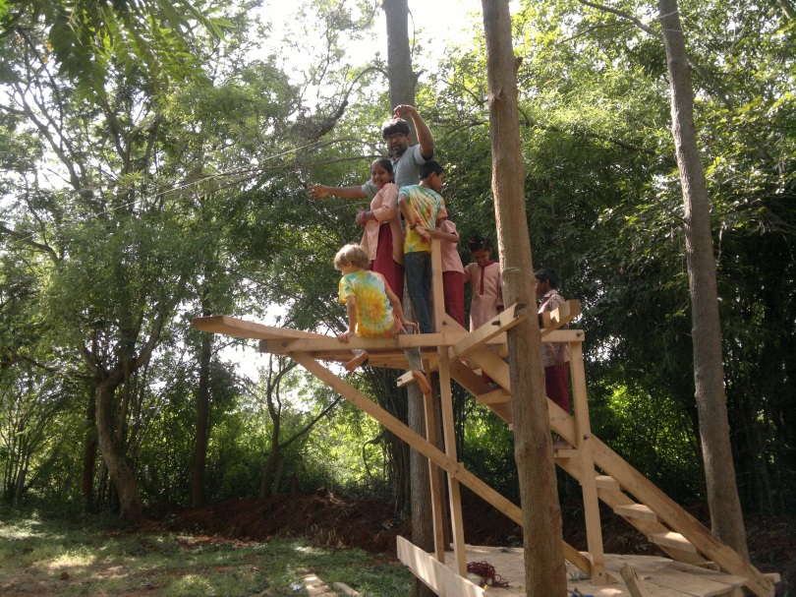

In March we also had the visit of a group from the London Institute of Education . The teacher students conducted a series of special classes in singing and pattern work using both natural materials and paint and colour.
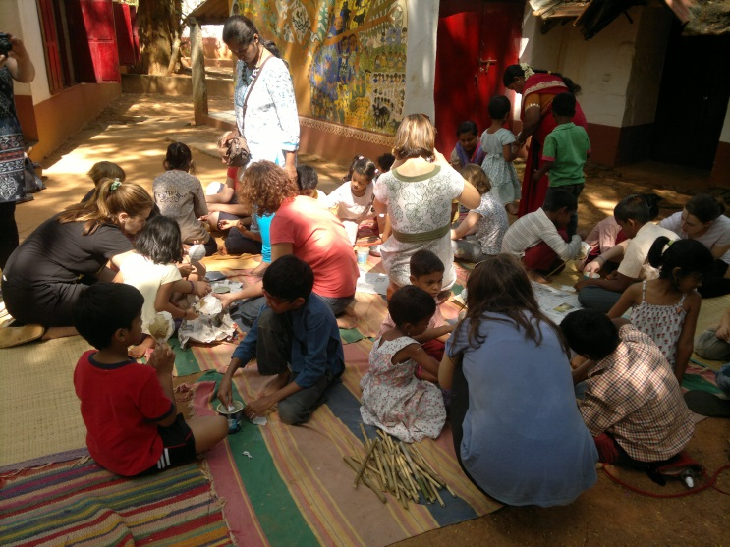
Student teachers working with children on pattern making in March .
From January to March In January a young volunteer, Rosie Oakley worked in the school and did a number of activities with the children. The children did a series of figure drawings from life and these were used to make a small mural.
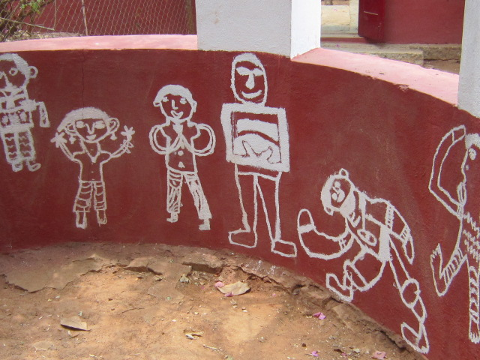
Mural done by the children
In February Santhosh Padmanaban, Sarojini and Jane accompanied the older children on a two day excursion to Mysore and Srirangapatnam. We all enjoyed a wide range of visits that included the Mysore Palace, the zoo, Brindavan Gardens and the historical sites at Srirangapatnam and Ranganathittu Bird Sanctuary.
In March we had the visit of more than 40 employees from Symantec. Together we were able to do some substantial work in the garden including cleaning the well area used for water- harvesting, emptying the compost and clearing the paths of fallen leaves. We greatly appreciated the willingness and earnest engagement of the volunteers . The work was followed by a shared lunch. The group also contributed monetarily and generously provided the school with some steel cupboards.
In March Radha Joshi, a student from APU stayed for two weeks and did a small research study about the use of art in schools. Two other students from APU also came in connection with a study about Alternative Schools.
After extensive discussions with the teachers, friends and associates of alternative schools a decision was taken to downscale the school and transition into a learning centre where children, students and teachers could come to use the many resources that we have including the space of the garden . (See separate note.)
At the beginning of March we met each of the parents to discuss the future of the children and to encourage them to seek enrolment in other schools in the coming school year. We assured them of some financial support in meeting the expenses . Some funds from the Workshop Account that had largely been made up of earlier sales of calendars and cards made by the children. ( Note that these accounts are audited along with the main school account.) Most parents agreed to look at other options but some, after discussions with their children, preferred that the children continue for another year. A number of the children who wanted to continue were those with learning difficulties who we all felt would benefit from another year in a more supportive environment.
During the course of the year on Fridays a group of home-schoolers from Bengaluru came to join in activities and this proved to be a very positive exchange. The parents of these children have facilitated a number of new activities and extended others such as weaving, origami and making simple structures.
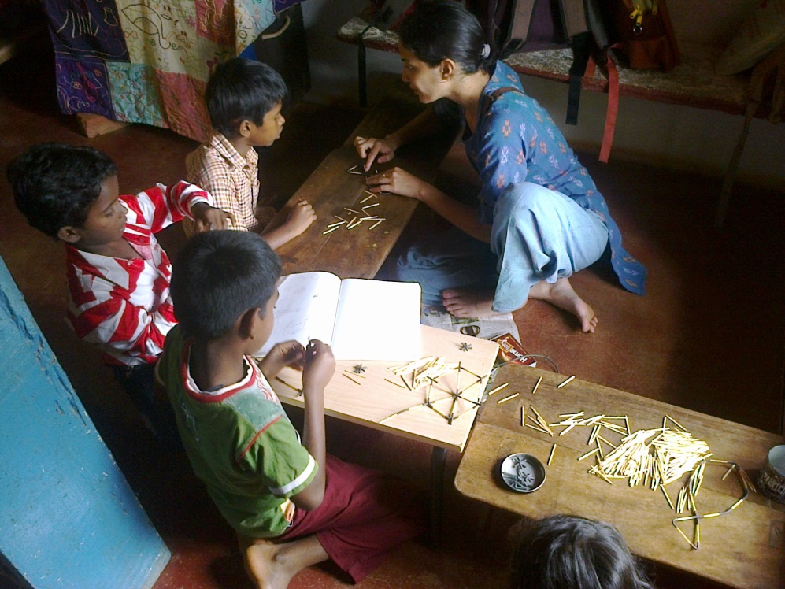
Two of the’ home-schooler’ mothers working with children on construction and origami.
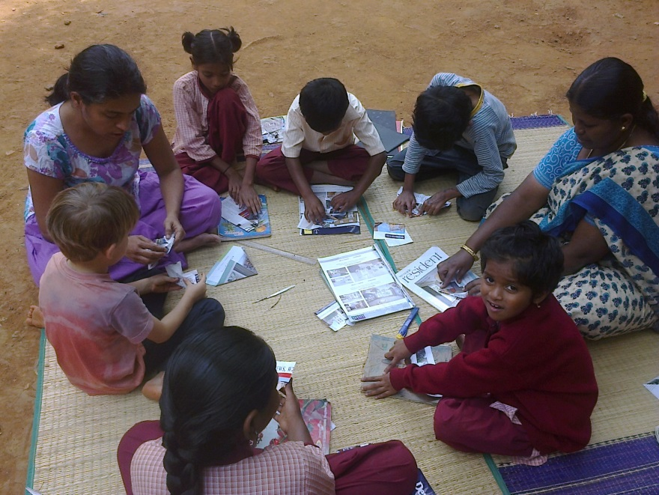
In April together with the home-schoolers we had an outing to Cubbon Park. We also visited the Aquarium there. One group had been doing a project on fish so this was a good opportunity to look closely at live fish and do drawings to complement their writing. School closed with a final function in mid-April and each of the children were given a school bag.
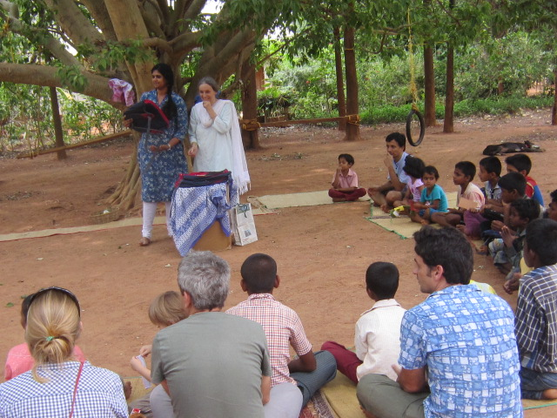
Anupamama giving each of the children a bag.
The children who left did not have a problem to be enrolled in schools and they are now continuing their studies in local schools. One boy, Dominic has joined St Joseph’s Indian High School in Bengaluru and is staying in the hostel there.
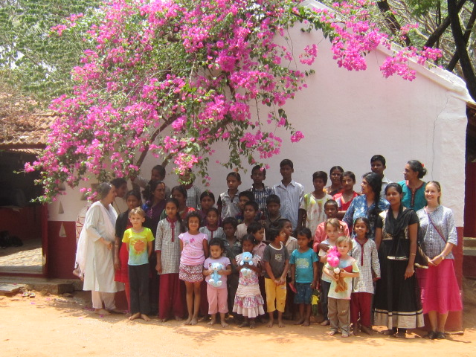
Children and staff April 2016
Mid- April – May
During the holidays extensive work was done on some of the buildings that urgently needed repairing. The roofs of two buildings were changed from asbestos and tin to metal sheeting. This was particularly important because books and materials needed protection from rain and termites. Two fixed deposits were which had been given much earlier by individual donors. were used to cover these expenses.
The bathrooms were also renovated and floor tiling was done to improve the hygiene and to facilitate easy maintenance.
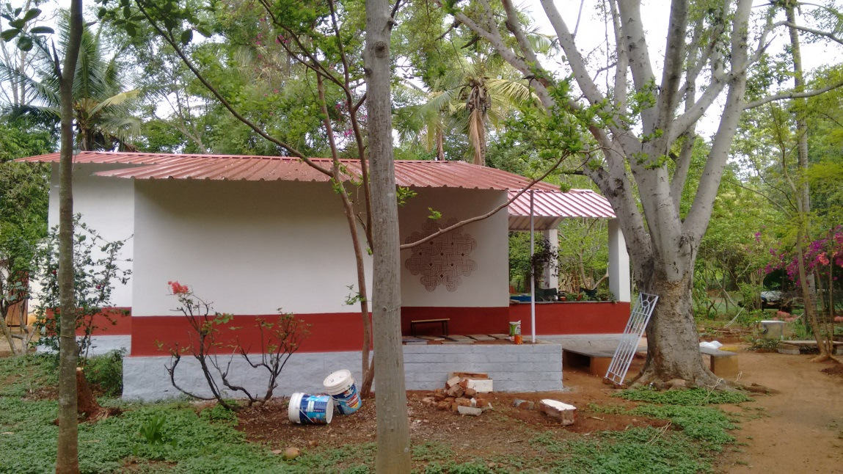
Sita Vanam which is now being used as the library.

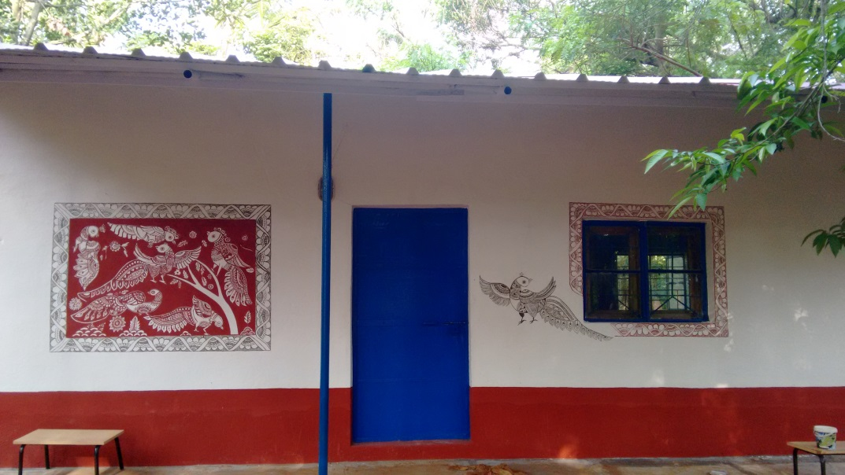
The room repaired for the computers and science resources .

June- July 2016
In June the school re-opened with 14 children. Sarojini, Rebecca and Jane have been working full time with conducting classes and major work on re-organizing materials in order to make them more accessible for groups who we hope to involve in the coming year. Extensive work has been done in the library and it is planned that this will provide a base for starting a pilot community library in the nearby village where reading would be encouraged, some remedial work could be done and craft activities facilitated. This all requires considerable organization and planning and this has been one of the main tasks of the teachers since the school re-opened in June.
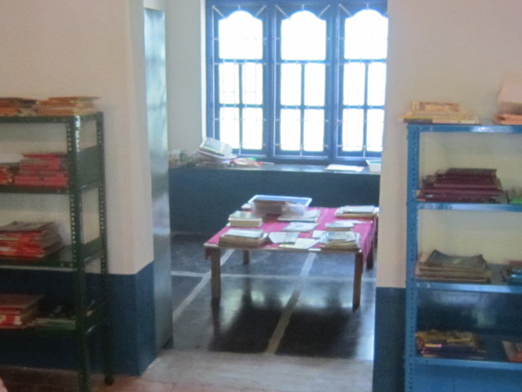
Re-organizing the library
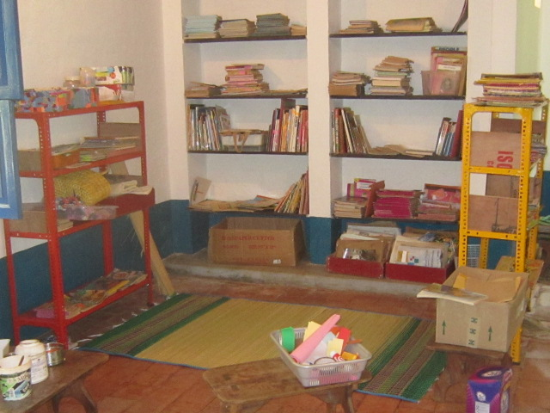
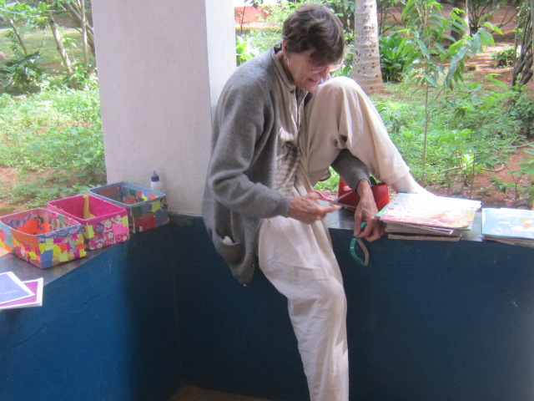
Sandy, a volunteer helping to catalogue books
Manoj, who has severe learning difficulties and limited speech and who was seriously ill last year with aplastic anaemia is now being supported to improve his communication skills. Recently a visit was made to COMMUNICATION – DEALL in HRBR layout, Bangalore, is an institution engaged in supporting children with language difficulties. This has given us some guidelines and we hope to build on this in the course of the year.
Karthik, a former teacher in the school and now doing an MA in Education at APU volunteered to help the children each create their own stories using Scratch programme and this proved a valuable learning experience both in developing language skills and giving practice in using the computer.
On Fridays Roshan conducts a class related to the garden and encourages children to look very closely at changes in the garden and to record their observations in writing and drawing. The children have also been each making “ a museum in a box”. This has helped the children to be much more attentive to things in the immediate environment.
Meanwhile the school has been supporting 12 children to continue their studies in the High School and two students coming from difficult home situations are being helped to do their PUC. Three children who were formerly students are being supported in the primary section.
In the coming months we are hoping to work out a series of modules that could be offered as workshops for students, teachers and local children.

Jane Sahi
July 23rd 2016

Present enrolment
Shashi Pavan
Maria Nisarga
Shobha
Manoj Kumar
Manish
Lakshmi
Antono
Alwin
Sandya
Prakash
Jacob
Sneha
Edwin
Sangeeta

Larthik’s support – computer = stories on Scratch programme
Home schoolers
Gardening Class
Visit of Dhwani Director

Sitavanam: An Open Learning Space
The Background
The school
The space has been used as a non-formal school since 1975 and has mainly served local children from economically disadvantaged families and children with learning difficulties. The Sitavanam Project would try to share and extend the activities that were an integral part of the curriculum but are usually not part of mainstream schooling. Over the last 40 years we have built up a number of resources including books, construction sets, language games etc. and these would provide resources that could be shared.
The three core teachers and volunteers who have been involved in the school over a number of years would continue to work but in addition we would draw on resource persons with expertise and experience in particular areas such as dance, pottery, library work and gardening.
Work with teachers
Handbooks on art and language activities have already been published: Learning Through Art in Kannada, English and Hindi, In Our Own Words in English and forthcoming in Kannada. In addition a series of books for children and Teachers’ Manuals on learning and teaching English have been published. These would provide some basis for discussions and workshops with teachers.
Workshops
On a small scale and over the years a number of different workshops have been held at the school. Children and teachers from a variety of schools have come including the Spastics Society, Ashram Shala teachers from Chamrajpet , Aditi Mallya, APD and Poorna. We have also had teachers and students coming from non-formal schools like Ananya (South Bangalore), Sevagram (Wardha) and Thulir (Dharmapuri District).
A transition from a school to an open learning space and resource centre
After five years of deliberations and discussions with the parents, the children , teachers and friends in other alternative schools we finally decided in February to close the Sita School. The discussions began when the framework of RtE made it clear that only registered and recognized schools would be able to function legally. This meant that we were putting the children at risk in the event of a sudden closure and also that we could be liable for not following regulations which are rapidly increasing such as with the recent legislation about surveillance.
In addition, because of the increase in administrative monitoring ,it was more difficult to enable children to shift to the mainstream as there was no official way for children to get transfer certificates. We explored various options of getting accreditation through NIOS, becoming a Bridge School or trying to get recognition in the normal way but finally decided that it would be more constructive to think of other options to use the space and resources.
Given the space, buildings, resources and skills that we have the most purposeful idea was to extend and share a number of the activities that the students of Sita School have been engaged in over many years with a wider range of people of different ages and from different places. This would mean involving not only children but students or teachers who would like hands-on experience of some of these activities so that they could introduce them in other settings. It would also mean involving both local children and children from Bengaluru who could come for example for a workshop or camp.
Development of different areas as learning spaces
Language resources and computer lab.
- To develop the library as an information centre and learning space where children, students, teachers and parents could have access to a range of Kannada, Hindi and English books, magazines and reference books. The books we have include a number of resource books for teachers.
- To give access to materials for writing and illustrating , making books of various kinds . Suggestions for story making and resources round particular themes would be made accessible.
- To make available a variety of resources including work-cards, charts and language games to support children’s learning especially for those with learning difficulties.
- To consider ways of taking books to local schools and encourage reading amongst students and teachers.
- To document some of the children’s work as a way to share ideas with teachers about independent and creative writing.
- To support drama activities by providing props and costumes for improvised plays and materials for puppet and mask making.
- To have dance and movement workshops
- To use the space for workshops for children, student teachers and teachers to explore creative writing activities.
- To make available the existing four computers for children to have exposure to computers and particularly to use interactive programmes like Scratch.
- Materials, books and resources would be available mainly in Kannada and English.

Craft and design
Paper
- To make available activities and materials especially waste paper [ such as newspapers and invitation cards etc ] to do constructions, collages, pattern making, book making, print making and origami work linked with math.

Thread, beads and cloth
- To make available thread, string and cloth ( including waste cloth) for a variety of activities such as applique, collage, doll making, embroidery, crochet and knitting. These would range from very simple, introductory activities to more complex.

- To provide looms from the most simple to more complex for weaving using a variety of materials including natural materials, waste materials and thread.

Visual art work with paint, clay and natural materials
- To offer a range of possibilities for experimenting with paint and colour .
- To explore clay and other materials for three dimensional sculptures and relief work.
Sitvanam Garden Project
One of our richest resources is the garden space that we have. This is something that few schools have and even if the school does have space it is rarely looked at as a learning environment for children to both enjoy and learn from.
This resource programme has been conceived as a process extending over one year to develop an outdoor environment that is hoped to facilitate and inspire young children and teachers. In this process we hope to foster in children’s learning experiences a variety of ways that will enable them to connect their personal stories to the surrounding environment. We hope that this experience will be enriching both in regard to their personal development in understanding how resources in an environment can be beneficial to their knowledge system as well as meaningful within the social ecological context. We hope children and teachers to take active roles to work in the garden both through reflective ways and in practical ways using their hands, feet and body. Stories will be explored as connecting imaginary matrixes and feelings in each one of us to the flora, fauna and geography of Sitavanam.
Through the seasons of the year children and teachers will explore the garden through activities such as the following:
- Poetry reading and writing related to the natural environment
- Story reading, telling and writing related to the natural environment
- Creating a garden explored through dreams and imaginary worlds
- Working with clay, rock, wood and other natural materials
- Exploring diversity of flora and fauna
- Exploring the seasons through senses and narratives – such as picture making, sculpture, pattern making and design.

Plans for the coming year
Using some of the savings we had some modifications of the buildings are already underway. In particular the library/ language resource room is being renovated to make it a leak-proof space and the roof has been replaced with a metal roof instead of asbestos sheeting which was both unhealthy and unsatisfactory to protect materials. The interior space has also been modified to provide better storage space and accessible shelving. The room that has been used for the computers has also been renovated by replacing the roof.
Also there is a plan to repair three bathrooms that urgently require renovation.
- In the coming year we are expecting about 10 children to continue to come on a daily basis. These would be children who are older and not affected by the regulation of compulsory enrolment and a few younger children who would benefit from a more flexible environment for one more year before joining the mainstream school.
- In addition we would like to offer support to some children after school in the subjects that they need help.
- The coming year would be spent mostly on planning and preparing for the new venture. This would involve a re-organization of existing materials to make them both accessible and usable by a variety of people including teachers, students, ‘home-schoolers’ and local children.
- Preparation would also be made to connect with other groups, schools , teacher training programmes to make a more consolidated programmed for the following year.
- It would also give time for the two teachers to visit existing learning centres and libraries. This would include a visit to Khelghar a center in Pune that has been functioning for many years and has become a significant resource to guide and train teachers for working in learning centre. Another site to visit would be Bookworm , a children’s library in Panjim, Goa that has a well-established outreach programme to support literacy in local schools and is also engaged in training people for children’s library work.
- The Sitavanam garden project would be piloted and would be documented .
- It would be hoped that we could conduct a number of workshops for children such as doll making and dance.

