Khajurdaha Nabankur United Club
(Organization for Rural and Urban Development)
Regd. Under Act XXVI of 1961
Regd. Office.
P.O. & Vill. – Khajurdaha, Dist.- Hooghly, West Bengal, Pin.—712 149,India,

Phone – 03213-230-231, E- mail – knuc@satyam.net.in ; Website- http://www.knucindia.org

Ref. No. : Knuc/F-18A-99 / 2297 Date: December 15, 2009

TO,

Mr. Sohil Tiwari,
ASHA FOR EDUCATION,
P.O. Box-1287, Princeton,
NJ 08542-1287, U.S.A.

Subject: Annual Report on LTTO Programme for the period from January to December 2009.

Dear Mr. Sohil Tiwari,

At the outset, we convey our heartiest thanks and gratitude to all of you at Asha For Education (Princeton Chapter) for active support to our LTTO programme.

Last few years, the LTTO programme was run under the stewardship of Mr. Sridhar Desikan. From 2008 onwards the programme is running under the stewardship of you; fund allocation for the year 2009 has been also done by you and accordingly we submit herewith the annual progress report along with financial statement for the period on LTTO Programme to keep you abreast with the progress & proceedings of the programme.

We also submit herewith the Future Plan for the year 2010 for your kind perusal and necessary action. Hope, you would be in position to allocate fund for the programme fully for the year. If it does not permit you, we would request you to think for co-financing the project for its smooth running as well as to give us a scope to develop self-mechanism for sustainability of the programme.

Conveying our thanks and gratitude to all of you once again we look forward to hearing from you.

With the best regards.

Yours Sincerely,

Satyajit Mondal.
Hony. General Secretary,
Khajurdaha Nabankur United Club.

Enclosure: 1. Annual Report on LTTO Program & other documents.

N.B: We shall be much obliged if you kindly acknowledge receipt of the report.

Page-1

ANNUAL REPORT ON LTTO PROGRAMME

FOR THE PERIOD FROM JANUARY to DECEMBER 2009
ORGD. BY
KHAJURDAHA NABANKUR UNITED CLUB (KNUC)

FUNDED BY
ASHA FOR EDUCATION, PRINCETON CHAPTER, U.S.A.

1. INTRODUCTION :

LTTO means – “Learn Together Teach Other”. It is an innovative step towards development of child education, education scenario of rural areas and development of school going culture within the community through introducing and developing Child-to-Child approach, Child-to-Parents approach and Child-to-Community approach. Keeping in view the above strategies, the program has been started in the year 1995. And since October 1999, by the intervention of Mr. Sridhar Desikan, the program has got active cooperation and support from Asha For Education, Princeton Chapter, U.S.A. Presently from 2008 onwards, on behalf of Asha For Education, the programme is running under the stewardship of Mr. Sohil Tiwari and this report is to keep him/ Asha For Education abreast with the progress of the program. We are grateful and hopeful for getting long-term support from Asha For Education in our efforts to bring about a wide, rapid & significant change in education scenario of concerned areas of Hooghly District of West Bengal, India.

2. GENERAL INFORMATION REGARDING PROJECT :

2.1. Reporting Period : JANUARY 2009 to 31st DECEMBER 2009.

2.2. Title of the Project : LEARN TOGETHER TEACH OTHER (LTTO).

2.3. Name & Address of Funding : ASHA FOR EDUCATION (Princeton Chapter)
Partner. P.O. Box-1287, Princeton, NJ 08542-1287, U.S.A.

2.4. Implementing Partner : Khajurdaha Nabankur United Club (KNUC).
Address : P.O. & Vill. Khajurdaha, Dist. Hooghly, West Bengal.
Pin Code-712 149. India.
Phone : 0091-3213-230231 (off) / (0) 9434125297 (M).
E-mail : knuc@satyam.net.in ; gs_nuc@bsnl.in
Website : http://www.knucindia.org
2.5. Reporting Pattern : Annual > JANUARY to DECEMBER.
2.6. Funding Pattern : Long Term on Yearly Basis.
2.7. Opening Balance as on 01/01/09 : US $ ---- = Rs. 2,663.99
2.8. Fund Received during the period : US $ ---- = Rs. 2,65,812.50
2.9. Local Fund Raised (including
provision for December’09 ) : US $ ----- = Rs. 2,28,780.00
2.10. Loan from Venders & Wel-wishers : US $ ------ = Rs. 1,31,500.00 Grand Total : Rs. 6,28,756.49

2.10. Fund Utilized during the period: Expenditure upto 30/11/09 Rs. 5,78,392.00
Provision for 1/12 to 31/12/09 Rs. 49,300.00
Unspent Balance as on 31/12/09 Rs. 1,064.49
Grand Total : Rs. 6,28,756.49

(Please find Annexure-A, the details of Receipts & Payments Accounts)

Contd……2

Page- 2
3. OVERALL OBJECTIVE :

To ensure child education and comprehensive development of education scenario, environment and school going culture within the community by providing care, support & guidance and lunching necessary facilities for child education and make the programme a “MODEL” and self-sustained.

4. ACTIVITY REPORT/ PRESENT STATUS OF THE PROGRAMME:-
Sl. No. | ACTIVITY | STATUS
1. | Basic, Primary & Higher Primary education, Care and Nurturing of 255 target children | During the period under review total 268 children have got education, care & nurturing according to action Plan. But due to sudden break (fund cutting) of fund we have faced many problem to tackle the situation.
2. | Performance test of target children. | Upto 3rd term is completed
3. | Health Check up & Medicare. | This component is going on & all children are getting regular medication by the active supervision of Mr. Asish Bag, Coordinator according to action Plan.
4. | Home visit / Family counseling /Guardian meeting and awareness & IEC Services. | It is going on according to action Plan
5. | Induction /Admission of new children into LTTO Program. | During the period under review total inducted children is 56 Nos.
6. | Re-linked & mainstreamed | Total no. of re-linked children is 37
7. | Rapport Building for getting Affiliation from WBBSE. | Going on & might get affiliation during the year 2010
8. | Provision for Exposure Visit for target children and other children or DISHA DOOT Programme.. | Not done during the period under review due to lack of fund.
9. | Development of Child Resource Centre. | Not done due to lack of fund.
10. | Children Park | Not done due to lack of fund
11. | Monitoring & Evaluation | According to action plan the management is doing it. On behalf of Asha For Education, Mr. Desikan & others last evaluated the program on 30th July 2007.
N.B: During last visit & evaluation of Mr. Desikan & Others, following suggestions were given to us for taking necessary action:-

Suggestion | Present Position
1) The school building should be completed  with outside plastering and its colouring. | Done by the active support of Asha For Education.
2) Additional Restroom/ Toilet should be done  for LTTO children. | Done by the active support of Asha For Education.
3) Proper medication, health check up & its  record keeping should be done regularly. | According to suggestion, the component is going on by the active supervision of Mr. Asish bag, Coordinator, LTTO Program.
4) For upgradation of concern Teachers,  Teachers Training should be done on regular  basis. | On the basis of Mr. Desikan’s suggestion, Mrs. Sefali Dey, MA, B. Ed, (Head Teacher) is carrying out responsibility of Teachers’ Training of LTTO Teachers.
5) Every class-room should be supported by High &  Low Bench for all LTTO children. | Not yet done due to lack of fund.
6) Exposure visit should be regularized for all  LTTO children. | Not yet regularize due to shortage of fund.
7) Don’t think for fund raising for sustainability of  the programme. | Asha For Education’s last decision of fund cutting for the program has made a big gap.

Page-3
5. MANPOWE TO RUN THE PROGRAMME:

Administrative | Teaching Personnel |  |  |  | Health | Non-Teaching |  |  | Total  Nos.
Programme Coordinator | Teacher for Basic Standard | Teacher for Primary Standard | Teacher for Higher Primary Standard | Teachers for Arts & Craft | Doctor for Routine  Health check up | Clerk | Cook | Sweeper | Total  Nos.
1 | 2 | 4 | 6 | 4 | 2 | 1 | 1 | 1 | 22

6. OUTPUT REACHED :-

Following the strategies and objectives of the programme, during the period under review i.e. from January 2009 to till the date the following outputs have been recorded:-

- 268 target children have been nurtured under the programme for their education and
development.

b) All LTTO children who have graduated from LTTO programme are continuing in
education.

c) For upgradation of concern teachers and teaching method, Mrs. Sefali Dey has taken
responsibility of training for the teachers.

- IMPACT OF THE PROGRAMME:
During the period under review, the project can stake claim the impact as follows: -

- While all Govt. Primary Schools used to run without restroom/toilet, we started movement to introduce toilet facilities for the children in the school compound. Presently Government has accepted the same policy and allotting money to every school for toilet facilities in the school compound.
- From the beginning we introduced midday Tiffin for the target children at LTTO school. Presently Government has accepted the same policy and providing money and materials to every school for midday meal for the children.
- From the beginning we gave importance on adequate infrastructure for child education. Presently Government has taken the same policy and trying to develop infrastructure in term of Teacher & Accommodation for child education.
- We presume that all above-mentioned steps, the Government has taken from the study report, which was done by Dr. Manabi Majumder, Centre for Studies in Social Science, Kolkata, an unit of Indian Council of Social Science Research, Govt. of India, who chose the LTTO School for comparative study and gave importance on the strategies of the LTTO School.
- Through the efforts local guardians and peoples have been more concern about their child education and above 90% children are continuing in education of the concerned areas.
- As a latest impact, Sarvya Siksha Mission has surveyed our LTTO programme. According to reliable source, our school has gained highest attention through the survey and they might provide some assistance to the school though the news didn’t get air so far.

Page-4
8. LESSION LEARNT :-

In the journey towards child education and development, K.N.U.C. has gained many lessons. Capitalizing such lessons/ experiences, we are intended to up-grade the program with all sorts of facilities to make the program a MODEL for child education, which ultimately will be the inspiration to other Institutions and bring a lot of changes in education scenario in rural areas.

9. MONITORING & EVALUATION & FINDINGS: -
All concerned teachers and program Coordinator has monitored the program regularly. On behalf of KNUC, Hony. General Secretary has also monitored the program on regular basis. School Managing Committee comprising of 11 members has monitored the programme on monthly basis. Through close and all round monitoring over the project, during the period under review, only one point come out i.e. sustainability of the programme. In this regard, our humble prayer to Asha For Education for reconsideration of last decision of fund reducing.

10. FUTURE INTERVENTION PLAN: -

In brief, we furnish here below the future plan (For the period from January 2010 to December 2010) of LTTO program for kind approval of ASHA FOR EDUCATION.
- The program will run with 270(approx) children during the period- January 2010 to December 2010.
- 270 children will get nurturing under the program according to action plan.
- Community sensitization and motivation activities and IEC services will have in motion as earlier.
- 270 children will get regular health check up and medication.
- To finish all outstanding works like, Child Resource Center, Children Park, Disha Doot for exposure visit etc.to make the programme model.
- To carry out the above-mentioned activities, the programme need financial assistance support from Asha For Education. Budget for the period from January 2010 to December 2010 has been shown in Annexure-B and Action Plan has been shown in Annexure-C.

10. ENCLOSER :-

- Receipts & Payments Accounts for the period Jan.’09 to December 2009 Annexure –A
- Budget for the period from January 2010 to December 2010. Annexure – B
- Action Plan for the period from January 2010 to December 2010. Annexure – C
- Photographs. Annexure - D

S. Mondal.
Hony. General Secretary.
Khajurdaha Nabankur United Club.

ANNEXURE- B
BUDGET FOR THE LTTO PROGRAMME FOR THE PERIOD JANUARY to DECEMBER 2010

Sl No | Item of Expenditure | Amount  (Rs.) | Amount (Rs.)
1.  2.  3.  4. | RECURRING COST:  Administrative :  = Honorarium to Coordinator @ Rs.3000/-per monthx12 months.  = Stationary, Audit Fees, Electric, Phone, Conveyance etc.  @ Rs. 1000/- x 12 months  Education :  = Books, Exercise books, pen, pencils etc @ Rs. 270/-(average)  per child per year x 250 children.  = Honorarium to teacher cum counsellors @ Rs. 1500/- per  month x 12 months x 6 teachers.(for Basic to Primary  standard)  = Provision for Recreation @ Rs. 100/- per child per year x 270  children.  = Provision for Exposure Visit @ Rs.100/- per child per year x  270 children.  = Provision for Arts, Crafts etc @ Rs. 100/- per child per year x  270 children.  Health Care:  = Honorarium to doctor @ Rs. 1000/- per visit x 4 visit in a month  x 12 months.  = First Aid & Medicine @Rs.25/-per child per month x 270  Children x 12 months.  = Nutrition @ Rs. 300/- per child per year x 270 children.  = Wages to Cook @ Rs. 1000/- per month x 12 months  Additional Cost For Class V - VIII :-  = Honorarium to Teacher @ Rs.2000/- per month x 12 months x6  Teachers.(for class V,VI,VII&VIII )  = Honorarium to Clark @ Rs.1500/- per month x 12 mths x 1No. | 36000.00  12000.00  67500.00  108000.00  27000.00  27000.00  27000 .00  48000.00  81000.00  81000.00  12000.00  144000 .00  18000 .00 | 48000.00  256 500.00  222000.00  162000.00
 | Grand Total : |  | 6,88,500.00
 | Less Beneficiary/Own Contribution 25 % |  | 1,72,125.00
 | Amount Requested from Asha For Education 75 % |  | 5,16,375.00
(Rupees five lac sixteen thousand three hundred seventy five only)

N.B: If Asha For Education considers the other components like Child Resource Center, Disha
Doot, High Bench & sit bench etc .during the year and invites budget, we shall be much
obliged and do the needful immediately.

S. Mondal.
Hony. General Secretary.
Khajurdaha Nabankur United Club.

ANNEXURE-C

ACTION PLAN FOR THE EXISTING LTTO PROJECT
FOR THE PERIOD FROM JANUARY TO DECEMBER 2010

Sl. No | Activities | Jan | Fe  b | Ma  r | Ap  r | Ma  y | J  un | Jul | Aug | Sep | Oct | Nov | Dec | Post Project Stage
1 | Basic, Primary & Higher Primary education, Care and Nurturing of 270 children
 | A. Education daily 2.30 hrs.
 | B. Recreation daily 1 hour
 | C. Nutrition daily 1 hour
 | D. Art & Craft weekly three days; 2 hrs. per day
2 | Health checkup by doctor ( specifically weekly 1 day) & medication on regular basis.
3 | Home visit, family counseling, Guardian meeting & awareness and IEC Services.
5 | Performance Study of the children
 | A. 1st Phase
 | B. 2nd Phase ( Semi Annual)
 | C. 3rd Phase
 | D. 4th Phase( Annual)
6 | Identification & Induction of new children in LTTO Programme
7 | Re-link services
8 | Exposure Visit/ Educational Tour.
10 | Rapport Building & Sharing with other institution
11. | a) Monitoring & Evaluation by concern staff on  Regular basis.
b) Monitoring & Evaluation by the General
Secretary on regular basis.
c) Monitoring & Evaluation by the School
Managing Committee on monthly basis.
d) Monitoring & Evaluation by donor
representative whenever they deem fit.
11 | Progress Report Submission by the management.
12 | Budget Submission for the consecutive year

S. Mondal.
Hony. General Secretary.
Khajurdaha Nabankur United Club.

PHOTOGRAPH-D
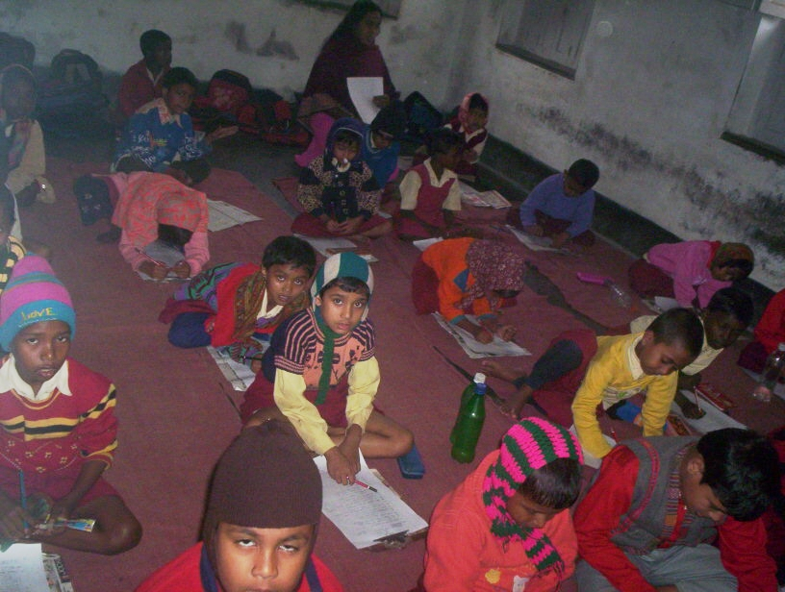
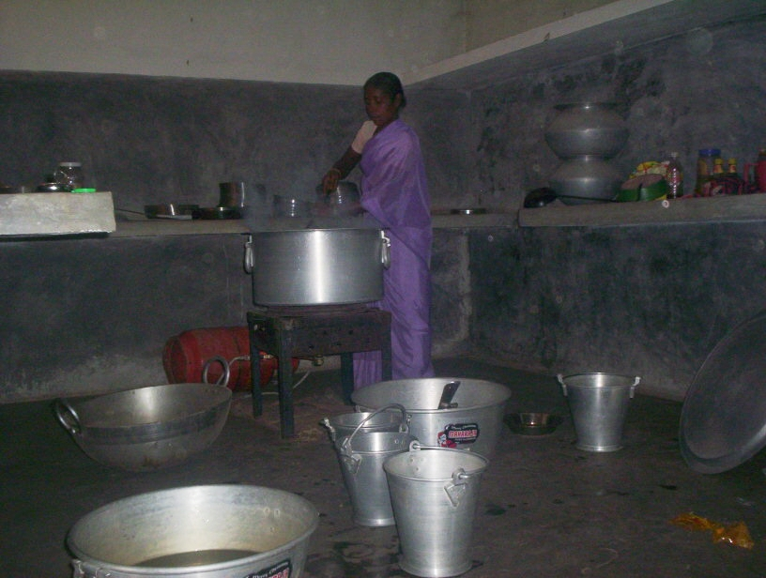
LTTO children are giving 3rd term Exam. The cook is preparing midday tiffing
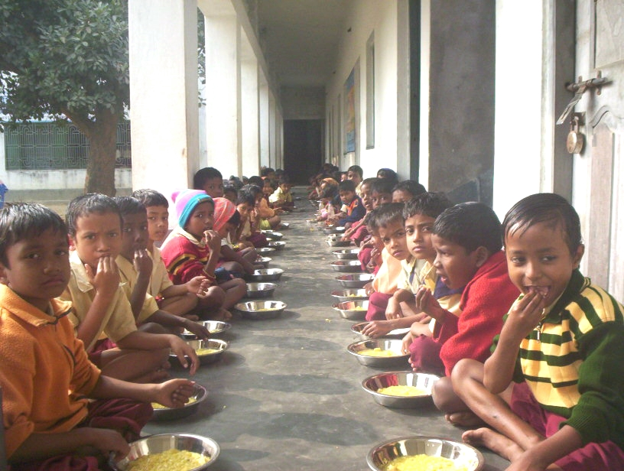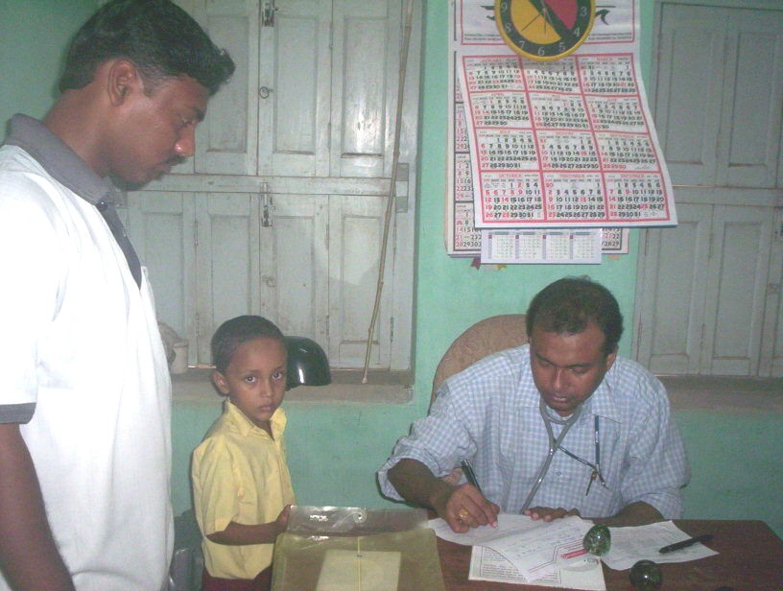
LTTO children are taking Tiffin Dr. Sadek Ali is providing medical check up.
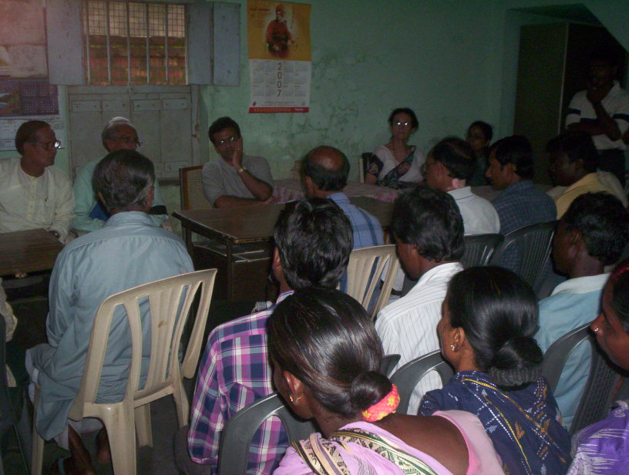
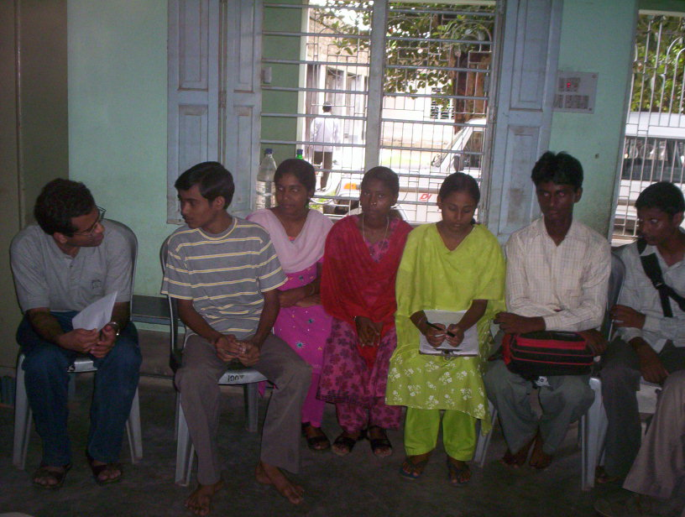

Mr. Desikan & Others are meeting with parents. Mr. Desikan is sharing with LTTO children who have
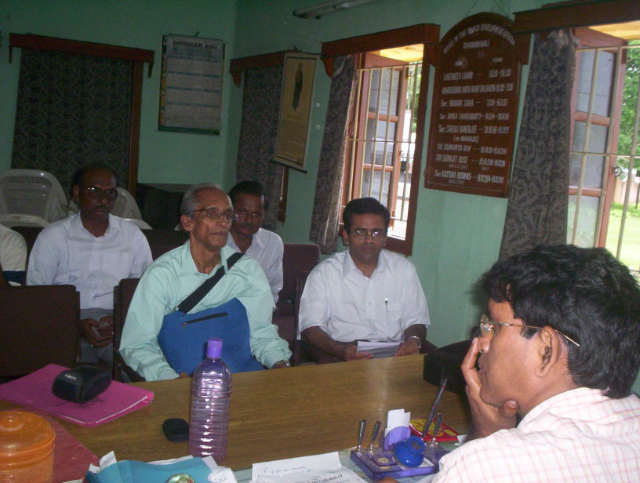
already been graduated from LTTO programme.
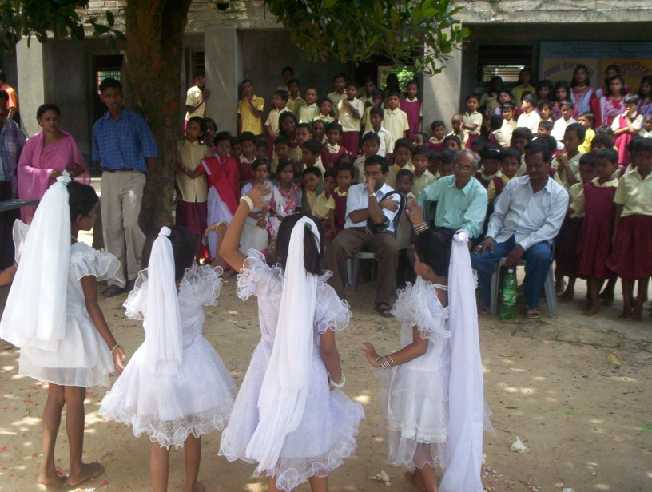

Mr. Desikan is sharing with B.D.O, Dhaniakhali Mr. Desikan & Others are observing cultural events
of LTTO children.
ANNEXURE -A

Receipts & Payments Accounts for the period from JANUARY 2009 to DECEMBER 2009
Title of the project “ Learn Together Teach Other”
Funded by: ASHA FOR EDUCATION, U.S.A . & Orgd. By : KHAJURDAHA NABANKUR UNITED CLUB (KNUC)
Khajurdaha, Hooghly, West Bengal, Pin – 712149, India.
RECEIPTS | Period 1/1/2009 to 31/12/2009 | Head of Expenditure | Budget for the period 1/01/09 to 31/12/09 | Actual Exp. From 1/01/09 to 30/11/2009 | Provision for Exp. for 1/12/09 TO 31/12/09 | TOTAL
To Opening Balance :  Cash in hand 1815.73  Cash at Bank 848.26  Grand Received from  Aaha For Education , U.S.A.  Local Contribution  (Upto 3oth November’09) 1,88,530.00  Provision for Dec. 2009 40,250.00  Loan from Venders & Wel-wishers | 2,663.99  2,65,812.50  2,28,780.00  1,31,500.00 | By Recurring Expenditure  1. Administrative  a) Honorarium to Coordinator  b) Stationery, Audit fees, Conveyance,  Telephone Bank commission, Field Visit etc.  2. Education  a) Books, Pen, Exercise Books , Pencils etc.  b) Honorarium to Teachers cum Counselors  c) Provision for Recreation  d) Provision for Exposure Visit  e) Provision for Art, Crafts etc  - Health Care  a) Honorarium to Doctor  b) First Aid & Medicine  c) Meals / Nutrition  d) Wages to Cook  - Additional Cost for Class V , to VIII  - Honorarium to teacher ( 6 Nos.)  - Honorarium to Clark.  Total ( 1 +2 +3 + 4 )  Unspent Balance :- | 36,000.00  12,000.00  62,500.00  ** 1,08,000.00  25,000.00  25,000.00  25,000.00  48,000.00  75,000.00  75,000.00  12,000.00  ** 1,44,000.00  ** 18,000.00  6,65,500.00  -------- | 33,000.00  11,184.00  62,861.00  99,000.00  23,697.00  ------  22,300.00  44,000.00  53,200.00  68,250.00  11,000.00  1,33,400.00  16,500.00  5,78,392.00  --------- | 3,000.00  800.00  -----  9,000.00  1,300.00  --------  2,700.00  4,000.00  7,500.00  6,500.00  1,000.00  12,000.00  1,500.00  49,300.00  --------- | 36,000.00  11,984.00  62,861.00  1,08,000.00  24,997.00  -------  25,000.00  48,000.00  60,700.00  74,750.00  12,000.00  1,45,400.00  18,000.00  6,27,692.00  1,064.49
GRAND TOTAL : | 6,28,756.49 | GRAND TOTAL : |  |  |  | 6,28,756.49
FUND POSITION :-
Opening Balance | Grant Receipt | Local Contribution (including provision | Total | Expenditure | Balance
 |  |  |  | 1/1/2009 to 31/12/09 (Including Provision ) | Balance
2,663.99 | 2,65,812.50 | 2,28,780.00  Loan 1,31,500.00 | 6,28,756.49 | 6,27,692.00 | 1,054.49

Satyajit Mondal, N.B: 1. We have got fund from Asha For Education only for ** mark points.
Hony.General Secretary, 2. Due to sudden fund cutting, we have faced many problems to tackle the other
Khajurdaha Nabankur United Club. components of the programme. To stop component(s) is quite impossible.

