Khajurdaha Nabankur United Club
(Organization for Rural and Urban Development)
Regd.Under Act XXVI of 1961
Regd. Office.
P.O. & Vill. – Khajurdaha, Dist.- Hooghly,West Bengal, Pin.—712 149,India,

Phone – 230-231 (Std. 03213), e. mail – knuc@satyam.net.in

Ref. No. : Knuc/F-67-03 / 2071 Date : February 04, 2007

TO,

Mr. Sridhar Desikan,
ASHA FOR EDUCATION,
P.O. Box-1287, Princeton,
NJ 08542-1287, U.S.A.

Subject : Progress Report on Government Primary School Upgradation/ Renovation Project.

Dear Mr. Desikan,

Conveying the best wishes to all of you at Asha For Education, we submit herewith the progress report on Govt. Primary School Upgradation/ Renovation Project for your kind perusal and necessary action. As we did not get the official approved letter for the project, probably may be, we could not follow your directives properly for the project. Yet we have tried utmost for the implementation of the project. If you notice something wrong, please correct us.

Conveying thanks once again, we look forward to hearing your kind comments and suggestion.

With best regards.


(Satyajit Mondal)
Hony. General Secretary,
Khajurdaha Nabankur United Club.

Enclo : 1. Progress Report
2. Financial Statements.
3. Comparative Photographs.

PROGRESS REPORT ON GOVT. PRIMARY SCHOOL RENOVATION PROJECT

FOR THE PERIOD FROM FEBRUARY ‘06 to DECEMBER 2006
ORGD. BY
KHAJURDAHA NABANKUR UNITED CLUB (KNUC)

FUNDED BY
ASHA FOR EDUCATION, PRINCETON CHAPTER, U.S.A.

1. INTRODUCTION:

KNUC started movement for development of child education and school going culture within the communities in the year 1995. In view of developing a rapid, massive and sustainable change in child education, through assessment and evaluation, it was come into planning for upgradation / renovation of existing Govt. Primary Schools under the jurisdiction of Khajurdaha-Melki Gram Panchayet of Dhaniakhali Block of Hooghly District, West Bengal. Accordingly, the planning was forwarded to Asha For Education, Princeton Chapter in the year 2003 seeking their help and approval. Finally, Asha For Education approved the partial part of the project in the year 2006 on which this report has been prepared to keep donor abreast with the progress of the project.

2. GENERAL INFORMATION REGARDING THE PROJECT:

2.1. Title of the project : Govt. Primary School Upgradation Project.

2.2. Objective of the Project : To develop the educational environment, scenario
and school going culture within the community and
ensure child education upgrading the Govt. Primary
Schools’ bad & poor position & condition following
the strategies of the LTTO Programme.

2.3. Location of the Project : Existing Govt. Primary Schools under the
jurisdiction of Khajurdaha-Melki Gram Panchayet of
Dhaniakhali Block of Hooghly District, West Bengal.

2.4. Funding Agency & Address : ASHA FOR EDUCATION,
P.O. Box-1287, Princeton,
NJ 08542-1287, U.S.A.

2.5. Implementing Agency & Address : Khajurdaha Nabankur United Club (KNUC).
P.O. & Vill. Khajurdaha, Dist. Hooghly,
West Bengal, India.

2.6. Reporting Period : February ’06 to 31st December 2006.

2.7. Approved Amount for the Project : Rs. 1,79,343.36

2.8. Contribution raised for the project : Rs. 25,800.00
Grand Total: : Rs. 2,05,143.36

2.9. Fund Utilized : Rs. 1,42,250.00

2.10. Unspent Amount : Rs. 62,893.36
(Please find Annexure-A, the detailed financial
statements)

Contd…….. 2

Cont. Sheet No. 2

3. ACTIVITY REPORT & PHYSICAL ACHIEVEMENTS:

During the period under review, renovation works under 5 (five) schools have been completed. The renovation works are as follows: -
Sl.No. | Name of Schools | Renovation work done | Present Status
1. | Basudevpur Haripada Smrity Primary School. | Kitchen Room (Cooking Shed)  Measurement- 12ft x 7 ft = 84 sq.ft. | The school authority is using the room properly for the preparation of Mid-day meal for the children.
2. | Melki Primary School | Kitchen Room (Cooking Shed)  Measurement- 13ft x 9 ft = 107 sq.ft. | The school authority is using the room properly for the preparation of Mid-day meal for the children.
3. | Deluara Primary School | Drinking Water Tube Well  Depth –239 ft. | The Tube well is functioning well and the children are getting adequate & pure drinking water.
4. | Kanajuli Primary School | Wall Plastering & Roof Repairing. Measurement- 1700 sq.ft. | Presently the school and the children are safe from rain water.
5. | Khajurdaha B.B. Primary School | Additional Room for Office Accommodation.  Measurement- 12ft x 7ft= 84 sq.ft. | Presently the additional room is used for Office purpose.
( Please see the photographs below according to Sl. No. )

4. PHOTOGRAPHS FOR COMPARATIVE STUDY: Please find Annexure-B

5. SUGGESTION:

We have a balance amount of Rs. 62893.36. If Asha For Education approves, the balance amount may be used to the schools for additional works. For example, we mention here the approaches of “Kanajuli Primary School” who has appealed for additional funding for Boundary Wall for their School. It requires approx. Rs. 30000/-.

(Satyajit Mondal)
Hony. General Secretary,
Khajurdaha Nabankur United Club.

ANNEXURE – B
PHOTOGRAPHS FOR COMPARATIVE STUDY 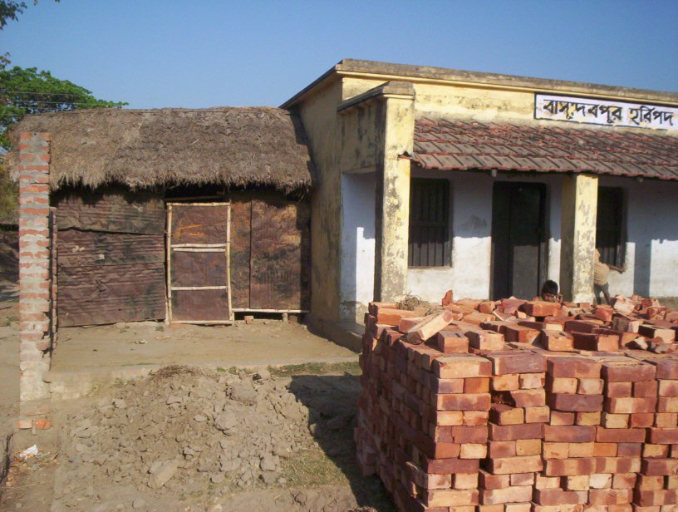 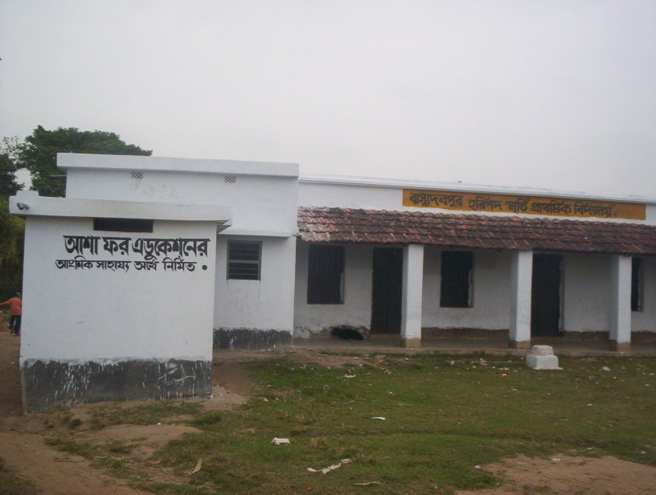
No. 1 > Pre Stage Post Stage
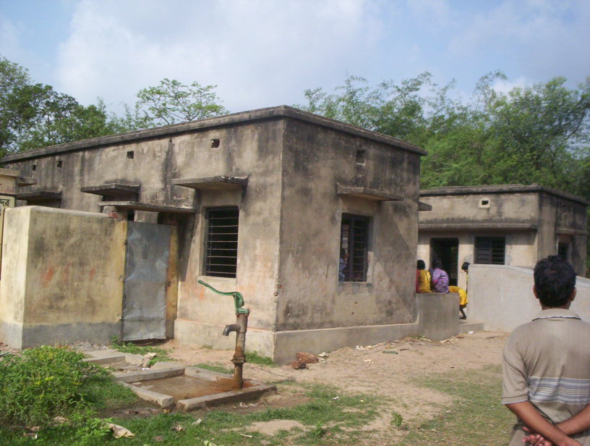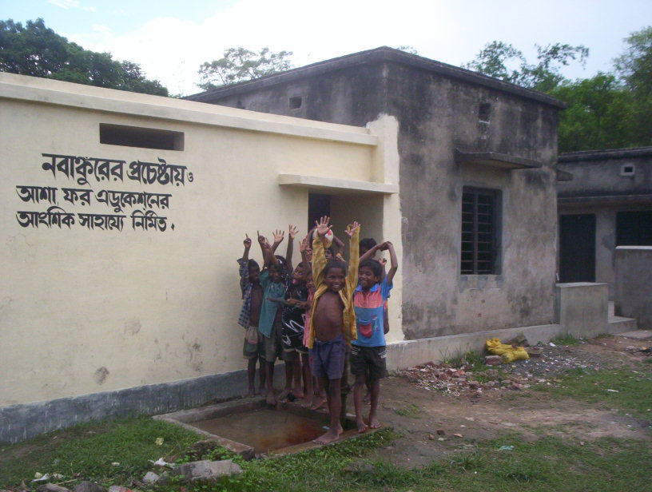
No. 2 > Pre Stage Post Stage

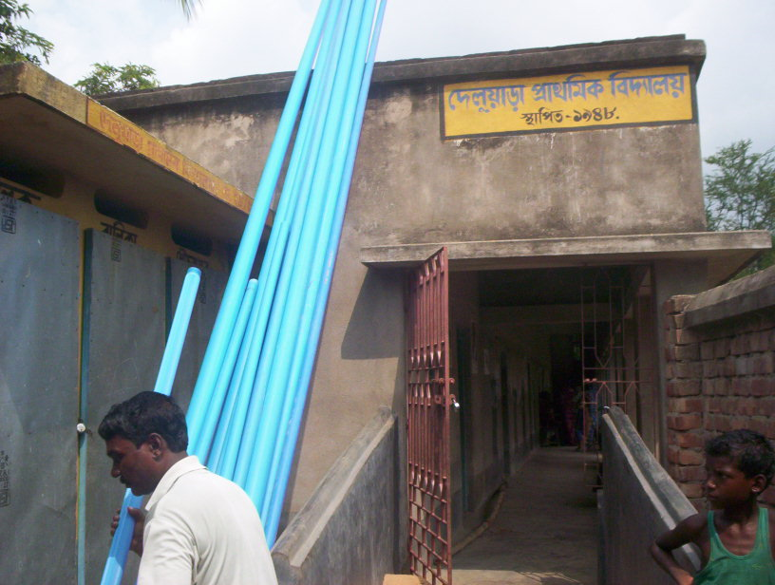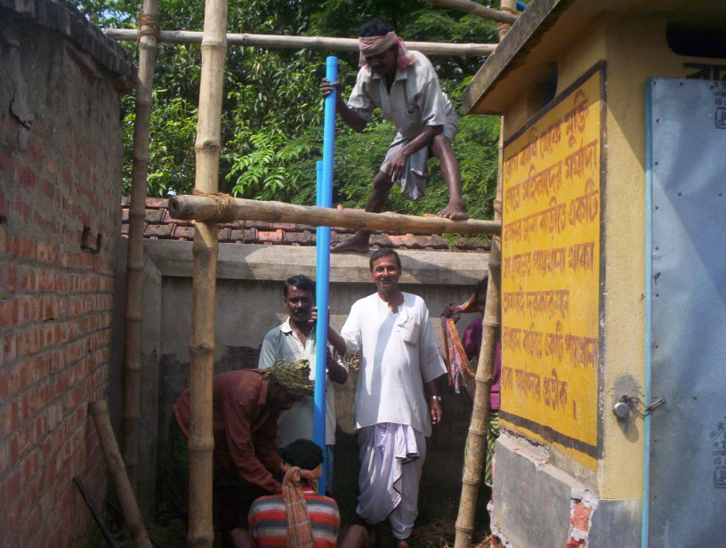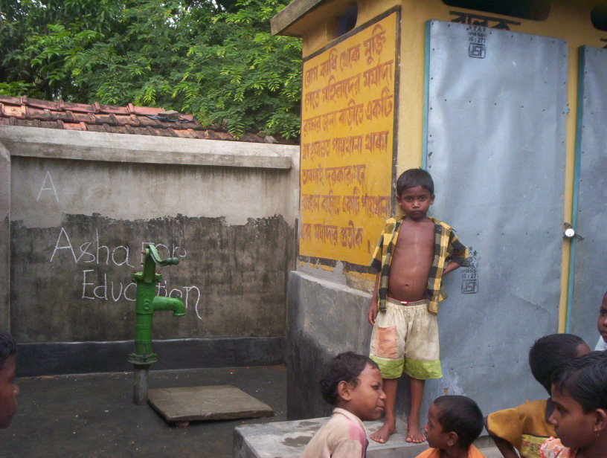
No. 3 > Pre Stage Middle Stage Post Stage
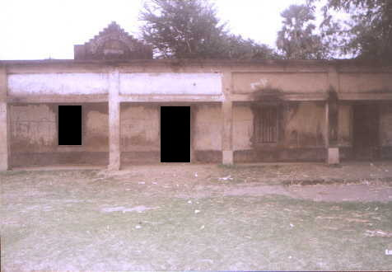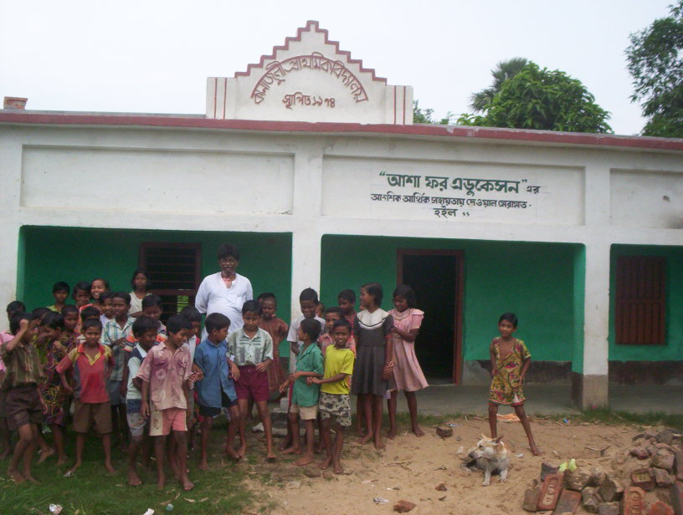
No. 4 > Pre Stage Post Stage
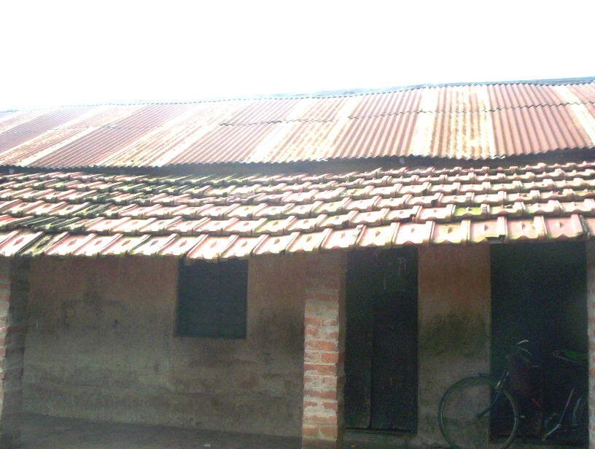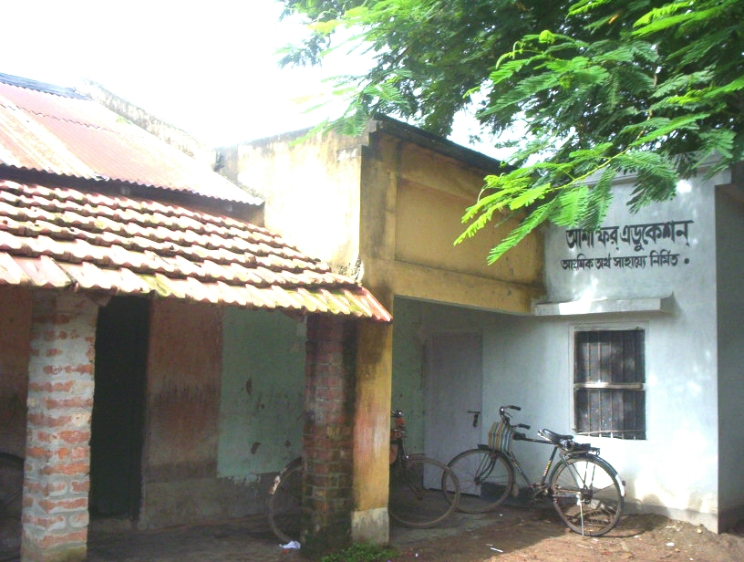
No. 5 > Pre Stage Post Stage
ANNEXURE- A
Receipts & Payments Accounts for the period from 10th FEBRUARY 2006 to 31ST DECEMBER 2006
Title of the project “ GOVT. PRIMARY SCHOOL RENOVATION PROJECT”
Funded by: ASHA FOR EDUCATION, PRINCETON CHAPTER, & Orgd. By : KHAJURDAHA NABANKUR UNITED CLUB (KNUC)
Khajurdaha, Hooghly, West Bengal, Pin – 712149, India.
RECEIPTS |  | Head of Expenditure | Expenses during the period
To Opening Balance :  Grand Received from  Asha For Education, Princeton Chapter, U.S.A.  Own Contribution | 00.00  1,79,343.36  25,800.00 | Cost of Renovation Materials & Labour Charges  Conveyance for supervision  Contingency Expences (Bank Commission & Audit Fees)  Unspent Balance as on 31/ 12/ 2006 | 1,38,460.00  2,500.00  1,290.00  62,893.36
GRAND TOTAL : | 2,05,143.36 | GRAND TOTAL : | 2,05,143.36
FUND POSITION :-
Opening Balance | Receipts |  | Total | Utilization | Balance
Opening Balance | Grant Received | Own Contribution | Total | During the period from 10th February 2006 to 31st December 2006 | Balance
Nil | 1,79,343.36 | 25,800.00 | 2,05,143.36 | 1,42,250.00 | 62,893.36

Satyajit Mondal,
Hony.General Secretary,
Khajurdaha Nabankur United Club.

