Proposal for funding of $5000 for Shoshit Seva Sangh in Sept 2014
INR 308050 to be sent in September/October 2014 will be used towards construction of basket-ball courts and badminton courts in the courtyard of the school. Prof. Chandralekha Singh has made the donation towards this already.

Below are the details of the school's construction project:

(i) As already intimated to Asha For Education it’s a turn-key project under a contract signed between Shoshit Seva Sangh and M/s Pragmatech Towers Pvt. Ltd., reputed builders based at Delhi. The rates are as per the Delhi Schedule of Rates 2012 released by Central Public Works Department (CPWD), Govt. of India. The building has a foundation for four stories whereas the superstructure will be of two floors measuring 54220 sqft. The turn-key project Agreement is attached at Annexure –‘A’.

ii) Layout plan attached at Annexure – ‘B’.

iii) The land and the building is in the name of Shoshit Seva Sangh.

iv) 65-70% of the building has been constructed and so far Shoshit Seva Sangh has spent Rs. 8,19,66,652/- (Rupees Eight Crores Nineteen Lacs Sixty Six Thousand Six Hundred and Fifty Two) towards the construction of the building. The construction began in January 2013 and the money has been spent on various items as indicated in the chart annexed at Annexure –‘C’.

v) The main sources of funding so far are the following –

(i) Thermax Ltd.
(ii) Ms. Anu Aga, Member of Parliament & Chairperson of Thermax Ltd.
(iii) Mr. Amit Chandra, MD, Bain Capital Advisors
(iv) Indian Oil Corporation (Govt. of India undertaking)
(v) Oil and Natural Gas Corporation of India (ONGC) (Govt. of India undertaking)
(vi) Industrial Development Bank of India (IDBI) (Govt. of India undertaking)
(v) R Jhunjhuwala Foundation
(vi) Housing Development Finance Corporation (HDFC)
(vii) Life Insurance Corporation of India (LIC) (Govt. of India undertaking)
(Viii)Individual donations

Annexure A
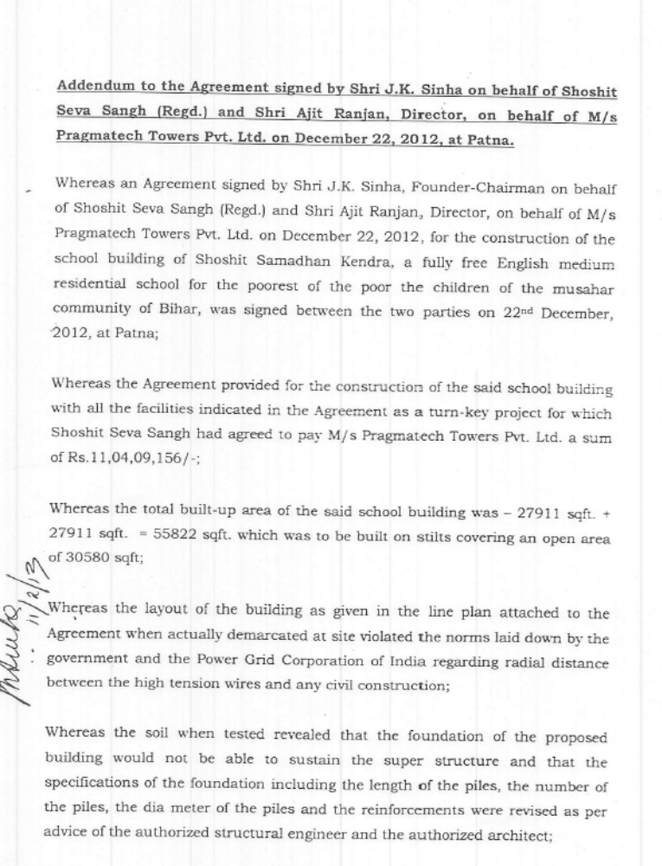

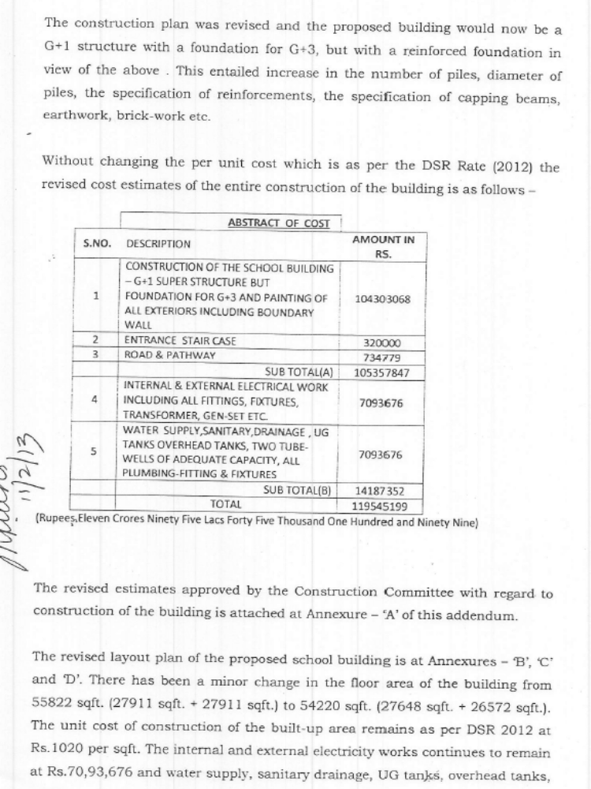

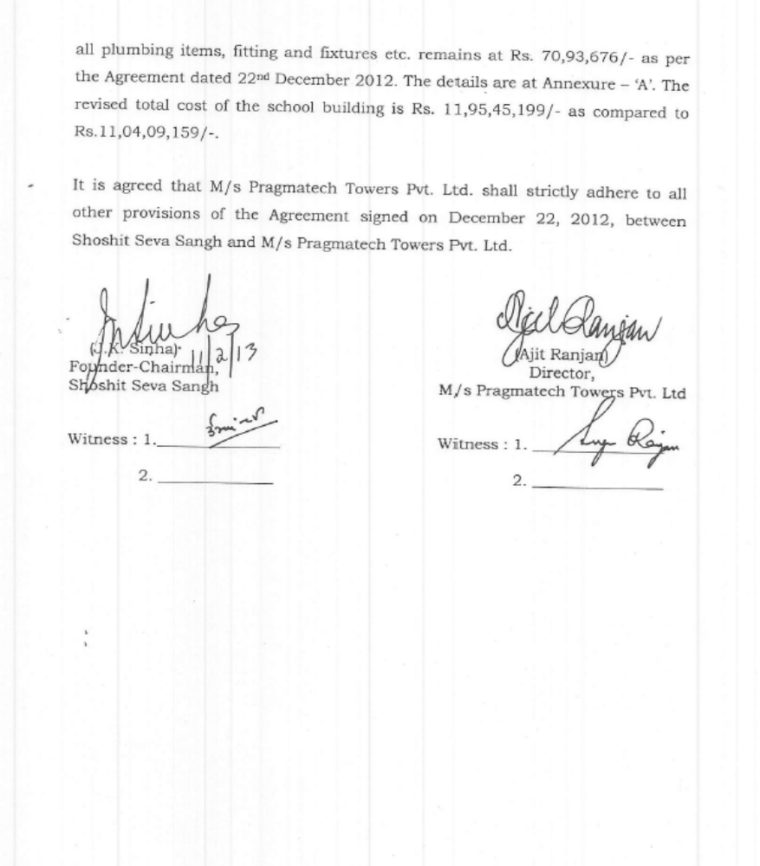
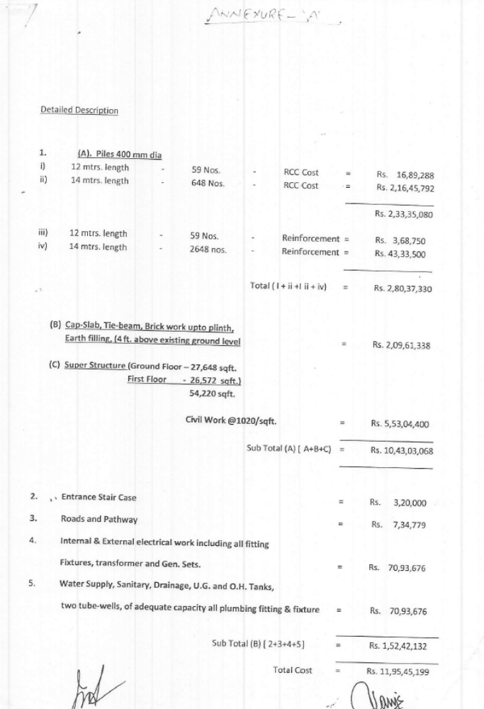
Annexure B
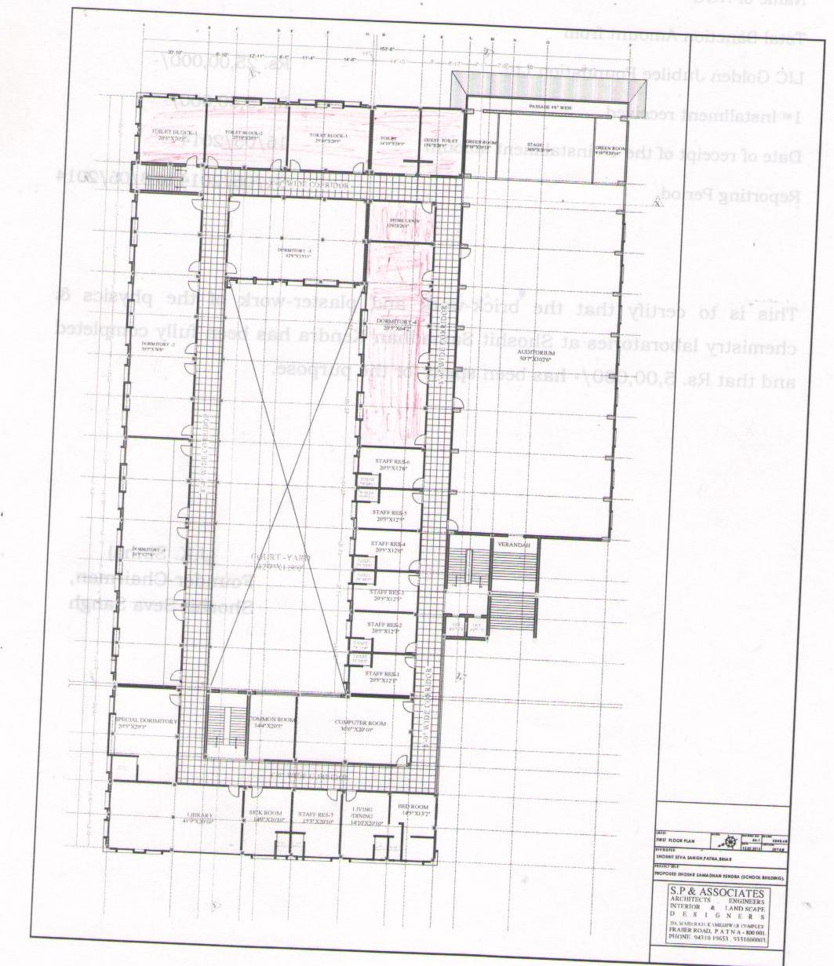

- Foundation for G+3
Annexure C:
Calendar of physical milestones and financial estimated requirement for the construction of the building of Shoshit Samadhan Kendra, a fully free English medium residential school for the poorest of the poor, the children of the musahar community of Bihar.

SL.No. | Item of work |  | Financial  Estimates | Remarks | Cash Position / Cash Flow
1 | 400 mm dia piles – 12 mtrs. length = 59 nos. |  | 16,89,288 | Completed | Paid
2 | 400 mm dia piles – 14 mtrs. length = 648 nos. |  | 2,16,45,792 | Completed | Paid
3 | Steel in 59 nos. |  | 3,68,750 | Completed | Paid
4 | Steel in 648 nos. |  | 43,33,500 | Completed | Paid
SUB TOTAL (A) |  |  | 2,80,37,330
5 | Cap slab, tie-beams upto plinth level |  | 1,58,61,338 | Completed | Paid
6 | Brick work + earth / sand filling upto plinth level |  | 40,00,000 | Completed | Paid
7 | PCC for flooring |  | 11,00,000 | Completed | Paid
SUB TOTAL (B) |  |  | 2,09,61,338
B. Super Structure (Ground Floor Area – 27,648 sqft.)
8 | R.C.C. Columns (158 nos.) |  | 45,00,000 | Completed | Paid
9 (i) | RCC beams & roof slab |  | 1,16,00,000 | Completed | Paid
9 (ii) | RCC PT (Post Tensioned) roof slab (5500 sqft.) |  | 37,06,843 | Completed | Paid
10 | Brick work, plaster (inside) |  | 25,00,000 | Completed | Paid
11 | Flooring & skirting with Kota stone |  | 23,94,117 | Completed | Paid
12 | P/F doors and windows |  | 10,00,000 | Under con
13 | Inner & Outer painting, finishing complete in all respect. |  | 25,00,000 | Not done
SUB TOTAL (C) |  |  | 2,82,00,960
- Allied works
14 | Entrance stair case |  | 3,20,000 | Under progress
15 | Road and Pathways |  | 7,34,779 | Not done
16 | Electrical |  | 50,00,000 | Under progress (30%)
17 | Sanitary |  | 35,00,000 | Not done
SUB TOTAL (D) |  |  | 95,54,779
D. First Floor
18 | RCC Coloumns (158 nos.) |  | 30,00,000 | Under progress (20%)
19 (i) | RCC beam & slab (21,072 sqft.) |  | 88,03,440 | Under progress (20%)
19 (ii) | RCC P.T. slab (5500 sqft.) |  | 32,00,000 | Completed | Paid
20 | Brick work, plaster (inside) |  | 60,00,000 | Under progress (20%)
21 | Flooring with Kota Stone |  | 11,00,000 | Not done
22 | Fitting of doors and windows |  | 25,00,000 | Not done
23 | Outer plaster and painting |  | 25,00,000 | Not done
SUB TOTAL (E) |  |  | 2,71,03,440
E. Allied works
24 | Electrical |  | 20,93,676 | Not done
25 | Sanitary |  | 35,93,677 | Not done
SUB TOTAL (F) |  |  | 56,57,353
Total (A+B+C+D+E+F) |  |  | 11,95,45,200

