---Prayas---
Amarpura Residential School for Tribal Girls
Post graduates reflections and future aspirations
Sally Jaquet, Rebecca Sines & Priya Meena July 2013

Document detailing the personal accounts and experiences of the students who attended Amarpura School for tribal Girls. Now graduates within grades 6 -8 at Nahagarh Kasturaba School, they give details on the benefits of education, future career prospects and their personal achievements.

Amarpura
Chittorgarh Road
Bhadesar
chittorgarh
Rajasthan, india

Contents

Foreword……………………………………………………………………..………………………………………3
Amarpura School background………………………………………………………………………………4
Acknowledgements………………………………………………………………………………………………5
Research and Volunteering……………………………………………………………..……………………6
Caste…………………………………………………………………………………………………………………….7
Graduate Names of Amarpura School…………………………………………………………………..8
Students Interviews…………………………………………………………………………………………9-31
Amarpura School’s future plans…….………………………………………………………………..…32

Foreword

Education is one of the most critical factors responsible for the development of a human being. Right to education, therefore, is held as a very important human right.

Amarpura School for girls is a shining example of the achievements young underprivileged students can accomplish with the support, motivation and commitment to every child’s education.
This book is to celebrate and recognise the great obstacles overcome by the children themselves who have attended Amarpura School and now have a brighter future ahead of them.
The value of education is greatly appreciated by all members involved in the Amarpura School project with children placed at the centre. Their learning, personal growth and futures are built through the great teaching offered within a secure and friendly environment to live, play and study.
Within the book you will find the personal accounts and interviews of 23 girls who are now graduates of Amarpura School who would like to share their views and experiences. They now all attend Kasturba Gandhi Balika Vidyalaya School for Girls within classes 6, 7 and 8.
We hope that you enjoy the stories of each individual student and appreciate the work of Amarpura School and its involvement in shaping these girls futures.

Amarpura School Background

Amarpura School is situated near the town of Bhadesar within the district of Chittorgarh, Rajasthan. Since 2008 the school has operated through the charity Prayas along with funding from ASHA. It aims to provide access to education for tribal communities.
Prayas is a non-profit organisation which intend to promote and support educational and developmental efforts within rural India.
Amarpura School for girls aims to educate students to Grade 5 equivalent in order to enroll students into Kasturba Gandhi Balika Vidyalaya for Girls. KGBV is a part of central government scheme under which residential higher secondary level schools are operated across the country.
Sumanji and Kimraji
Kimraji is an influential and important member of Prayas. He has been actively involved in many aspects of the charity for many years. His passion and enthusiasm for Amapura school for tribal girls is shared and enjoyed equally by his wife Sumaji. Together they hold the foundations of the school and manage all elements in which facility the girls education and personal needs.

Acknowledgements reaserch and voluntering

~ A student is a direct reflection of their teacher ~

It is clear to see that the achievements and future opportunities for the graduates of Amarpura are strongly linked to the guidance and teaching they received whilst studying.
For which it is Kusum and Priyanka who have provided many details of the framework to the children’s experiences. Their teaching styles are interactive and imaginative with the ability to uplift and empower the children though learning. They also act unconditionally as big sisters with a caring and playful nature.
The student’s interviews give further details on just how vital to the student’s wellbeing they are and how cherished they are by the girls.

~ Making school feel like home ~

Raju and Meera Meena are Amarpura School’s cooks and caretakers. Raju and Meera, along with their daughter Danou, are always present within the school and can be seen laughing and joking with the girls as well as consoling and reassuring them when they are upset.

reaserch and voluntering

~ Shining a light on an incredible project, teachers and students ~

From an outsider’s perspective, it was incredible to see the contrast and development from the timid and scared new arrivals to Amarpura School to the independent, confident and intelligent graduates in Nahagarh School. The girl’s were very happy and enthusiastic to speak to us about their experiences and it shone through their conversations just how privileged they felt to have gone to Amarpura School.
We would like to highlight just how important the staff at Amarpura school were to the girls. Every one of them mentioned Priya and Kusom- proving these women to be inspirational to their students. Kimraji and Sumanji were parental figures to the children when they were far from home and Raju and Meera were a constant source of comfort when they needed it.
Although there is only so much we can do for this school as outsiders and working here for only 3 months, we hope to show how incredible this school really is and the opportunities it has given so many young girls who would have otherwise had none. It was a privilege to work on this project and we wish all the girls, current and graduated, the best successes in later life.

Caste

India’s caste system is incredibly complex and intricate in regards to rules and regulations of which certain people must abide by depending upon the family in which they were born to. The term caste is used to specify a group of people in relation to social hierarchy. . Its history is multifaceted and still today the values of the caste system are held strongly.
An individual’s caste can have a severe and negative impact on their opportunities in life such as education, career and marriage.
Prayas carry out a lot of work with the Bheel Caste- a lower tribal caste who are largely discriminated against. In Rajasthan there are 1,900 Bheel families. There is a 3% education rate in women of the Bheel caste and 11% in men. Disease and inadequate housing occurs more frequently. There is also a high ratio of child marriage and therefore an increase in underage mothers. This negatively affects the health of the younger Bheel generation as the women haven’t developed enough to bear children.
Amarpura school facilitates the learning of a variety of castes, as a result girls from different castes have the opportunity to learn and play together, breaking down barriers, whilst giving the lower castes opportunity in education that they wouldn’t otherwise have.

Graduates Names of Amarpura School

- Meera Bheel
- Bhuri Bheel
- Ratani Bheel
- Manju Meena
- Geeta Meena
- Champa Meghawal
- Guddi Bavri
- Ratni Bheel
- Prem Bheel
- Anguri Meghawal
- Aarti Meghawal
- Meera Meena
- Jamana Meena
- Sharita Meghawal
- Khrishna Bheel
- Shangita Meghawal
- Lalita Bheel
- Jinani Meena
- Shita Meena
- Sharda Bhavri
- Shushila Meena
- Thavari Meena
- Ganga Bheel
- Dhali Khatik
- Ghaddi Meena
- Shagar Kumari
- Raju Meena
- Ravina Berava
- Shapana Berava
- Aarti Chavariya
- Rekha Meena
- Tulashi Meena
- Shima Bheel
- Vardi Bheel
- Shantosh Bheel
- Rekha Meena
- Krapa Meena
- Shokali Meena
- Shita Meena
- Rukamnee Meena
- Manisha Soni
- Shantosh Jogi
- Dhani Bheel
- Devali Bheel
- Nermala Jogi
- Pooja Khatik
- Parsh Bhavri
- Maya Meghwal
- Jyoti Meena
- Lali Meena
- Shona Jath
- Chanda Rawat
- Lalita Rawat
- Devakanya Bheel

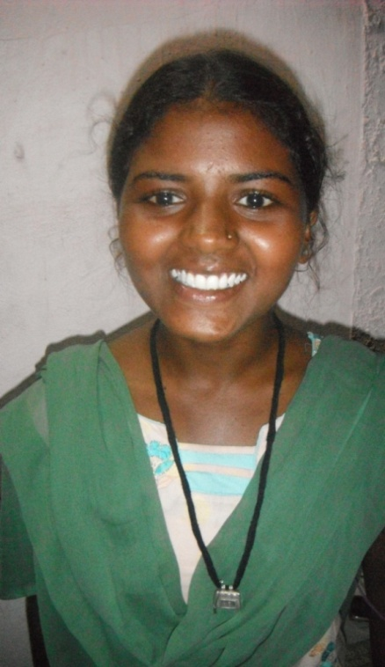
Meera Bheel
(Meera is currently studying in Jaipur in Bodh Shik School)
Age: 14
Class: 8
Home Village: Magarada Village
Favorite subject: English
Family background: 2 sisters and 1 brother. Parents are farmers.

Why is education important?
Education is very important for making a good life and living. It is free and can help your village and family.
How did Amarpura School benefit you?
I spent two years in Amarpura School. The teachers were good and all of the staff are good natured. Amarpura School gave me allot of opportunities, without it I would have no future.
Describe your achievements?
- First prize in a general knowledge competition
- First rank in 8th class (Awarded a laptop)
- Good tailoring certificate

What career and aspirations would you like to achieve?
I would love to become a Doctor so I will study Biology in 11th class. I would also like to travel to America.
Advice to younger pupils
Take the advantages of education. The food and people are good at Amapura School.

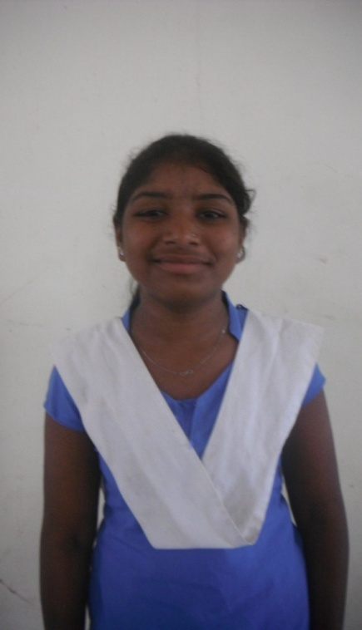
Jamana Meena

Age: 13
Class: 8
Home Village: Pratapgarh
Favorite subject: Science
Family background: 2 brothers and 3 sisters. Parents work on a farm.

Why is education important?
It improves my family background and job prospects if I have an education
How did Amarpura School benefit you?
Amarpura School was very good because the teachers are very good. It gives a better education then other schools
What career and aspirations would you like to achieve?
I would like to be a doctor as I like to help other people

Advice to younger pupils
Don’t worry about feeling sad when you miss your family just work hard.

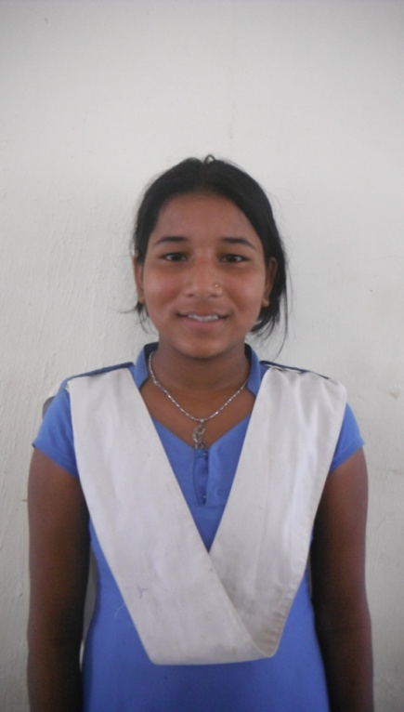
Raju Meena

Age: 13
Class: 8
Home Village: Pratapgarh
Favorite subject: English
Family background: 2 brothers and 1 sister. Parents are farmers.

Why is education important?
Education is important because my mother and father are poor so I can get money to help them.
How did Amapura School benefit you?
The teaching in Amarpura School is better than other schools. I learnt to write in Pratapgarh But it was not as good.
Describe your achievements?
- I won a first prize in a game in a tournament

What career and aspirations would you like to achieve?
I would like to be a Doctor as I like to cure people, maybe in a hospital

Advice to younger pupils
Learn in school and your parents will be proud.

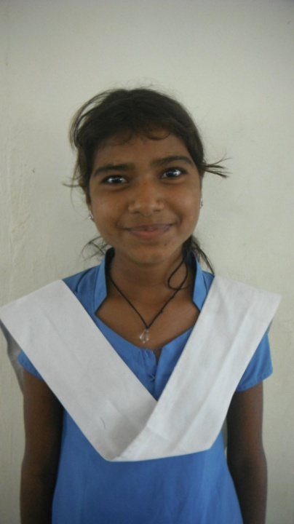
Shushila Meena

Age: 12
Class: 8
Home Village: Pratapgarh
Favorite subject: Science
Family background: 2 brothers and parents work on a farm.

Why is education important?
If you want achieve your dreams you must be educated. It’s the only way to stop caste problems and child marriage.
How did Amarpura School benefit you?
The school had good teachers, good food and good rules.
Describe your achievements?
- I got a medal in a dance competition

What career and aspirations would you like to achieve?
I want to be a Doctor. I would also like to help other poor girls with their education.

Advice to younger pupils
If you don’t learn what would you do? You would just work on a farm, get married and there will be problems. You can do more if you’re educated.

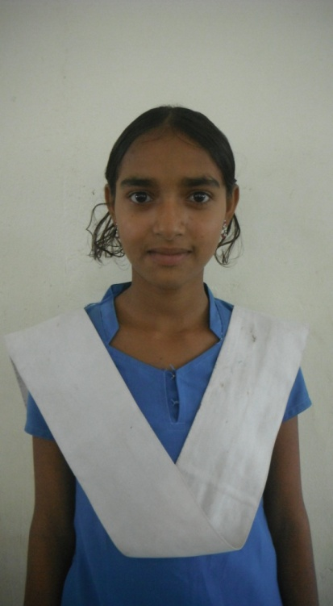
Meera Meena

Age: 13
Class: 8
Home Village: Pratapgarh
Favorite subject: Hindi
Family background: 5 sisters and 1 brother. Parents work on a farm.

Why is education important?
Education is good for a job.
How did Amarpura School benefit you?
Amarpura School had good teaching and good teachers.
Describe your achievements?
- I won first prize at coco games

What career and aspirations would you like to achieve?
I would like to become a Teacher and tell others about the importance of Education.

Advice to younger pupils
Learn well. Your parent’s name will become famous and everyone will be proud.

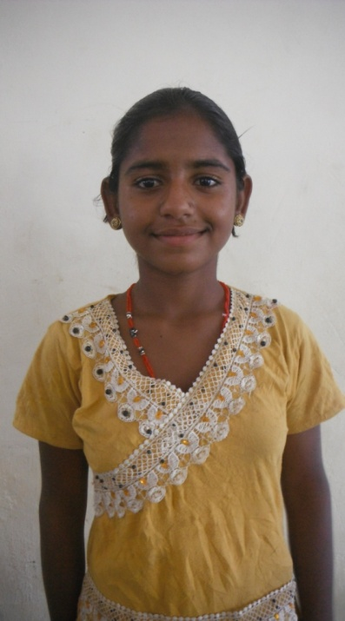
Shanthosh Jhogi

Age: 12
Class: 6
Home Village: Khodip
Favorite subject: Hindi
Family background: 3 sisters, 2 brothers. Parents work on a farm

Why is education important?
To achieve your dreams you need to be educated.
How did Amarpura School benefit you?
Amarpura School gave me a good education.
Describe your achievements?
- I won a dance medal

What career and aspirations would you like to achieve?
I want to become a teacher and one day travel to Jodhpur.

Advice to younger pupils
Look at your friends and where they are

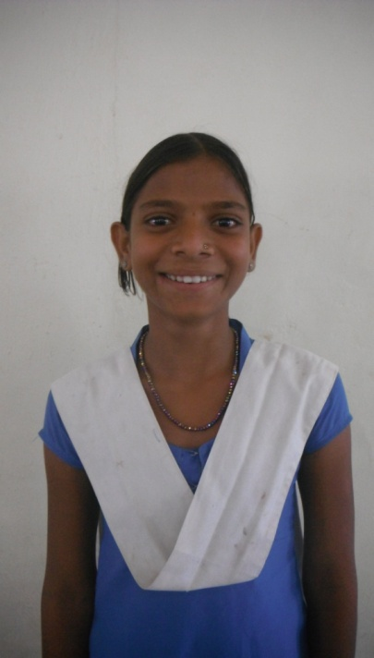
Thawari Meena

Age: 12
Class: 8
Home Village: Pratapgarh
Favorite subject: Hindi
Family background: 3 sisters, 1 brother. Parents work on a farm

Why is education important?
Education is important to get a good job.
How did Amarpura School benefit you?
Amarpura School had good teachers and good food.
Describe your achievements?
- I won a trophy for playing the Khabodi

What career and aspirations would you like to achieve?
I want to become a Policewoman and one travel to Jodhpur.

Advice to younger pupils
Make your family and friends proud.

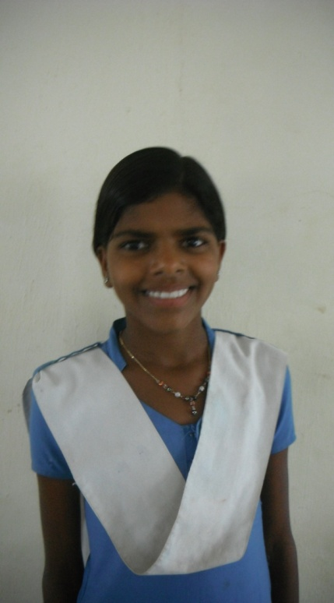
Ghudi Meena

Age: 12
Class: 8
Home Village: Pratapgarh
Favorite subject: Maths
Family background: 1 sister, 1 brother. Parents work on a farm

Why is education important?
Education is important for you to get a job
How did Amarpura School benefit you?
Amarpura School gave me a good education.
Describe your achievements?
- I won prize for singing

What career and aspirations would you like to achieve?
I want to become a Policewoman and tell non-educated girls about the importance of education.

Advice to younger pupils
Come to school!

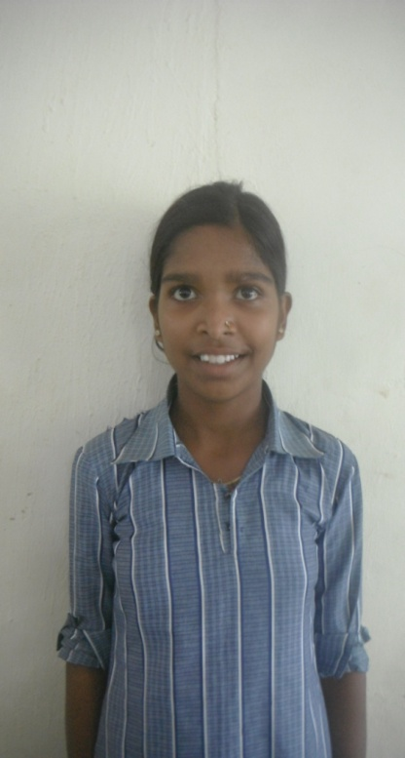

Jeevnee Meena

Age: 12
Class: 8
Home Village: Pratapgarh
Favorite subject: Science
Family background: 1 brother. Parents work on a farm

Why is education important?
If we open more schools that poor girls can come to, everyone can have an education
How did Amarpura School benefit you?
Everyone who was there was good natured and was very helpful towards my further progress.
Describe your achievements?
- I won a prize for singing

What career and aspirations would you like to achieve?
I would like to be a Scientist and would also like to campaign to stop child marriage.

Advice to younger pupils
I would talk to the father and mother and tell them to send their children to school

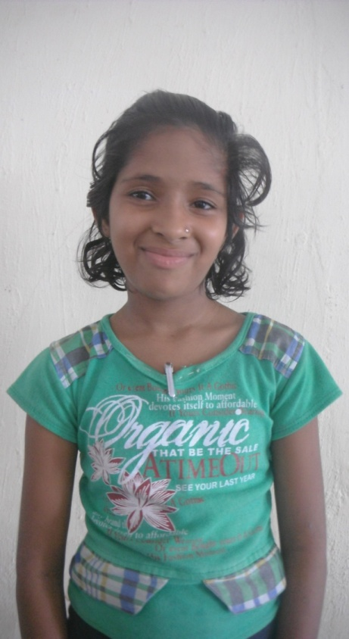

Manisha Soni

Age: 10
Class: 7
Home Village: Chittorgarh
Favorite subject: Maths
Family background: 2 brothers. Mother is a tailor and Father works in a factory

Why is education important?
It can improve job prospects
How did Amarpura School benefit you?
It was a fun school
Describe your achievements?
- I received a gift for dancing

What career and aspirations would you like to achieve?
I want to be an Engineer and one day hope to go to England.

Advice to younger pupils
School is fun

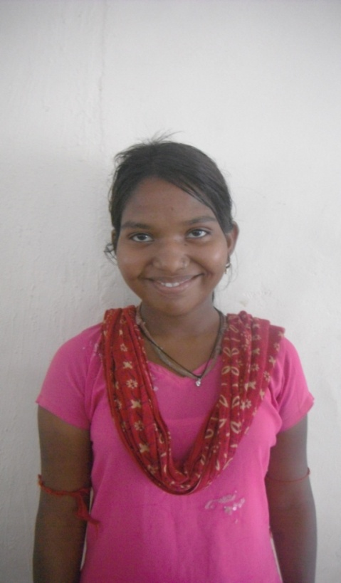
Sharda Bavri

Age: 15
Class: 8
Home Village: Pipilwas
Favorite subject: Hindi
Family background: 1 brother, 2 sisters. Parents work on a farm.

Why is education important?
Life’s problems can go away if you have an education.
How did Amarpura School benefit you?
Not only was the teaching good but the extra-curricular activities were fun too.
Describe your achievements?
- I won a prize for singing

What career and aspirations would you like to achieve?
I would like to be a Teacher and go to Agra to see the Taj Mahal.

Advice to younger pupils
To get a good career, you need to learn specific subjects in school.

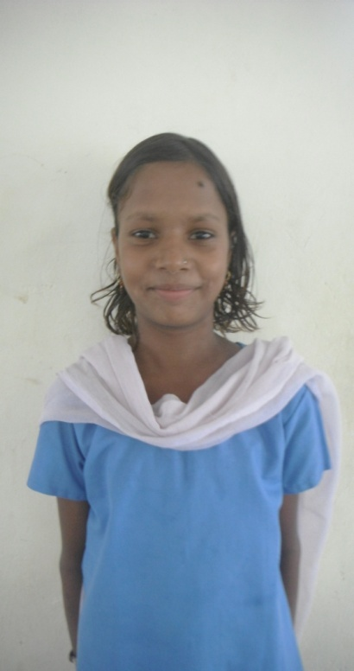
Dhanni Bheel

Age: 11
Class: 6
Home Village: Bhelon Ka Kera
Favorite subject: English
Family background: 2 sisters and 2 brothers. Parents work on a farm

Why is education important?
Education can help get rid of societies problems.
How did Amarpura School benefit you?
Good teachers and education.
Describe your achievements?
- I have won a dance prize

What career and aspirations would you like to achieve?
I want to be a teacher and travel to Jodhpur.

Advice to younger pupils
School teaches me new things.

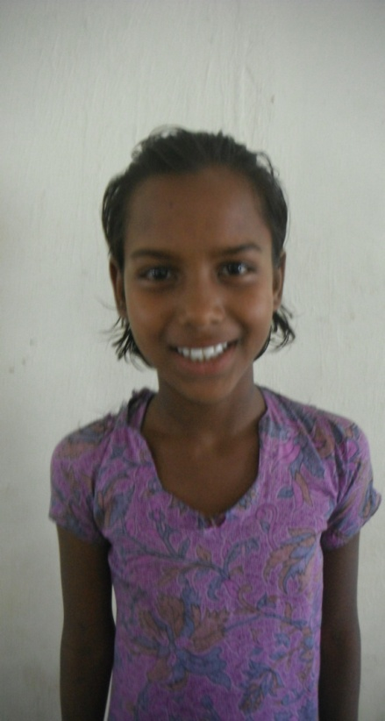
Neemala Karbiliya

Age: 11
Class: 6
Home Village: Kapasam
Favorite subject: English
Family background: 2 brothers. Parents sell bedsheets

Why is education important?
Education is important to gain self-confidence and get a job.
How did Amarpura School benefit you?
Teachers gave good advice.
Describe your achievements?
- I am good at dancing

What career and aspirations would you like to achieve?
I would like to be a Teacher and go to Jaisalmer and ride camels.

Advice to younger pupils
This is a good school, the teachers are nice. You don’t have to go home.

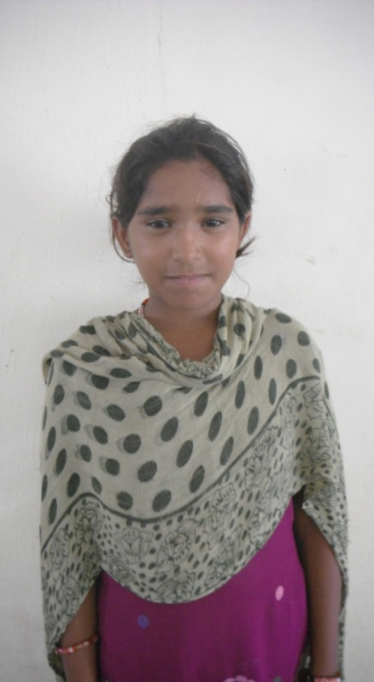
Bharas Bhavri

Age: 12
Class: 6
Home Village: Koshital
Favorite subject: Hindi
Family background: 3 sisters, 1 brother. Parents are farmers

Why is education important?
My father did not have an education but my sister did. She talked to him and said it was good. Now I have more opportunities.
How did Amarpura School benefit you?
The teachers were good.
Describe your achievements?
- I have a dance award

What career and aspirations would you like to achieve?
I would like to be a Teacher and go to Jaisalmer to see the sandunes.

Advice to younger pupils
If you have problems you can talk to your teacher and she will help you.

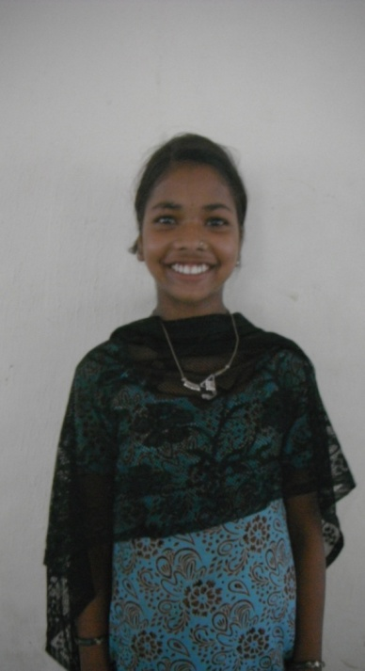
Vhardi Bheel

Age: 12
Class: 7
Home Village: Bhelon Ka Khera
Favorite subject: Social Science
Family background: 2 brothers, 2 sisters. Parents work on a farm.

Why is education important?
Education is important to put everyone at the same level, regardless of caste.
How did Amarpura School benefit you?
All the pupils were nice.
Describe your achievements?
- Painting prize
- Poetry prize

What career and aspirations would you like to achieve?
I want to become an Engineer and go to Delhi to see the Red Fort.

Advice to younger pupils
You can achieve your dreams though education. You can go further to get a good job by going to college or university.

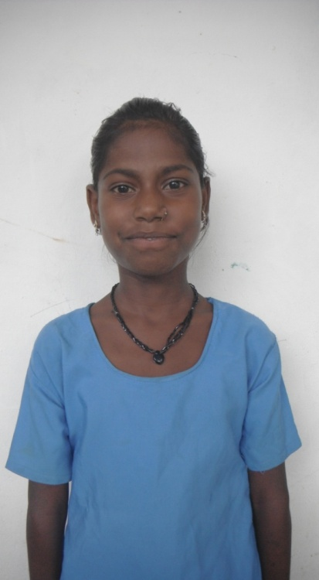
Devli Bheel

Age: 11
Class: 6
Home Village: Kuretha
Favorite subject: English
Family background: 3 sisters. Parents work on a farm

Why is education important?
There are problems in society that education can stop
How did Amarpura School benefit you?
The teachers and schoolgirls went on a picnic to Udaipur where we got to see different things.
Describe your achievements?
- I have a dance award

What career and aspirations would you like to achieve?
I would like to be a Teacher and one day see the Taj Mahal.

Advice to younger pupils
Amarpura School is a good school with good access to education. You can make your family proud.

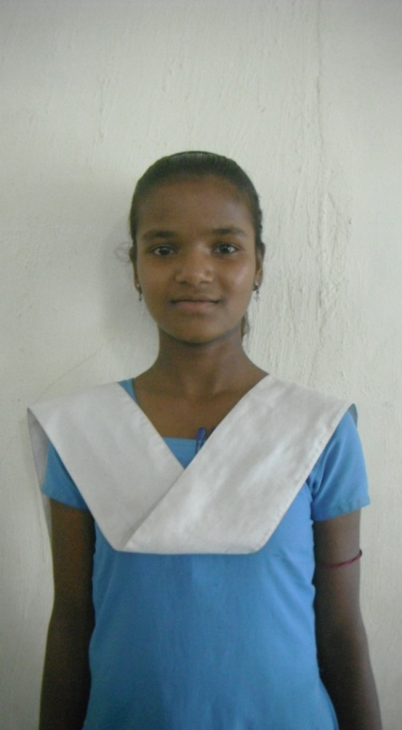
Seema Bheel

Age: 12
Class: 7
Home village: Bhelon Ka Khera
Favorite subject: English
Family background: 3 sisters. Parents are farmers

Why is education important?
Education is important to achieve your dreams
How did Amarpura School benefit you?
Kimraji and Sumanji are a father and mother figure to us. I enjoyed going on holiday.
Describe your achievements?
- Longjumping
- Dancing
- Singing

What career and aspirations would you like to achieve?
I want to be a Policewoman. I want to one day go to America on an airplane and see the ocean.

Advice to younger pupils
Respect your teachers. If you don’t understand your lessons, try hard and ask questions.

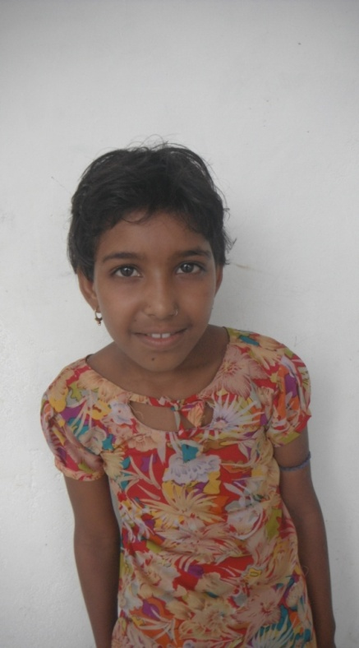
Maya Meghawal

Age: 13
Class: 6
Home Village: Karediya
Favorite subject: Hindi
Family background: 1 brother, 1 sister. Parents are farmers

Why is education important?
You can help your family if you have an education.
How did Amarpura School benefit you?
I gained a good education in Amarpura School. We also had the opportunity for holiday.
Describe your achievements?
- I learnt to paint

What career and aspirations would you like to achieve?
I want to be a teacher and go to Jaisalmar and see the sand.

Advice to younger pupils
Learn well.

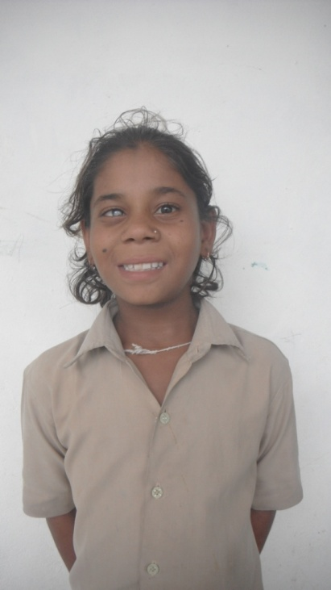
Pooja Khatik

Age: 10
Class: 6
Home Village: Narabdeeya
Favorite subject: English
Family background: 3 sisters. Parents are farmers

Why is education important?
Education is important so that you can help your family.
How did Amarpura School benefit you?
Amarpura School had good teachers.
Describe your achievements?
- I am good at drawing

What career and aspirations would you like to achieve?
I want to be a doctor and go to England to see the cliffs.

Advice to younger pupils
The teachers are very good and you can learn from them. Finish your work on time.

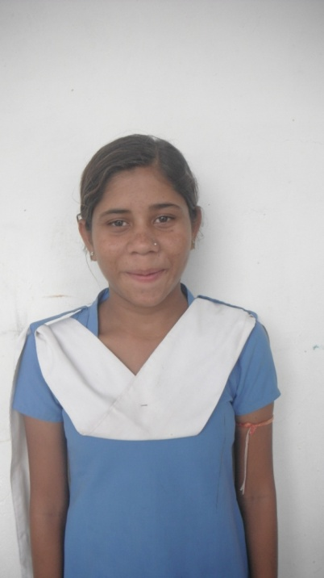
Dhali Khatik

Age: 13
Class: 8
Home Village: Narabdeeya
Favorite subject: Maths
Family background: 3 sisters. Parents are farmers

Why is education important?
Because I am educated I have more opportunities in my life than my sister who is married.
How did Amarpura School benefit you?
I gained a good education from Amarpura School.
Describe your achievements?
- I can solve maths questions the fastest in my class

What career and aspirations would you like to achieve?
I want to be a teacher and see the Agra forest.

Advice to younger pupils
You can make lots of friends at school.

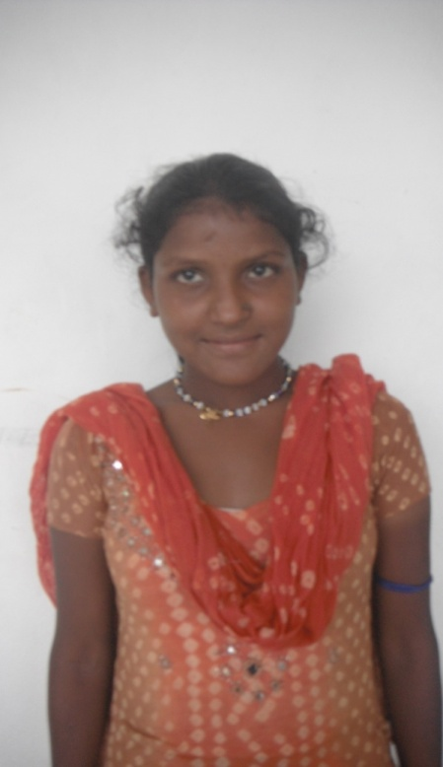
Khrishna Bheel

Age: 13
Class: 8
Home Village: Ganpat Kheda
Favorite subject: Social Science
Family background: 1 brother, 3 sisters. Parents are farmers

Why is education important?
If girls are educated you get a higher dowry.
How did Amarpura School benefit you?
Priya and Gusom were very kind. The food was tasty and Raju the cook is very nice.
Describe your achievements?
- Painting
- Poetry

What career and aspirations would you like to achieve?
I want to be a Policewoman. I also want to go to Mount Abu and see the sunset there.

Advice to younger pupils
Respect your teachers.

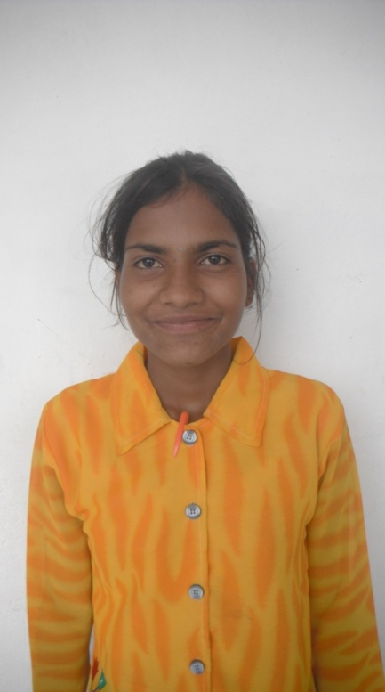
Ganga Bheel

Age: 14
Class: 8
Home Village: Nara Badiya
Favorite subject: Social Science and Hindi
Family background: 3 sisters, 1 brother. Parents are farmers

Why is education important?
If I am educated I can help work in charities which combat domestic abuse.
How did Amarpura School benefit you?
Teachers have good ideas and thoughts- they solve problems.
Describe your achievements?
- I have a dancing and a singing award

What career and aspirations would you like to achieve?
I want to be a Policewoman. I want to see the Taj Mahal as well one day.

Advice to younger pupils
Society’s problems can change if you are educated.

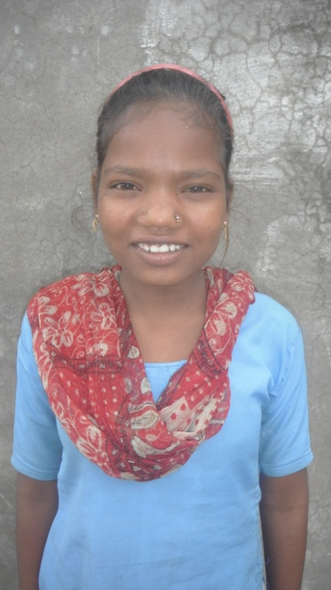

Devkanya Bheel

Age: 13
Class: 6
Home Village: Pirkheda
Favorite subject: Maths
Family background: 1 brother and 1 sister. Father is a farmers

Why is education important?
Education is a good thing.
How did Amarpura School benefit you?
Amarpura School has good teaching.
Describe your achievements?
- I have won a first prize trophy in running.

What career and aspirations would you like to achieve?
I want to be a teacher and go to University in Delhi.

Advice to younger pupils
Respect your teachers. If you don’t understand your lessons, try hard and ask questions.

Amapura School future plans

ASSHA for Education provide a substantial amount of support and funding to Amarpura School through the NGO Prayas. As funders they aim to implement change in India by focusing on basic education, in the belief that education is a critical requisite for socio-economic change.
All donations and funding contributes to maintaining the school and hostel facility along with providing the girls with adequate food, clothing and learning resources. As the school has great hopes and future plans which will provide many more children with the access to education the need for funding is ever present.
Prayas wants to direct its efforts towards meaningful and sustainable improvements instead of temporary relief. They aim to enable and empower people to improve their lives and conditions.
Prayas are working in conjunction with Amarpura School towards a bright and sustainable future. They have many creative and innovative plans which will continue the progress and success of the school. There have been discussions of potential sponsorship schemes and an opportunity to create a privately funded school which in turn would subsidies the running costs of maintain Amarpura school.
In order for either of theses proposals along with other ideas the contribution from outsiders is crutial to the success of the school. Volunteers, both national and international, play an important role. The involvement of skilled professionals from a variety of backgrounds could also contribute greatly to the projects future accomplishments. Above all funding and awareness of the schools fundamental principles is essential to future progress.

