“Always do right, It will gratify some people and astonish the rest” – Mark Twain
Total Number Working Days of the Learning Center 20 Days
Weekend Holidays (Saturday & Sundays) 07 Days
Parents meeting 01 Day
Children’s Average Attendance of the Learning Center 29 Children
Total Number of Children 33 Children
Long Absentees 01 Children

Vijay Prathapan has not come this full month. During the repeated enquiry with relatives they said that the mother kept him with her in Chennai. If she comes they will inform to meet us.

Chapter Coordinator Guidance

“Man becomes great exactly in the degree in which he works for the welfare of his fellow men” – Mahathma Gandhi

On 1st of February 2011 Mr. Rama Subramanian, Asha for Irvine, Chapter Co-Ordinator visited our Learning Center. He had interaction with staff, he obtain the information and developments of PT Session. The physiotherapist explained about the past status of the children and how the Physiotherapy sessions improvise the children’s mobility. What are development stages, and use of physiotherapy and mobility equipments.

The MR Session is explained the information about the children special education and its improvements. The special educator explained past status of the children, developments attained by the children after the special education, and the equipments used for the special education.

He met and congratulated the children took participate in the state level Disable Day Sports meet in Chennai. He admired the Kalaiselvi’s fine art working (emboss paint). He analyzed the two self help group routine activities.

During his visit the Ranjani’s parents are came to our Learning Center. He had interaction with the parents.

The new children admitted between his last trip and this trips are introduced. As well as the new assistant special educator staff Ms. Malarkodi and Ms. Mary Joshi are introduced to him.
In fine had discussion with Managing Trustee Mr. P. Ravi, during this discussion the consolidated sum up from August 2009 were explained to him. The discussion goes on in various topics are The registration procedures and registered under Government Act and PWD Act, Local Contribution approaches with various concern ie., La Ferme Des Crocodiles, France, Give India – Online Donation Option Registration and Local Sponsors. 3 community awareness program regarding the physically challenge ness issues. Staff & Children outings, self help group formation and its activities. Additional support service details about the beneficiaries.

Networking with other foundations, Mukthi Foundation for Mobility equipments, Banyan Foundation and Vazhndhu Kattuvom Scheme Project.

The final discussion made regarding the co-ordinator position. Mrs. Sujatha will be assign in the position of Special Educator as well as the co-ordinator of the Learning Center.

“Blessed are those who give without remembering. And blessed are those who take without forgetting” – Bernard Meltzer

Scheduled Activities in February
Mrs. Chitra, rejoined on 2nd February, as more children (24 children) are in need of special education session, we appoint her as an assistant special educator, she is having 1½ years experience in our learning center in this session. She dropped her job due to her family problems six months before.

The staff group gathering conducted on 3rd February, the discussion were made about the children’s achievements, parents feed back and forthcoming goal plan are allocate to the concern staff.

The parents meeting conducted on 5th February 2011. 23 parents are took participated in this meeting. The additional extra support service system is followed as last month, because the system makes the parents to attend the parents meeting regularly and also attracted irregular parent’s attention to attend the parents meeting. The discussion carried out that Mr. Rama Subramanian is assured that he will provide the matching grant for 17member X 20 months X 110 Rs = 37,400/- the idea of the chapter coordinator is shared with the parents that the matching grant need to plan to establish a group business. The business needs to organize by the team members and the income from the group business can be shared among the team members. The choice of the business option according to the regional business opportunity can be selected by the team members. Palani’s parents are advised to take the appropriate medical treatment (surgical correction for his hip dislocation) measures. We are insisting the parents again and again to concentrate in the hygienic measures. For the Government document purpose we insist the parents to get the certificates from the previous schools, community certificate for the purpose of Government schemes.

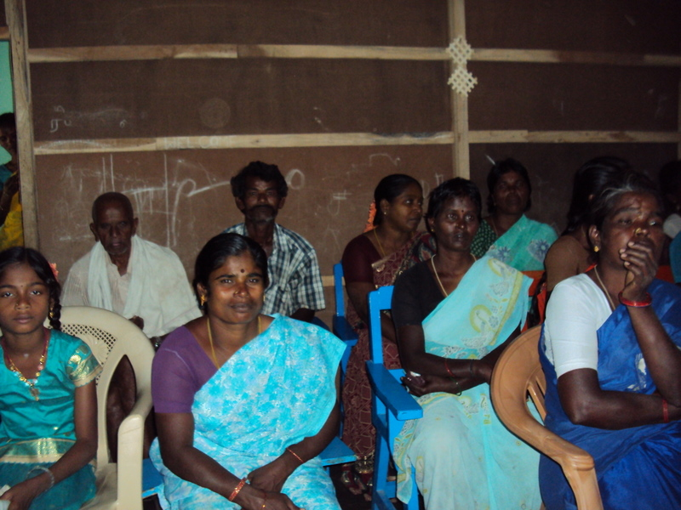
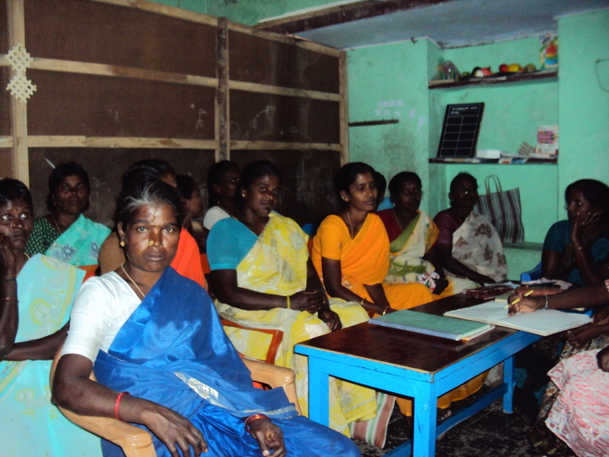
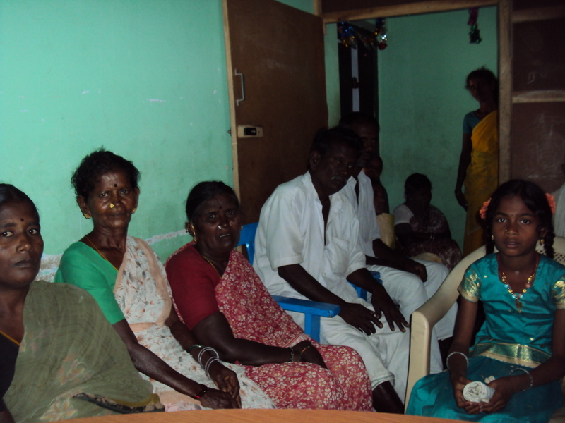
Ms. Shanthi, Care taker taken holidays from 7th to 23rd due to his brother death.

On 11th February Gowtham, Gokul, Manjula and Vinitha attended the assessment campaign in Gingee Taluk Office and then on 12th took to Villupuram DDAW Office, through ADIP Scheme 4 wheel chairs are issued by R.B. Charitable Trust Salem.

John Milton, 15 years, the child is born in CMC Hospital Vellore, diagnosed with CP/MR, the father is working in EB as a foreman, mother is a Elementary School teacher. The Mother underwent open heart surgery in the form of Mitral Valve Replacement in CMCH, Vellore. The boy brought our center for assessment and therapy.

The boy John Milton underwent therapy in various institutions – Baby Hospital, Egmore, KK Nagar Institute, Spastic Society- Tharmani, Anbu Illam – Vellore for the period of 2 years, and underwent therapy under SSA Scheme Chetpet for 2 years. Due to the irregular therapy for the last one year the child’s mobility affected again. At present the parents are bringing the boy by their own transportation from Chetpet to our Learning Center.

Mrs. Mary, school head master in France from La Ferme des Crocodiles, French Organization visited our Learning Center on 23rd February. She is very much interested and keen on the MDPS Assessment System.

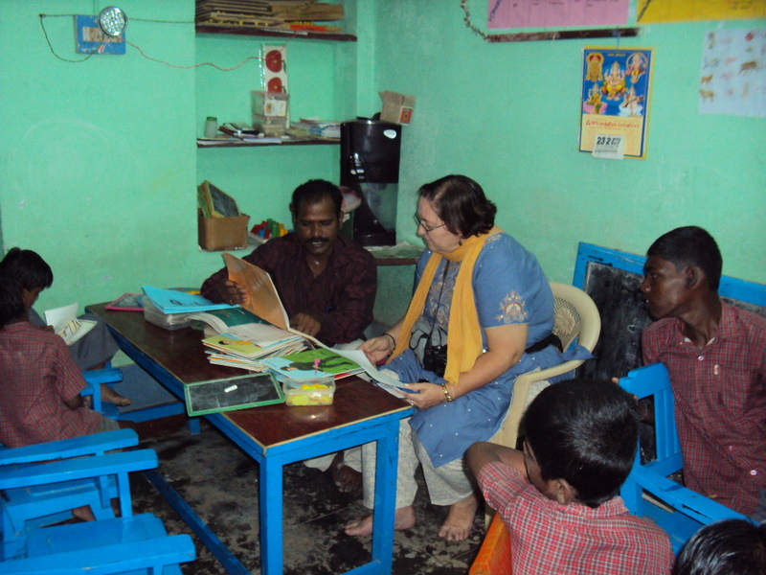

We received the information from DDAW Office, Villupuram that in Alampoondi Village on 25th February the campaign is taking place under the MLA Fund, 12 children -Abishek, Venda, Vinitha, Manjula, Shanthi, Arjun, Vignesh, Ajaiguru, Kanniammal, Gokul, Karthi and Gowtham from our Learning center are attended and the measurement given for the mobility equipments.

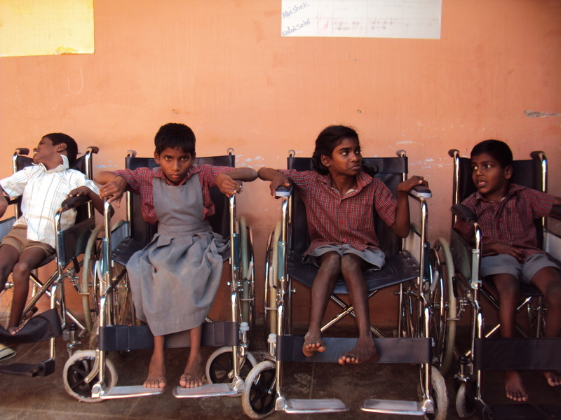

Approach to ABAN Offshore Limited for Vehicle
On 11th February Mr. Balaji and P.N. Joseph from ABAN Offshore Limited visited the 2nd visit. As all the selection team members are not able to visit, they invited us on 15th February 3 O’ Clock to present the proposal in front of the selection team members. We prepared the proposal for the school van, collected various company school van quotations.

We presented the need of a school van, through this how we can extend the service to the more children in need of our service, will cut down the rented vehicle expenses. The selection team members conveyed that they will present our proposal to their board and let us know the result later.

VAZHIKATTI - Government Scheme
The Government of Tamilnadu introduced a new scheme named VAZHIKATTI to serve the Differently Abled & Physically Challenged person living in the villages. Through this scheme a resource person will be selected from each Panchayath (village). The selection priority for resource person will be physically challenged / parents / relatives of physically challenged with the minimum educational qualification of 8th Standard. The resource person will guide the physically challenged / differently abled person in their villages.

We applied to extend our service to Villupuram District, Melmalayanoor Block consist of 55 Village Panchayath under VAZHIKATTI Scheme. If we get sanction under the scheme we can include the parents under this scheme and our service can be extended to more children through the community intervention practices.

Medical Treatment
On 4th February Vignesh, Gunapriya and Manigandan had tiny blisters over the mouth. They are treated in Avalurpet Government Primary Health Center.

Shanthi is not attended our Learning Center from 7th to 11th due to the Mumphs. The parents treated her with traditional treatment.

Balaji has the complaints of bleeding while he passes the stool on 17th February. The child treated with the appropriate doctor. The doctor provided with ointment and medicines, if the problem repeated means he need to undergo the investigation to diagnose the Piles complaints.

Parents / Visitor – Visit
This month 27 persons including parents are visited our Learning Center to know about our Learning Center Activities.

Supplement Support to the Children & Family
The milk support and medicine support are provided to the children. Kalai is provided with the monthly self help group subscription of ` 110/- the monthly remuneration of ` 200/- for her vocational activity Emboss Painting is paid.

Abishek, Poovarasan, Deepak, Manimegalai, Sharmila, Ranjani, Vijay, Ajai Guru, Purushothaman and Kanniammal parents received the supplementary nutrition support Horlicks.

This month Karthi Recurring Deposit Account started. This month ` 1500/- deposited in six children RD Accounts as savings.

Local Contribution
Prakash share his happiness of his wedding day (on 5th) celebrated on 7th February by providing mid day meals and evening milk to the children.

The neighbor house provided with 4 packs of biscuits on 10th February, to the children.

On10th February through Online Donation option Give India Donation Option we received a child sponsorship ` 13,000/- in our bank account.

On 25th VKP Volunteers team members sponsored 20 pack of biscuits and 1 pack of chocolates during their exposure visit to our Learning Center.

5th February Sharmila’s Mother, 17th Vijay’s mother contributed ` 250/- to compensate the vehicle running expenses. On 7th Palani’s parents provided 2 liter Kerosene, 18th Deepak parents provided 10 liter of kerosene for the cooking purpose.

“Optimism is a force Multiplier” – Colin Powell

Reported By
P. Ravi,
Managing Trustee,

