Report on Kosi Flood Relief Operations
Organized by Gyan Sewa Bharti Sansthan
Supaul District, Bihar

Oct 20, 2014

Gyan Sewa Bharti Sansthan (GSBS) received Rs. 7 Lakhs in funds from Asha towards relief operations in Kamalpur and Hairpur villages of Supaul District, Bihar, which were badly affected by the flooding of the Kosi river. In the first week of October, GSBS operated relief camps where food and other essential materials were distributed to 300 families affected by the floods. These families were identified in advance, the criterion for selection being that they be legitimate residents of Kamalpur and Hairpur. These villages come under the purview of a long-standing project supported by Asha-Canada.

To prevent misuse, each family received one token that had to be shown when they came to collect the material. Mr. Shekhar Jha from GSBS oversaw the entire operation. He reported that the local Panchayat representatives and other local leaders put some pressure on them to also hand out relief supplies to people not on the pre-selected list. With some difficulty, GSBS was able to explain to them why only 300 families could be supported through this operation.

GSBS also organized some medical camps in the flood-affected areas. Doctors were brought in from Darbhanga for this purpose.

Some pictures of the relief operations and medical camps are included below.

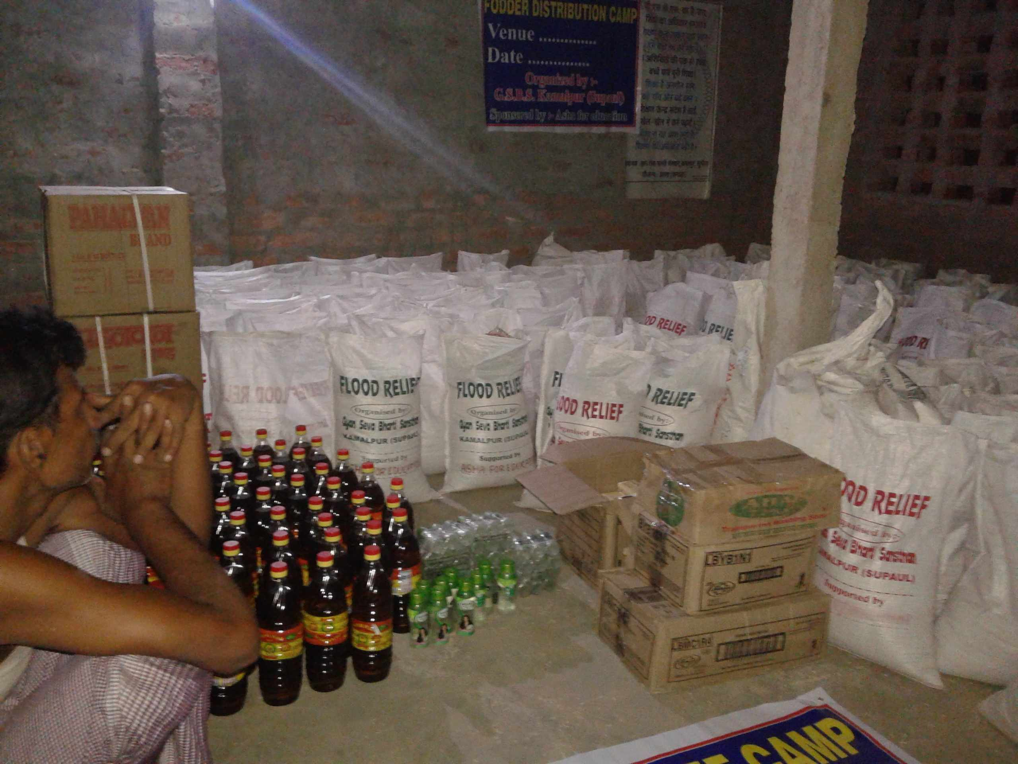
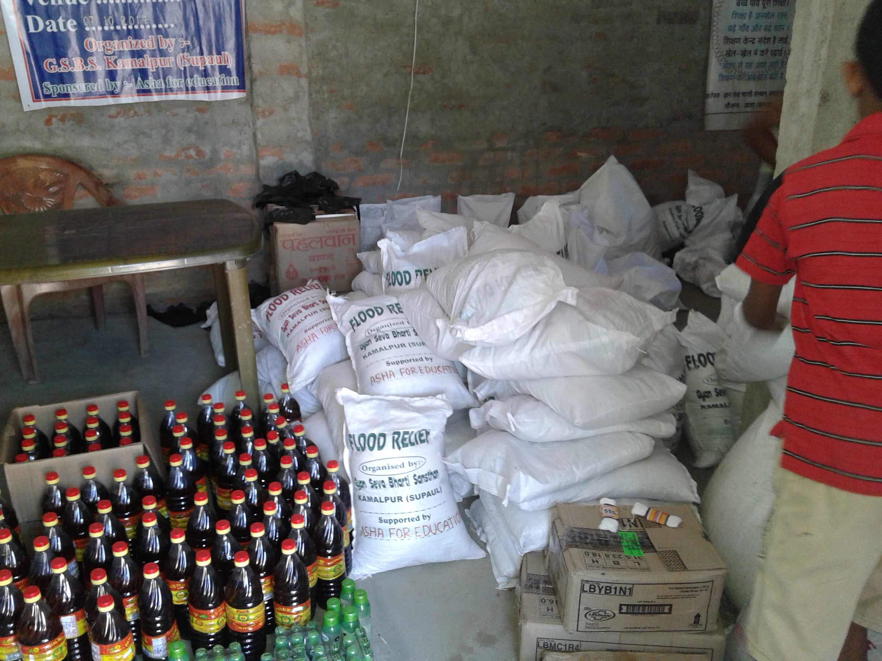

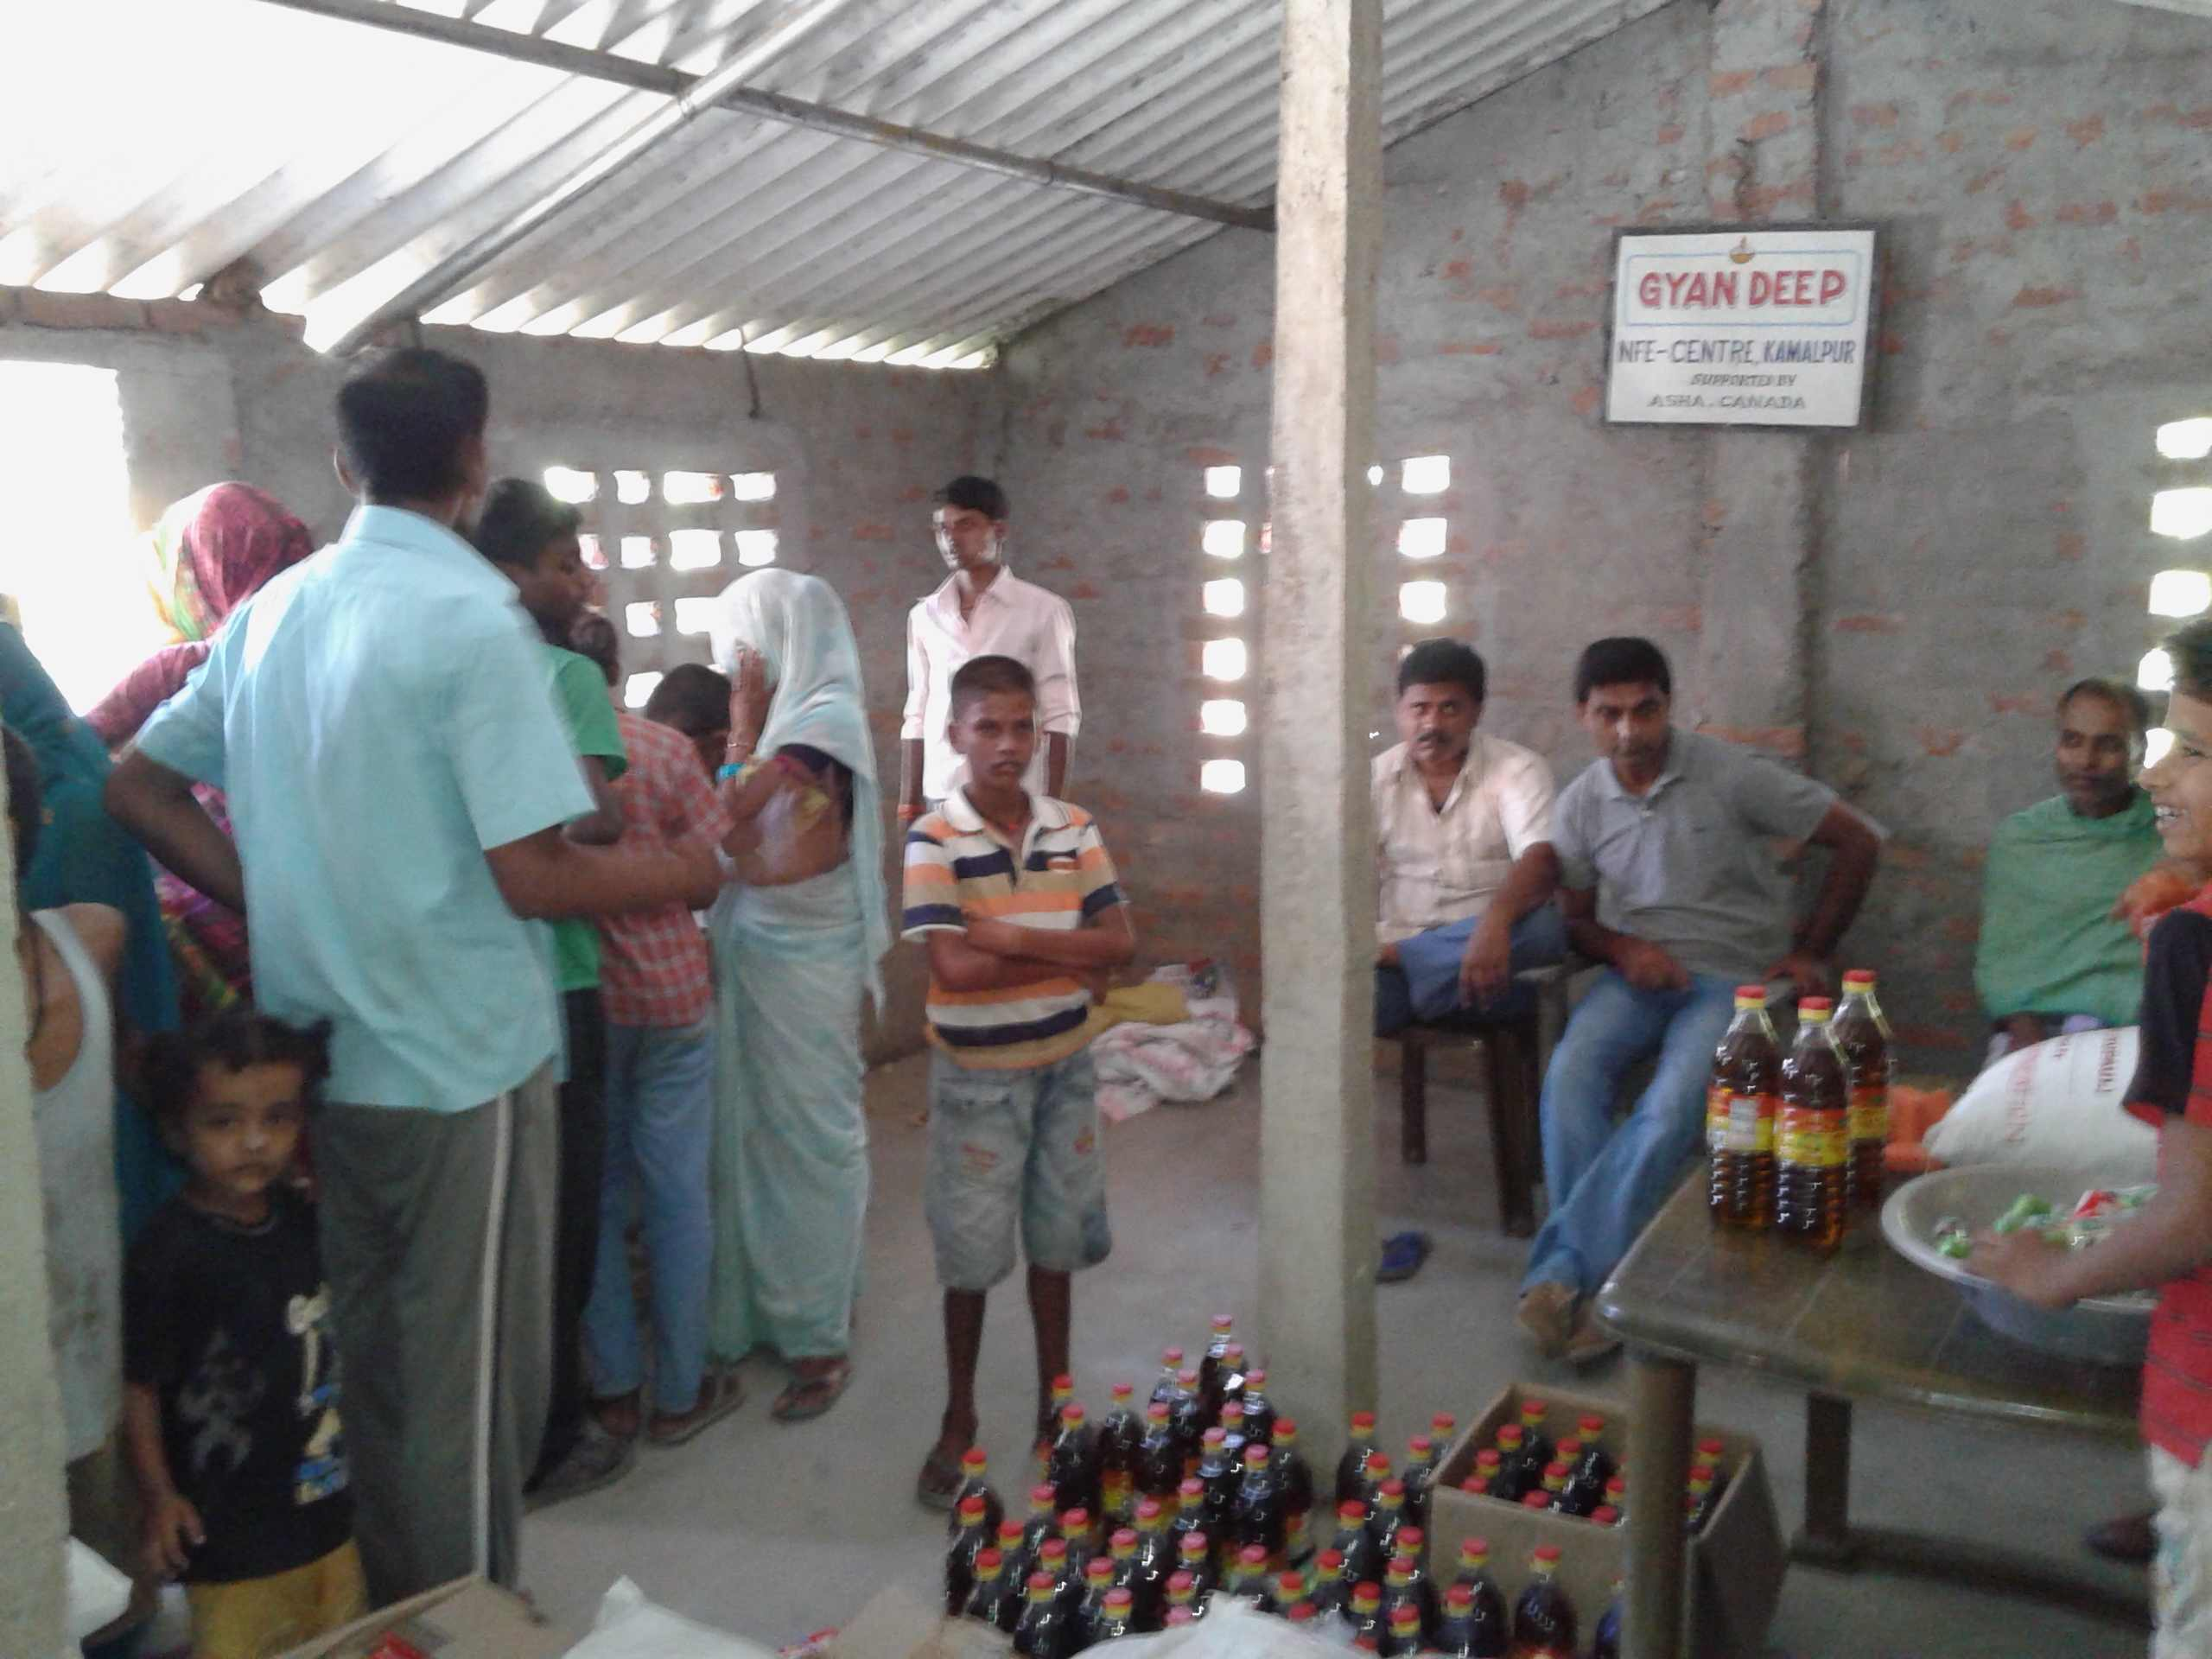

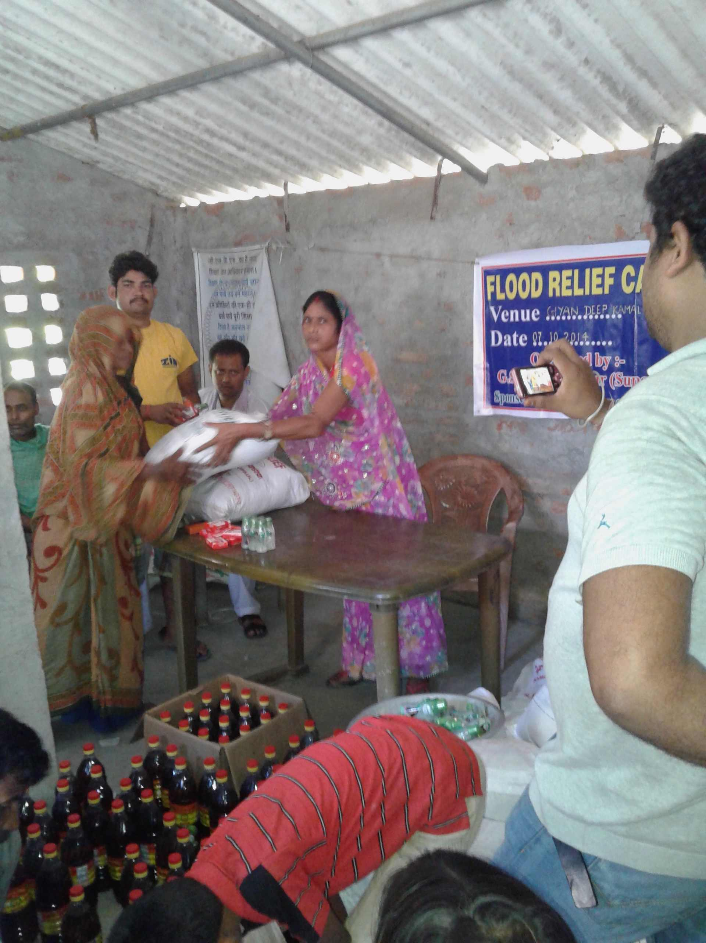

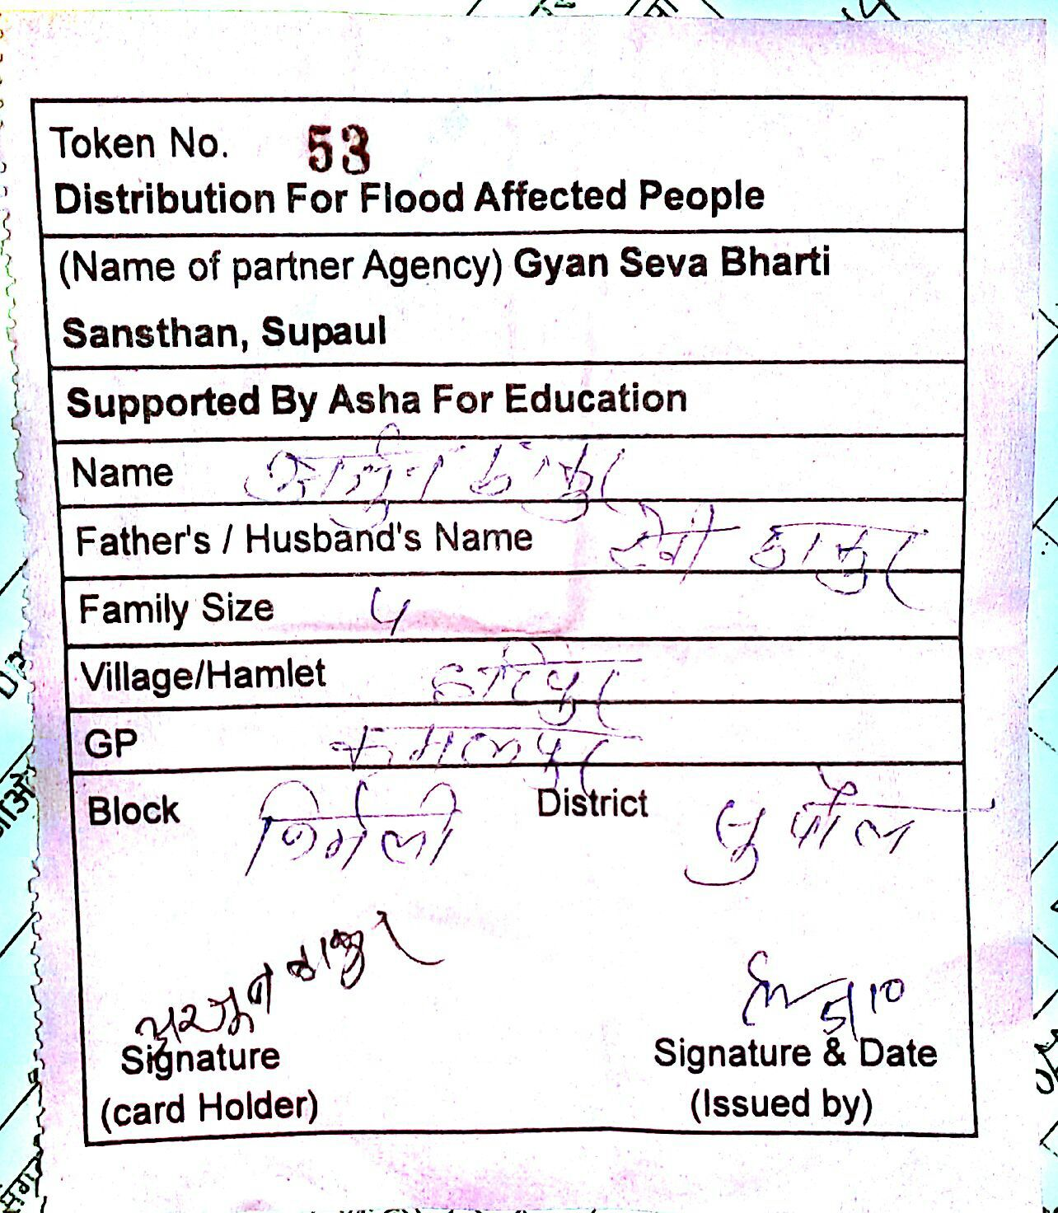

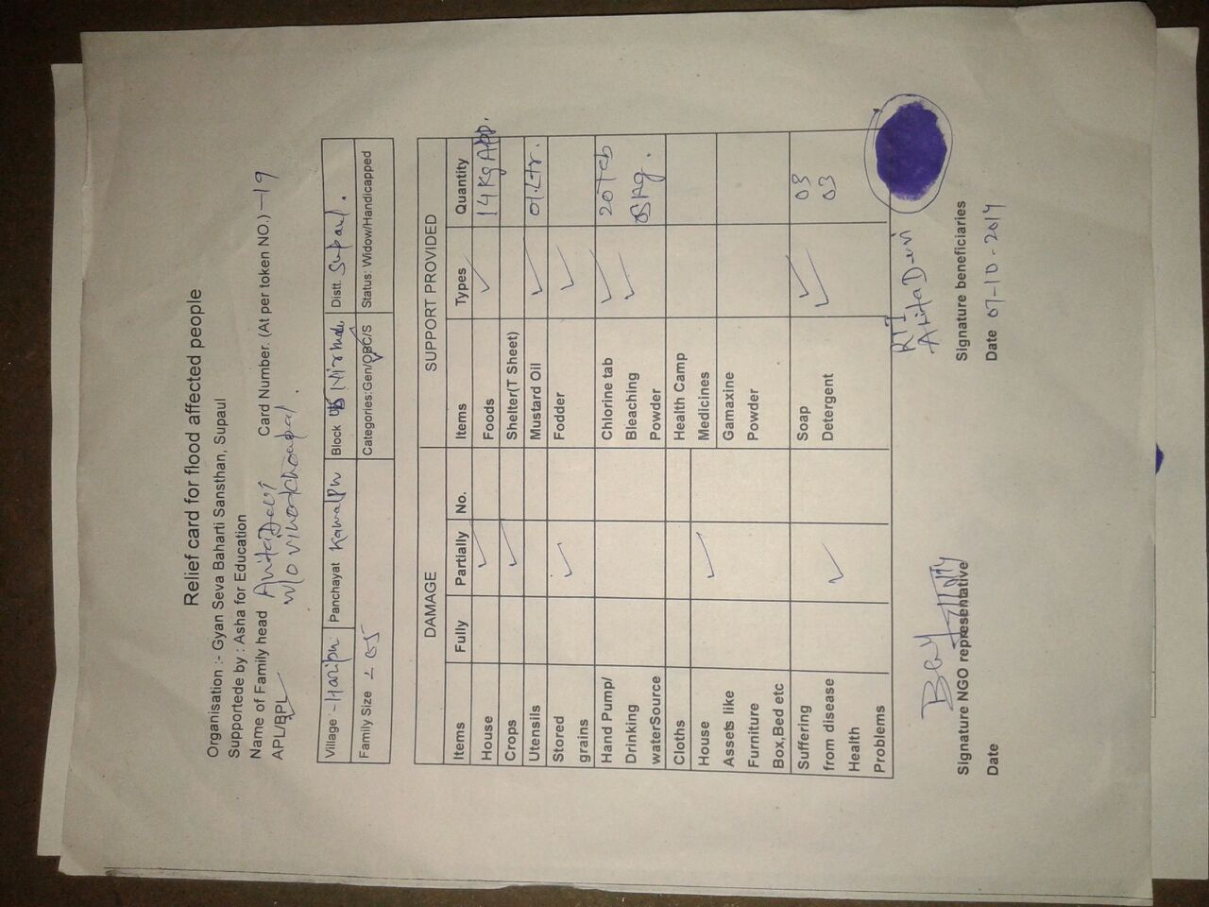
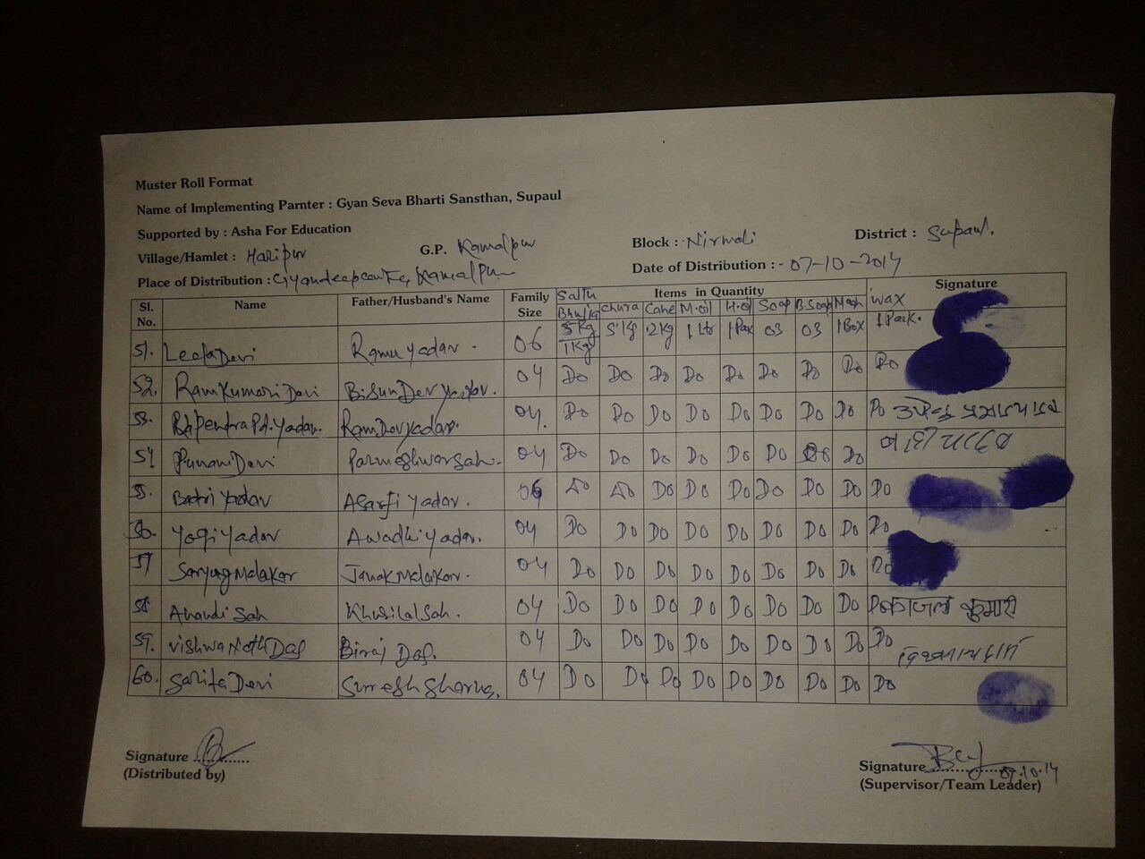

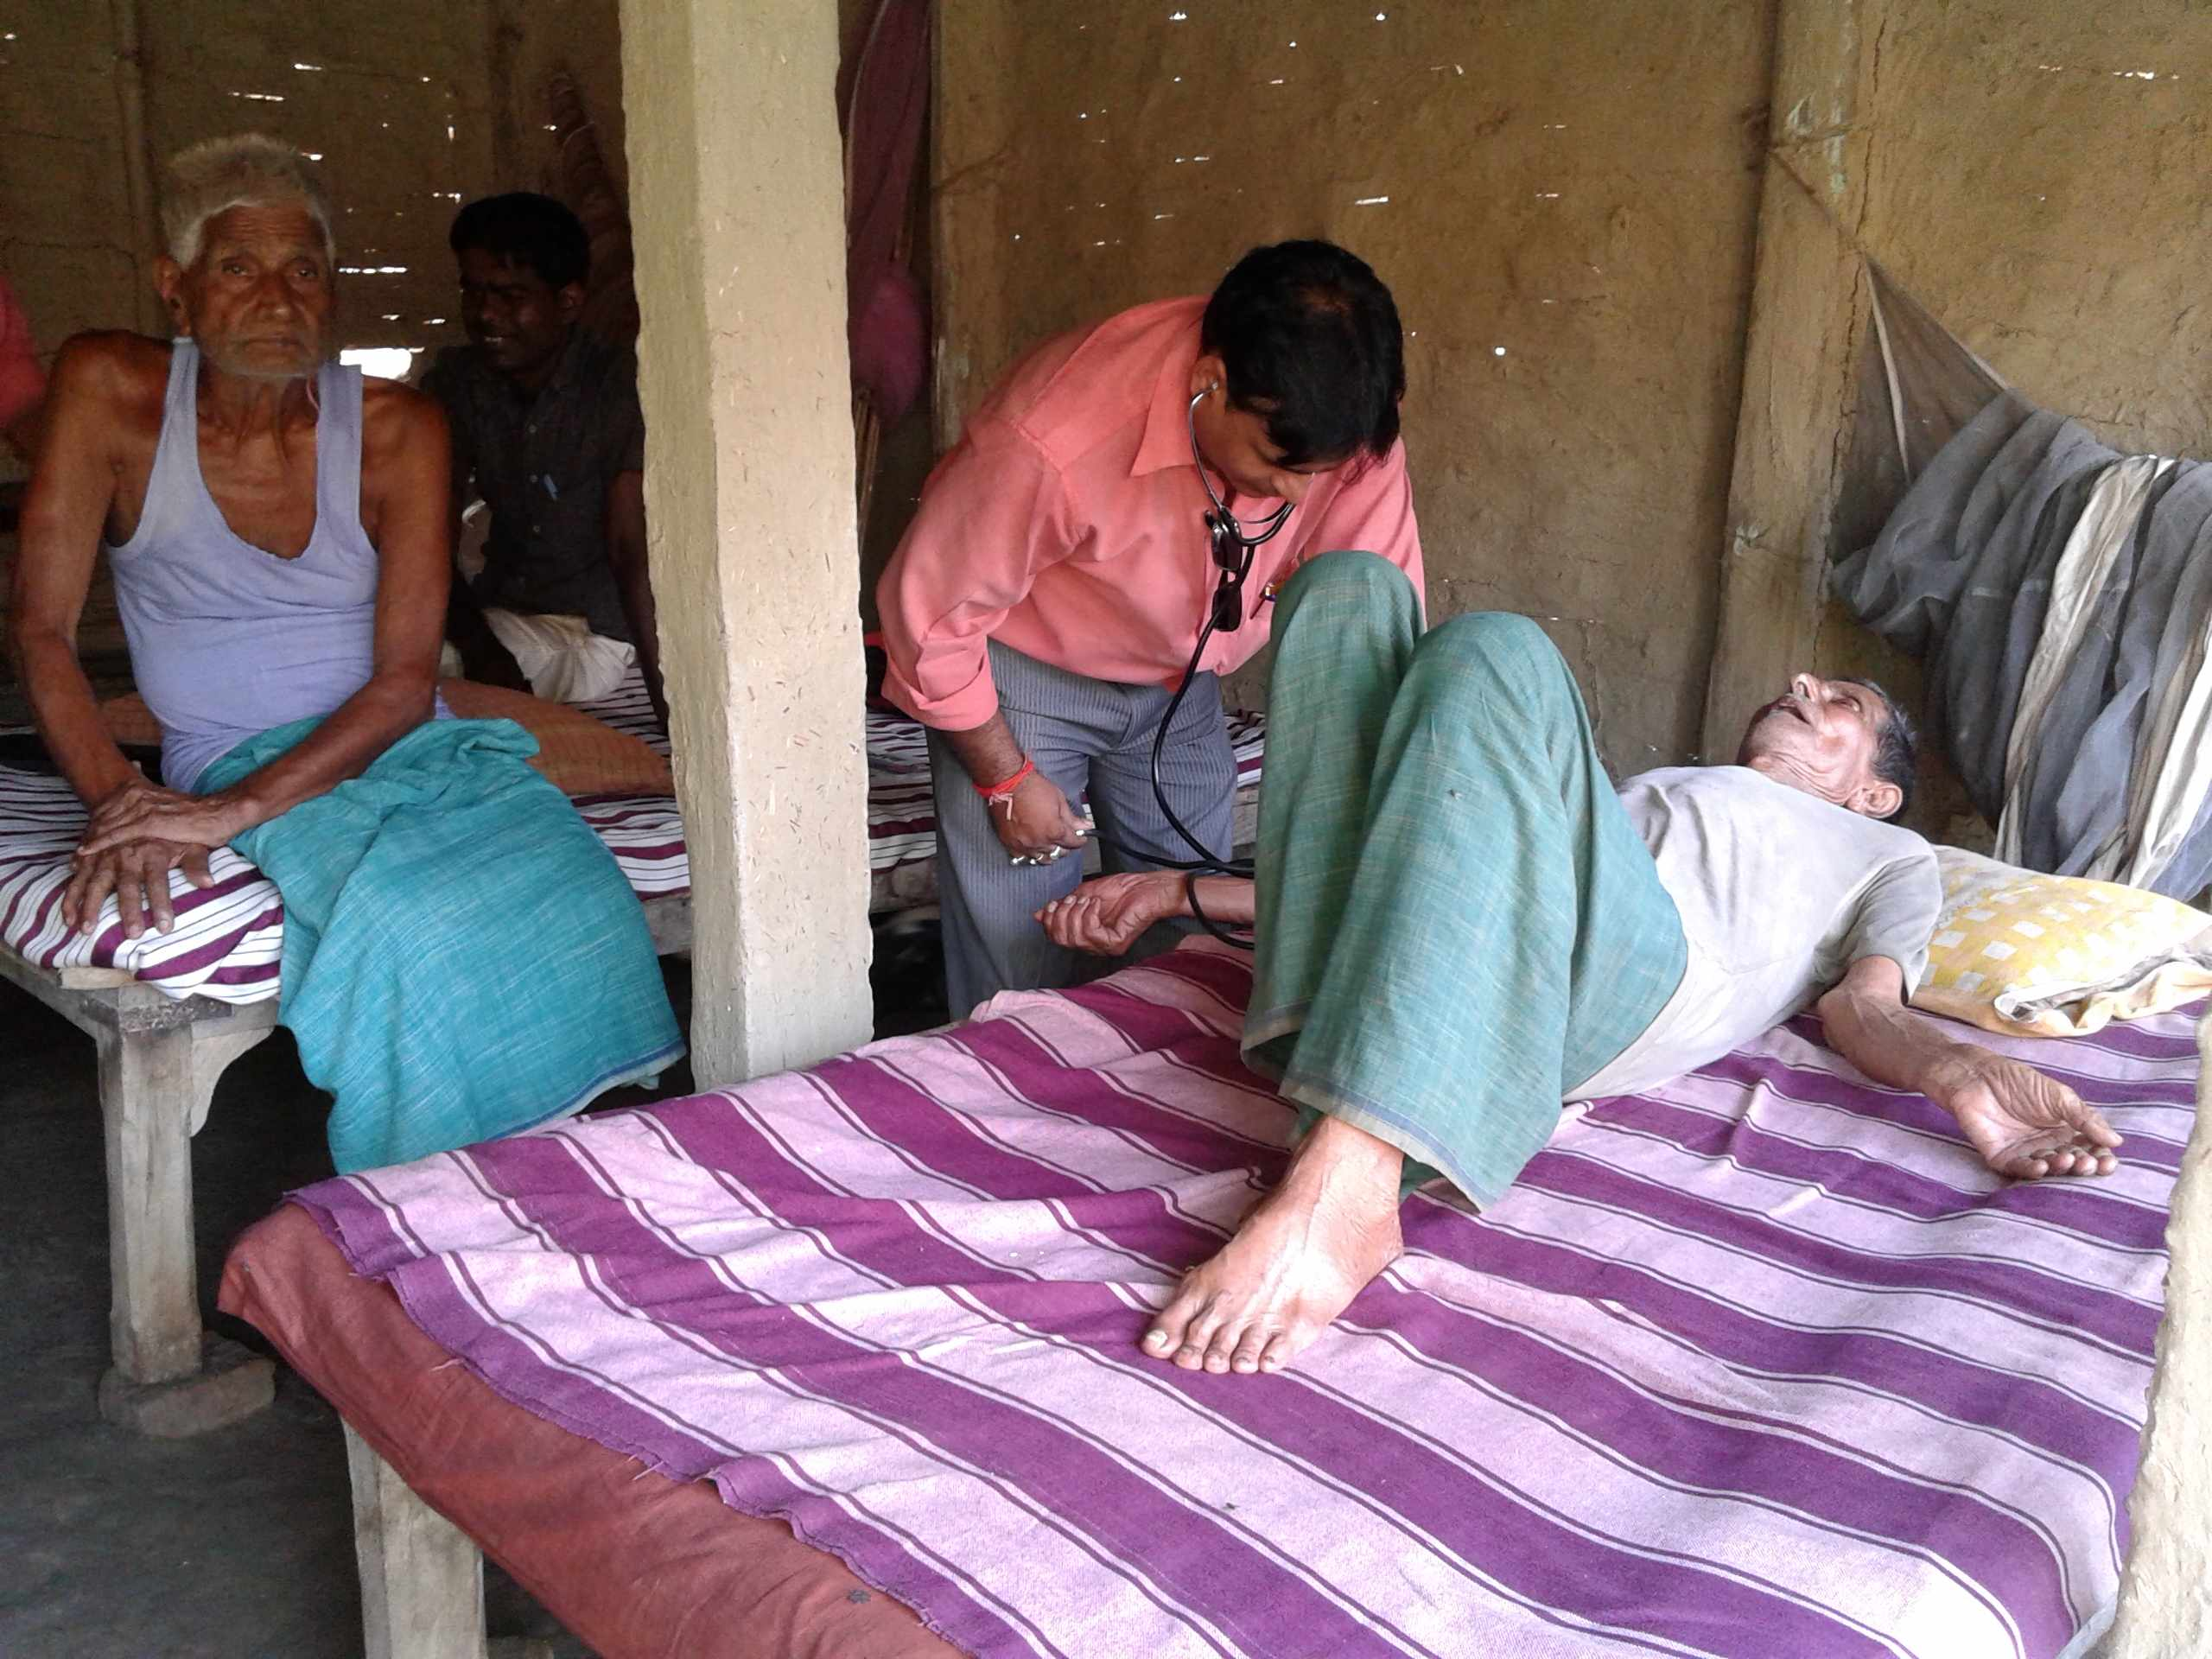

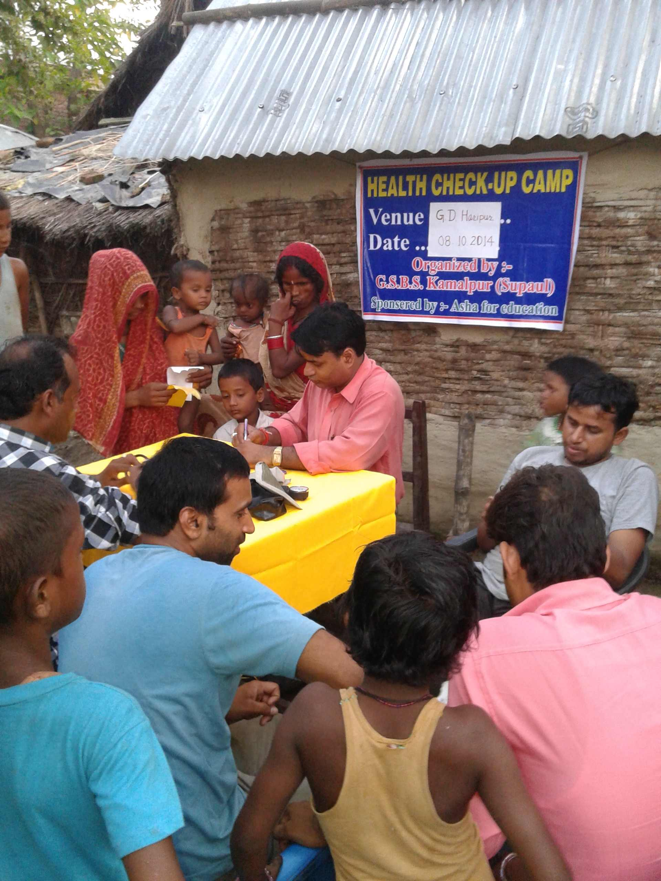
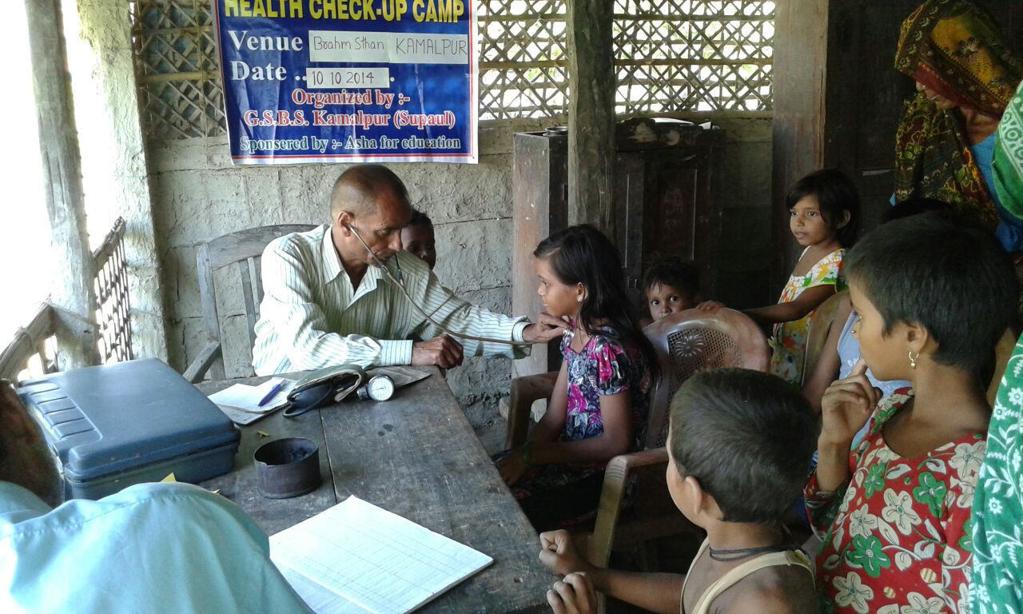

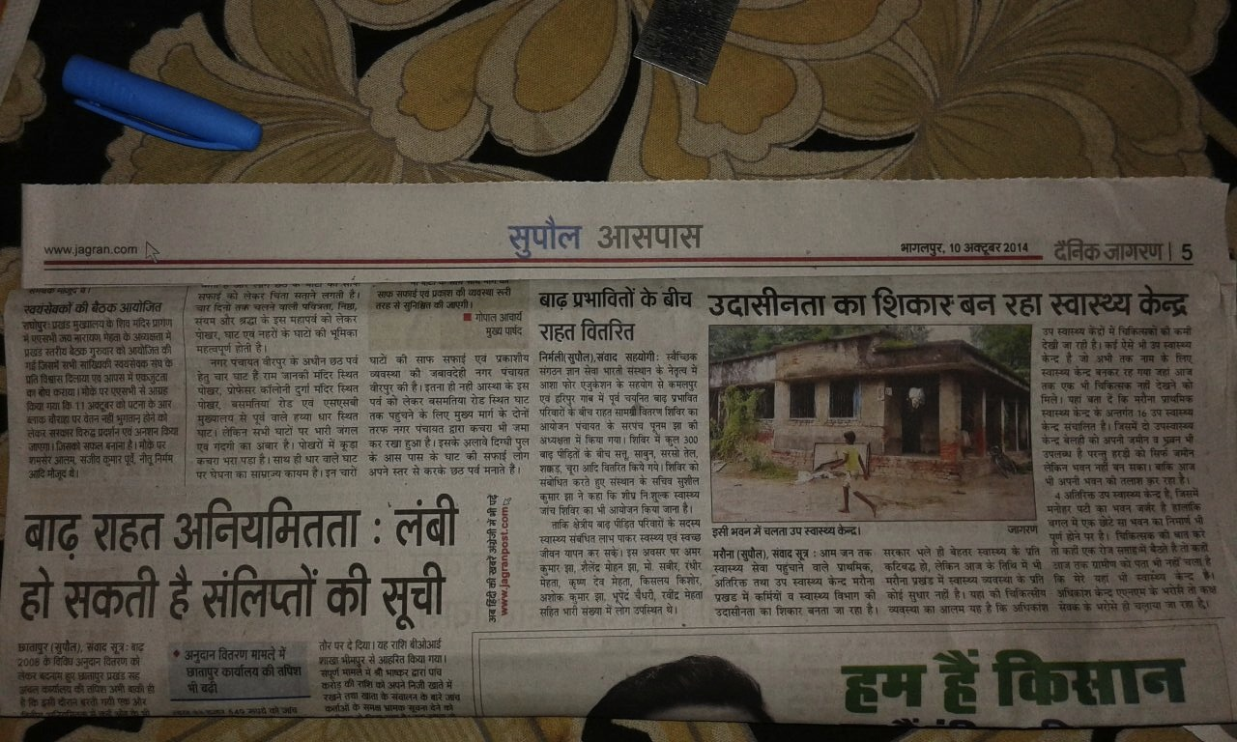

Newspaper clipping of report on flood relief operations – see fourth column of page.

